WORKFORCE DEVELOPMENT DIVISION

Workforce Program Policy

Technical Assistance Bulletin 292, Change 2

Keywords: AEL; TANF/Choices; Performance; TAA; VR; WIOA;WorkInTexas.com

Subject: Assessments in WorkInTexas.com—Update

Date: September 23, 2025

This Technical Assistance (TA) Bulletin provides Local Workforce Development Boards (Boards) with updated information about assessments available in WorkInTexas.com for assessing employability and job retention needs as well as achieving measurable skills gains.

Recissions
Technical Assistance Bulletin 292, Change 1

Background
As stated in Workforce Development (WD) Letter 09-19, Change 3, issued March 18, 2024, and titled “Workforce Innovation and Opportunity Act Performance Outcomes: Measurable Skill Gains―Update,” when pretesting and posttesting are used to demonstrate educational functioning level (EFL) gains, Boards must use the following National Reporting System (NRS)–approved tests:
- Adult Basic Education
  - TABE 11/12
  - TABE 13/14
  - CASAS Reading Goals
  - CASAS Reading Goals 2

  - CASAS Math Goals 2
- English as a Second Language (ESL)

  - CASAS Reading STEPS
  - CASAS Listening STEPS

  - BEST Plus 3.0

  - BEST Literacy 2.0
  - TABE CLAS-E Forms C/D
The NRS-approved tests listed above are available for use in the WorkInTexas.com Assessments tab > Basic Skills Assessment tab, Educational Functioning Level for Measurable Skills Gain ribbon for Workforce Innovation and Opportunity Act (WIOA), and Trade Adjustment Assistance (TAA) program applications.
The tests above may also be used for EFLs and as a general assessment of employability and job retention needs for Temporary Assistance for Needy Families Employment & Training (TANF E&T/Choices) customers.

Assessments Tab―Basic Skills Assessment
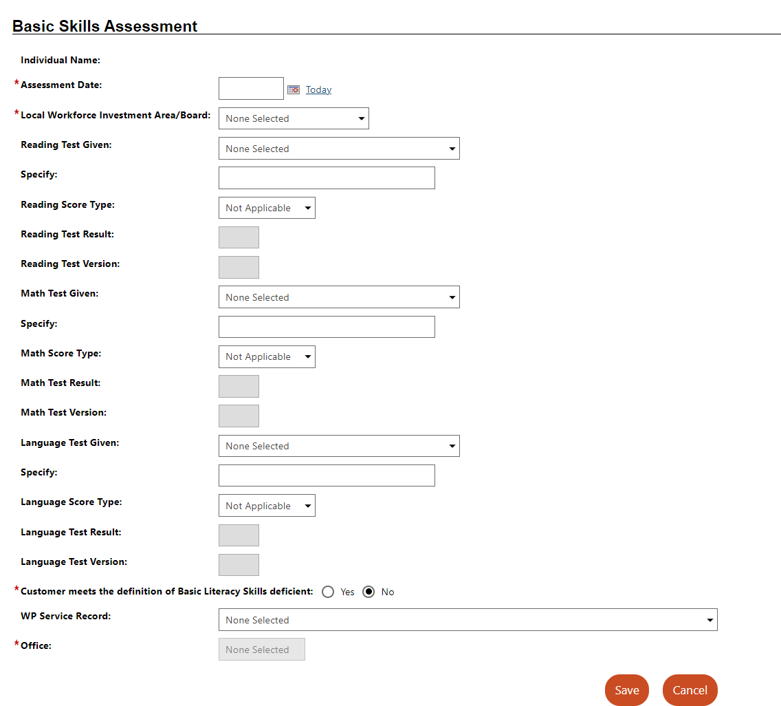
Staff may enter reading, math, and literacy assessment scores in the WorkInTexas.com Assessment tab—Basic Skills Assessment.
Assessments are created on a customer record but may be associated with one or more programs, if applicable. After selecting the test type, staff records the assessment results using grade-level equivalent or raw (scale) score, as appropriate.
The Basic Skills Deficiency status will be calculated and displayed automatically. Any individual who requires an ESL test would be considered basic skills deficient under WIOA.

Program Ribbon—Educational Functioning Level for Measurable Skills Gain
Workforce Solutions Office staff must document pretest and posttest EFL gains through the appropriate program ribbon. Once a pretest record is created for a WIOA or TAA program participant, staff may select the pretest to document the results of up to three posttest attempts. Workforce Solutions Office staff may enter posttest results up to the date of program exit.
For EFL gains, the raw score (pretest or posttest score on screen) must be entered to complete the record.
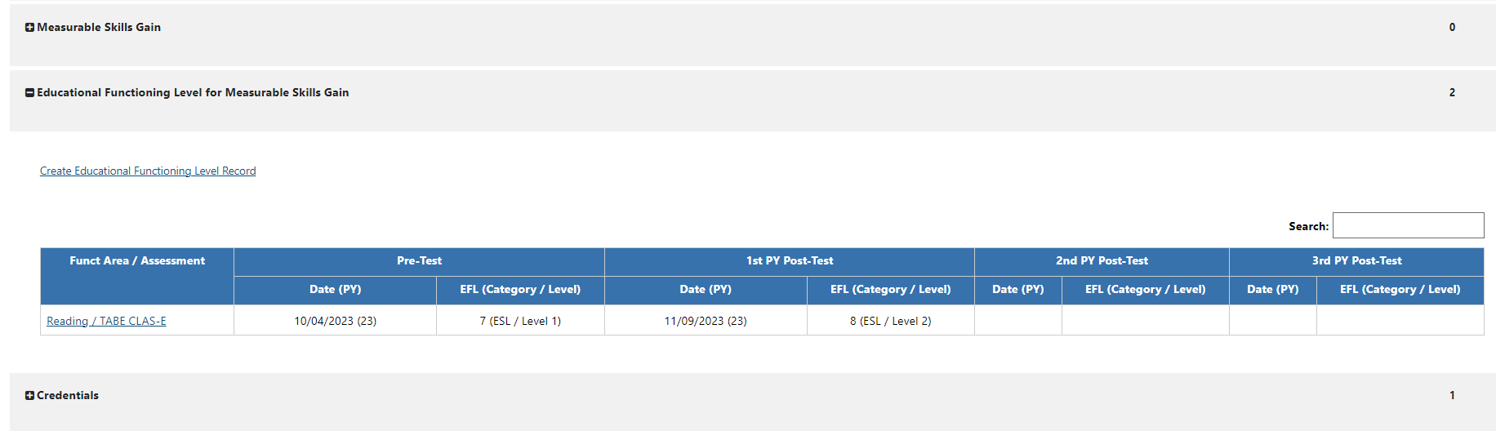
Please distribute this information to appropriate staff members. Send inquiries regarding this TA Bulletin to wfpolicy.clarifications@twc.texas.gov.

Attachments
Attachment 1: Revisions to TA Bulletin 292, Change 1, Shown in Track Changes

References
WD Letter 09-19, Change 3, issued March 18, 2024, and titled “Workforce Innovation and Opportunity Act Performance Outcomes: Measurable Skill Gains―Update”

NRS-approved assessments, test benchmarks, and related information are maintained on the National Reporting System for Adult Education website.
Basic skills deficient status at program entry may be determined through formal assessments, including NRS-approved tools, other valid tools, or interview or observation, in alignment with program-specific guidance.

