Work Location for Michael Hamilton should be Director of Customer Experience instead of Customer Experience.

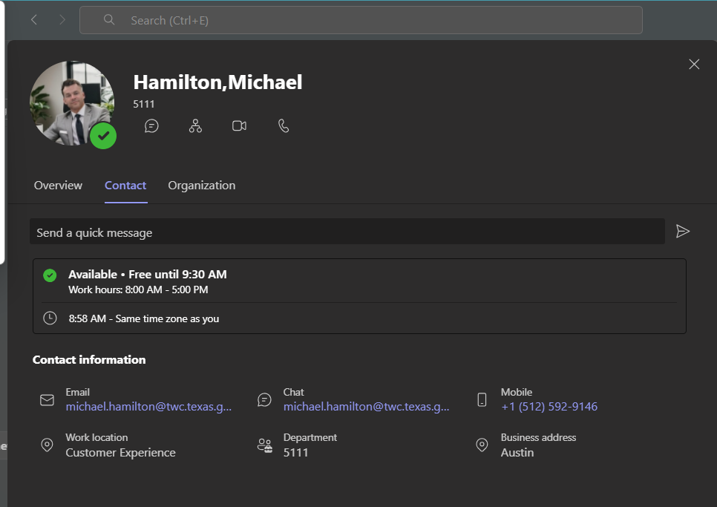
For example, other directors have their title in the work location:
