Employer Alert: Be Aware of a New Scam Email

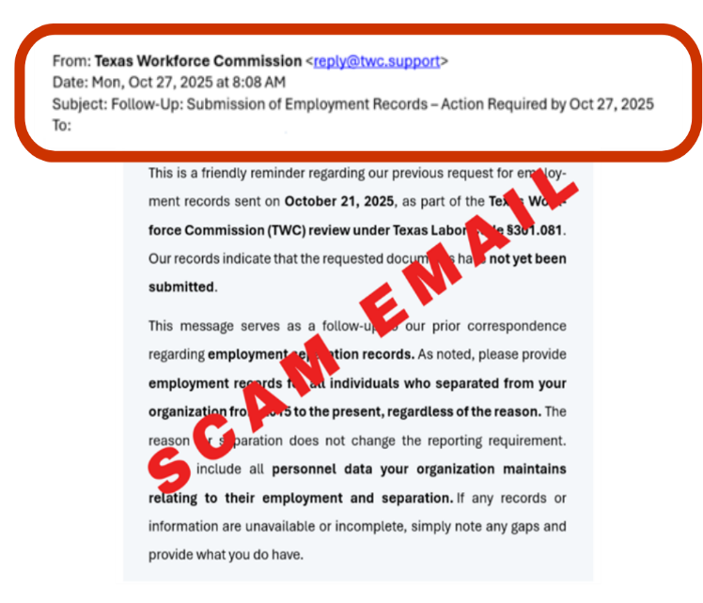
Employer Alert About a New Email Scam Requesting Employment Records
Please be aware of a recent scam email with the subject line: “Follow-Up: Submission of Employment Records – Action Required by Oct 27, 2025”
The email requests employment separation records for all personnel from 2015 to the present. The email also links to a webpage portal that is designed to look like TWC’s Employer Benefits Services (EBS) application.
This email is NOT from TWC. The portal is NOT a valid TWC webpage. Do not upload any files to this fake portal.
REMINDERS:
- TWC sends emails only from @twc.texas.gov and @public.govdelivery.com
- TWC sends information to employers in English only, not Spanish
Cybercriminals use phishing attacks to get past spam filters and virus-detection systems. Scammers can mimic an official TWC web application, so that it looks exactly like TWC’s Employer Tax Services or Employer Benefits Services. TWC reminds employers to be aware of possible scams.
If you think you have encountered a scam or have questions, submit an external contact request here: https://apps.twc.texas.gov/EXTCBK/ecrs/employer
Want to verify this email came from TWC? Go to TWC’s website (www.twc.texas.gov) and search for “Scams.” Select the search result for the “Avoiding Scams & Schemes” webpage. You will find a copy of this email under “Valid Notices Sent to TWC Customers.”

