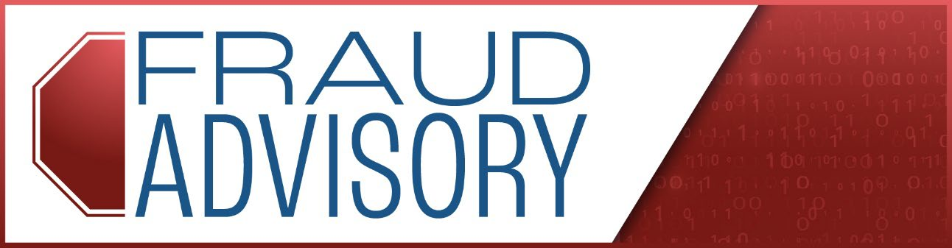
August 2026
Watch Out for Scams! Protect Your Unemployment Money
Fraudsters are using new scams to try and steal your unemployment benefits. They want to get into your account and take your money.
These new scams were recently found in North Dakota. We have not seen them in Texas yet, but you should still be on the lookout! Here is what you need to know to stay safe.
What Do the Scams Look Like?
Tricky Phone Calls: You might get a call from a robot using Artificial Intelligence (AI).
- The robot might say you have money waiting for you, like $4,000 in unemployment benefits.
- It will ask for your private information, like your Social Security number, address, or bank account details.
- The call can sound strange. The robot may talk very fast without pausing for breath. Even if you ask questions, the robot will keep repeating the same question to get your information.
- The phone number might look like it's from your local area code, but it's a trick to make you trust the call.
Fake Job Ads and Romance Scams
- Scammers try to get your information in other ways. They post fake job ads online or pretend to be a new friend or romantic partner. Their goal is always the same: to get your personal details so they can steal your money.
How to Protect Yourself
- Hang up on suspicious calls. If a call sounds strange or promises you money, just hang up.
- Never give out your information. Do not give your Social Security number, bank details, or password to anyone who calls you unexpectedly.
- Don't trust the phone number. Scammers can make it look like they are calling from a local number.
Staying alert is the best way to keep your benefits safe.

