Fake Email
  - Date: 10/20/2025
TWC was notified a scam where an email is sent advising the person to log on to “your Texas Unemployment Insurance (TX UI) account” to certify for benefits. The email gives a link of cutt.ly/Ur9tN9nh, which takes the user to a fake TWC page that asks for your User ID, Password, and PIN.
This is a SCAM.
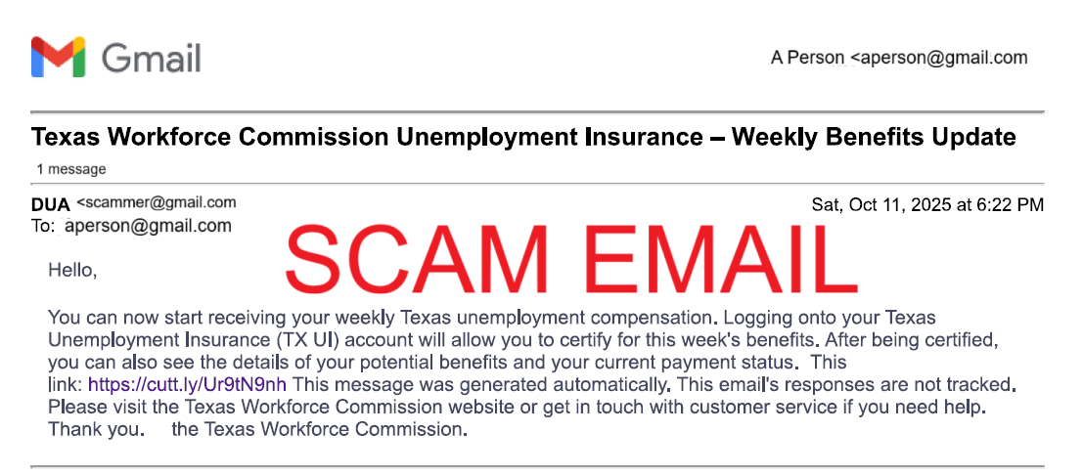
Spot the Fake
TWC’s online services is called Unemployment Benefits Services (UBS).
- We are NOT “Texas Unemployment Insurance (TX UI)”
TWC’s UBS system’s address is apps.twc.texas.gov/UBS/security/logon.dohttps://apps.twc.texas.gov/UBS/security/logon.do.
- The fake website address is wixsite.com (where the link takes you).
- The fake website also asks for your PIN when signing on. TWC’s UBS does not ask for a PIN to sign on.
TWC’s emails end with @twc.texas.gov.
- TWC does not send emails using Gmail. Or Yahoo mail. Or any other public web mail provider.
TWC’s website is twc.texas.gov.
- TWC does not use links like the one in the email, cutt.ly/Ur9t9…
Look for other clues that an email is fake, such as formatting that looks wrong, grammar, and spelling errors.
To be safe, NEVER click a link from an email or text. Go to your web browser and type the web address. TWC’s address is twc.texas.gov.

