Fraud UBS Page Scam
  - Date: 04/07/2026
Scam websites are like a game of Whack-A-Mole. As soon as one is down, another pops up. Customers must be careful and always check the website’s address to verify it is real.
TWC was notified of a scammer web page “twc-texas-gov.com” that is trying to trick our customers. While the page looks like TWC’s Unemployment Benefits Services log on screen, it is FAKE. How do you know it is fake? Look at the web address (also called the URL).
The fake address: “twc-texas-gov.com” – has “.com” at the end
The real address: “apps.twc.texas.gov/UBS/security/logon.do” – has “.gov” at the end.
To confirm a TWC website is legitimate, make sure the web address ends in .gov.
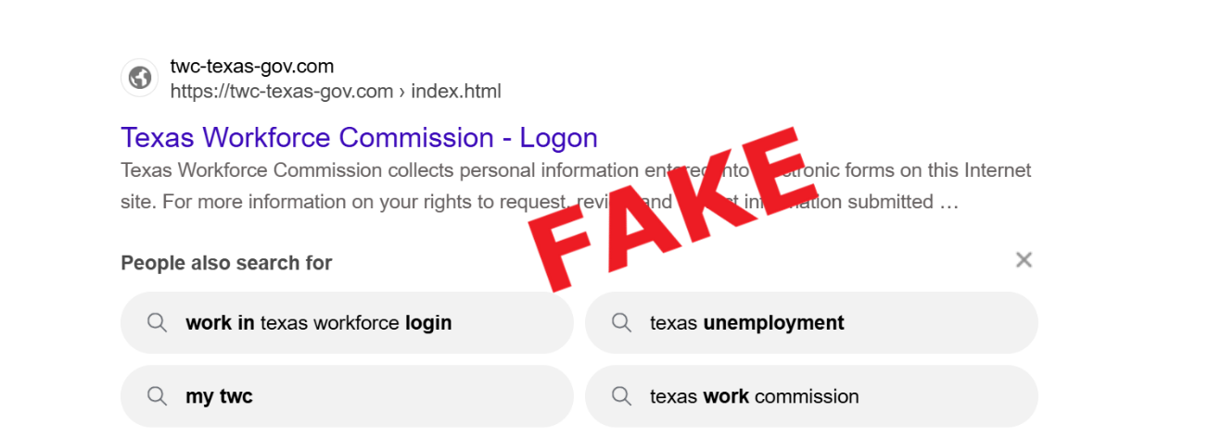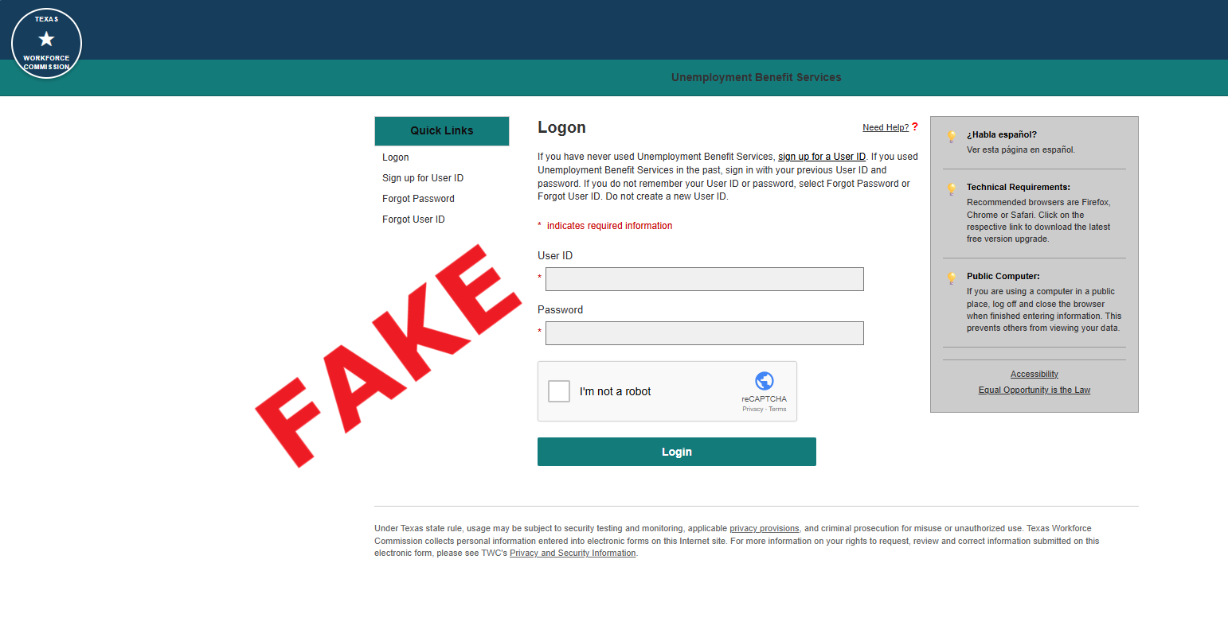
twc.texas.gov

