Texas Adult Education and Literacy

Performance Guide:
Employment, Training, and Educational Outcomes

Table of Contents
Purpose 6
Demonstrated Effectiveness with Data 6
Overview of AEL Contracted Measures 6
What are the AEL contracted measures? 6
Foundation for Understanding Performance 7
What is the AEL program year? 7
Who is an AEL participant? 7
Who is included in AEL performance measures? 8
Who is excluded from performance measures? 8
What is a period of participation? 10
What counts as a participatory service? 13
How does a participant exit? 13
What is a planned gap? 14
Contracted Measures: Enrollment Targets 15
Coding AEL Students in TEAMS 15
Contracted Measures: Measurable Skill Gains 16
Who needs an MSG and when? 17
Expanded MSG Options to Measure Outcomes 17
Planned MSGs 19
MSGs in TEAMS 20
MSG Type 1—EFL MSG 22
MSG Type 1a—Achievement on a Pretest/Posttest 22
MSG Type 1b—Postsecondary Enrollment MSG 22
MSG Type 2—HSD/HSE Achievement 23
MSG Type 3—Postsecondary Transcript or Report Card 24
Example That Count 24
MSG Type 3 TEAMS Entry 25
MSG Type 4—Progress Milestone 25
Example That Counts 26
MSG Type 4 Teams Entry 27
MSG Type 5—Skills Progression 27
Example That Counts 29
MSG Type 5 Teams Entry 29
Contracted Measures: Exit-Based Outcomes 29
Employed/Enrolled Q2 Post-exit—LBB Measure 30
Employed/Enrolled Q2 Post-exit 30
Employed/Enrolled Q2–4 Post-exit—LBB Measure 31
Credential Attainment—WIOA/LBB Measure 33
Failure to Meet Contracted Measures 35
Additional WIOA Performance Indicators 36
Employed Q2 Post-exit—WIOA Measure 36
Employed Q4 Post-exit—WIOA Measure 37
Median Earnings Q2 Post-exit—WIOA Measure 37
Effectiveness in Serving Employers 38
SOPs and Data Accuracy in TEAMS 39
Standard Operating Procedures 39
Data Validation 39
Monthly Performance Reports 40
Tableau Data Dashboards 40
TEAMS Reports to Monitor Performance 40
Appendix A: Background for this Policy 42
Previous TWC AEL Policy 42
Federal Regulation and Policy 42
Policies on which this Guide Is Based 42
Texas-Specific AEL Performance 43
Federal Requirements: Primary Indicators of Performance Negotiations 43
Failure to Meet Federal Performance 45
Texas Requirements: TWC-Set Performance 45
Commission-Approved Contracted Measures & Performance-Based Criteria 46
Performance Quality Improvement Awards 47
Appendix B: Glossary of Terms & Acronyms 47
Basic AEL Services 47
Contracted Measures 47
Credential 48
Credential Attainment 48
Demonstrated Effectiveness 48
Direct-Contact Hours 48
Educational Functioning Level (EFL) 49
Effectiveness in Serving Employers 49
Employment Rate—Q2 Post-exit 49
Employment Rate—Q4 Post-exit 49
Exit 49
Exit-Based Outcome Measures 49
Integrated Education and Training (IET) 49
Integrated EL Civics 50
Intensive AEL Services 50
Legislative Budget Board (LBB) 50
Measurable Skill Gains (MSGs) 50
MSG Type 1—EFL MSG 50
MSG Type 1a—Achievement on a Pretest/Posttest 51
MSG Type 1b—Postsecondary Enrollment MSG 51
MSG Type 2—HSE/HSD Achievement 51
MSG Type 3—Postsecondary Transcript or Report Card 51
Type 4 MSG—Progress Milestone 51
Type 5 MSG—Skills Progression 52
Measurable Skill Gains (MSG) Targets 52
Participant 52
Participants-Served Target 52
Participatory Service 52
Performance-Based Criteria 53
Performance Measures (also Contracted Measures) 53
Period of Participation (POP) 53
Planned Gap 53
Postsecondary Education or Training (also Workforce Training) 54
Educational Enrollment 55
Primary Indicators of Performance 55
Proxy-Contact Hours 55
Program Year 55
Recognized Postsecondary Credential 56
Reportable Individual 57
Texas Educating Adults Management System (TEAMS) 57
Trade-Related Benchmarks 57
Workforce Training 58
Appendix C: Program Year Contracted Measures and Performance-based Funding 59
Appendix D: List of Revisions 59
Revisions to the Performance Guide 59

Purpose
The purpose of the Texas Adult Education and Literacy Performance Guide: Employment, Training, and Educational Outcomes (AEL Performance Guide) is to provide Adult Education and Literacy (AEL) information and guidance on:
- the importance of demonstrated effectiveness as it relates to an entity’s ability to apply for AEL grants;
- AEL grantee performance measures (also known as contracted measures), composed of:
- federal performance requirements under the Workforce Innovation and Opportunity Act (WIOA); and
- Texas-specific performance requirements and measures;
- how grantees may measure progress toward required performance outcomes;
- recommendations for tracking the performance and outcomes of AEL participants;
- performance considerations related to performance-based funding and Workforce Awards; and
- how the Texas Workforce Commission (TWC) develops AEL contracted measures.

Demonstrated Effectiveness with Data
By law, TWC is required to award multiyear statewide AEL grants, commonly referred to as the core AEL grants, through a competitive procurement. For an entity to be eligible to apply for these grants, it must have demonstrated effectiveness in providing AEL activities, as required by federal regulations at 34 CFR Part 463. This requirement applies to entities that have been awarded AEL grant funds previously and those that have not. TWC reviews the following performance data when determining which entities are eligible to receive funds:
- Performance data in reading, writing, math, English language acquisition, and other subject areas
- Outcomes data related to employment, attainment of a secondary school diploma or its equivalent, and transition to postsecondary education and training
Only after an entity has proven demonstrated effectiveness will TWC review its application for AEL grant funds.
The US Department of Education’s (ED) Office of Career, Technical, and Adult Education (OCTAE) provides technical assistance on this topic in the Determining Applicant Eligibility When Conducting a State Competition for Adult Education and Family Literacy Act Funds Technical Assistance Guide.
Part of the application for statewide AEL grant funds is information on the grantee’s past effectiveness.

Overview of AEL Contracted Measures

What are the AEL contracted measures?
AEL grant awards outline the annual target enrollment and performance measures, also known as contracted measures, which grantees are contractually required to meet each program year. The AEL contracted measures are as follows:
- Participant enrollment targets
- Measurable skill gains (MSGs), as negotiated with ED
- Exit-based outcomes, as outlined in the General Appropriations Act (GAA) and passed by the Texas Legislature, as follows:
- Employed/Enrolled Q2 Post-exit
- Employed/Enrolled Q2–4 Post-exit
- Credential Rate
The following contracted measures are based on WIOA federal performance measures, which are further described in this guide:
- Employed Q2 Post-exit
- Employed Q4 Post-exit
- Median Earnings Q2 Post-exit
- Effectiveness in Serving Employers

Foundation for Understanding Performance
This section provides the foundation for understanding how AEL performance measures, such as enrollment targets, MSGs, and exit-based measures, are calculated. These measures comprise an AEL grantee’s contracted measures.
Appendix B provides a glossary of AEL performance-related terms and acronyms that are found in this guide.

What is the AEL program year?
The AEL program year is July 1 to June 30 of each year.

Who is an AEL participant?
A participant is an individual who has:
- taken an approved pretest, as allowed in the Texas AEL Testing Guide, that establishes an Educational Functioning Level (EFL); and
- accrued 12 direct-contact hours or has maintained a period of participation (POP) from a previous program year into a new program year.
Once an individual becomes a participant, he or she stays a participant until exit (90 days without a participatory service), as further described in How does a participant exit?
A participant crossing into a new program year may maintain the participant status by earning greater than zero direct-contact hours or proxy-contact hours recorded in the Texas Educating Adults Management System (TEAMS) in the new program year.
Participants who do not have an approved test in TEAMS will not be counted toward any performance measure.

Who is included in AEL performance measures?
All AEL participants are included in AEL performance measures, unless the participant has an exclusionary reason. However, only exiting program participants (exiters), unless excluded from performance, are included in exit-based measures.

Who is excluded from performance measures?
Participants who exit services due to the following circumstances may be excluded from performance measures if the AEL provider records an exclusionary reason in TEAMS and maintains documentation of the exclusion in the participant’s file:
- The participant is enrolled in education programs while incarcerated in correctional institutions and remains incarcerated at exit from the program.
- The participant exits the program because he or she has become incarcerated in a correctional institution or has become a resident of an institution or facility providing 24-hour support, such as a hospital or treatment center, while receiving services.
- The participant exits the program because of medical treatment that is expected to last longer than 90 days and precludes entry into unsubsidized employment or continued participation in the program.
- The participant exits the program because he or she is a member of the National Guard or other reserve forces and is called to active duty for at least 90 days.
- The participant dies.

No MSG Exclusions for Corrections
Participants who enroll in the AEL program while incarcerated and who remain incarcerated at program exit are included in the MSG performance measures. These participants may be excluded from other WIOA exit-based measures, such as credential rate and employment indicators, if an exclusionary reason is entered in TEAMS and acceptable documentation is retained in the participant’s file. Table 1 provides an overview of these exclusions as they appear in TEAMS.
Table 1: Exclusions Terms in TEAMS
TEAMS Term | Exclusionary Reason | When to Use this Reason
Became Institutionalized | The participant has become incarcerated in a correctional institution or has become a resident of an institution or facility providing 24-hour support, such as a hospital or treatment center while receiving services. | This describes a participant who exits because he or she went into a corrections or justice-involved facility for more than 90 days, and not an individual who is incarcerated at program entry.
Health / Medical | The participant needs medical treatment that is expected to last longer than 90 days and precludes entry into unsubsidized employment or continued participation in the program. | If the participant is in a treatment facility (medical or substance related) that prohibits him or her from seeking employment
Deceased | The participant died while participating in AEL services | Self-explanatory
Reserve Forces Called to Active Duty | The participant is a member of the National Guard or other reserve military unit of the armed forces and is called to active duty for at least 90 days. | Self-explanatory
Current Criminal Offender | A participant who is a criminal offender at program entry in a correctional institution and is participating in AEL services funded by §225 AEFLA funds and remains incarcerated after exit | This is different from ‘became institutionalized’ because current criminal offenders were already incarcerated at program entry. Exclusions from exit measures must be manually entered into TEAMS. Use of a funding code for a current criminal offender does not exclude the participant from exit-based measures.

Entering Exclusions in TEAMS
Exclusions must be recorded in TEAMS before the 90-day exit date is determined, and the start date of the entered exclusionary reason must be later than the last service date. Providers may use the POP TEAMS report to determine the 90-day exit date. The provider may enter an exclusionary reason if the Exiter Flag status in TEAMS is “no.”
Figure 1 shows where a provider may enter an exclusionary reason in TEAMS. While Source Documentation is not a required field in TEAMS, providers must maintain a copy in the participant’s file and may upload a copy in TEAMS. Acceptable types of source documentation for an exclusionary reason include:
- file documentation with notes from program staff;
- information from partner services;
- WIOA status and exit forms;
- electronic records;
- withdrawal form with an explanation; and
- information from the institution or facility.
Figure 1: Exclusionary Reasons in TEAMS
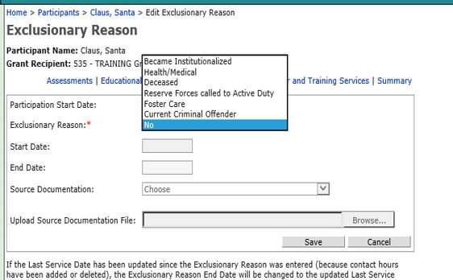

What is a period of participation?
A period of participation (POP) is an interval of measurement that begins each time an individual is found eligible for the AEL program through a pretest and accrues 12 direct-contact hours to then become a participant. The POP ends each time a participant has not received a participatory service for 90 days.
POPs may span across program years, and a participant may have multiple POPs in one program year. POPs add an additional period of measurement that is used to calculate participation, contact hours, testing intervals, and exit-based performance measures within and across program years.

When a POP Begins and Ends
A POP begins on the day an eligible individual with an approved pretest accrues 12 direct-contact hours. Direct-contact hours are documented by “D” in TEAMS.
A POP ends after 90 days without a participatory service (when inactivity in TEAMS triggers exit). The exit date is the day of the participant’s last participatory service.
A provider may not manually begin or end a POP in TEAMS. TEAMS calculates the beginning of a POP after a participant is found eligible through a pretest and has accrued 12 direct-contact hours and then calculates the end of the POP after 90 days have passed without a participatory service and the participant is not in a planned gap, which triggers exit. Additionally, if a participant ends service with one provider and begins with another within 90 days of the date of the last participatory service by the first provider, the POP will continue and both providers would be accountable for the participant’s performance until exit.
After exit, in order to regain participant status and start a new POP, the individual must:
- have a valid test score in TEAMS (as outlined in the Texas AEL Testing Guide); and
- accrue another 12 direct-contact hours.

POPs across Program Years
When a POP spans across a program year, participant contact hours carry forward into the next program year and it is not necessary to retest a participant with a valid test. The Texas AEL Testing Guide provides more detail on test validity and when providers must test or retest a participant.

MSGs and POPs
MSGs are program year–based and exit measures are POP-based performance measures. Participants are in the denominator for MSG for each program year in which they are participants, and grantees are accountable for one MSG gain each program year, even when a participant has more than one POP during that year. If a participant’s POP spans across program years, the participant is counted separately in the MSG denominator indicator for each program year. (For more information, see Figure 2.)

Exit-Based Measures and POPs
Exit-based measures are calculated after a participant’s POP ends, not at the end of a program year. Therefore, a participant with multiple POPs in a program year is counted separately for each POP in both the numerator and denominator of each applicable exit-based measure, which makes it possible for multiple independent outcomes for each POP.
For each POP, AEL grantees are accountable for and must manage and collect evidence of participant performance, as applicable, for each exit-based measure.
For example, a participant with two POPs during a single program year will have exit-based measures collected and calculated based on both POPs. Two separate outcomes will be based on the performance after each exit if the participant is in the denominator for that particular measure.
A participant whose POP spans across a PY is included in the denominator only for the PY in which the participant exits. For example, Figure 2 illustrates a participant whose POP begins in Program Year 2001 (PY’01) and who exits in PY’02. The individual is counted as a participant in both program years. The participant is in the denominator for MSGs in both program years, but exit-based measures must be documented and calculated based on the November PY’02 exit date.
Figure 2: POP Spanning Program Years and Performance
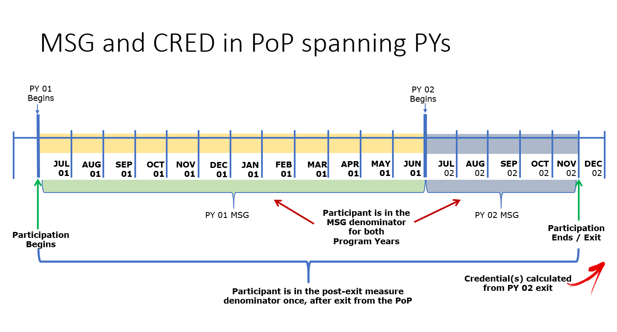
POPs may also have an impact on when or if a high school equivalency (HSE) credential will count as an MSG or count for the purposes of the credential attainment, or both. Figure 3 provides an example for when an MSG Type 2 would count as an MSG and assist in meeting part of the HSE credential performance measure.
Figure 3: MSG and Credential
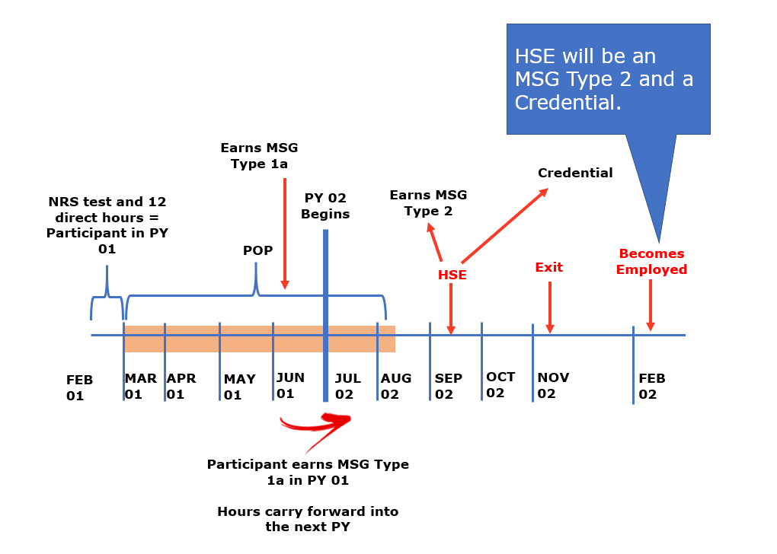

What counts as a participatory service?
A participatory service is an activity or service that initiates or extends a POP after an individual becomes eligible for AEL services. A participatory service begins a POP after a participant is found eligible by taking a pretest and accruing 12 direct-contact hours.
After an AEL provider determines an individual is eligible to receive AEL services, the following services are considered participatory services:
- Testing (excluding official HSE tests)
- Direct-contact or proxy-contact hours
- Workforce training hours in isolation up to 60 days after the end of accruing direct-contact or proxy-contact hours

How does a participant exit?
Exit is the last day that a participant receives a participatory service. This date may not be determined until 90 days after the participant last received a participatory service. After 90 days of inactivity, exit is retroactively calculated to the last day of participatory service unless there is a planned gap initiated in TEAMS. TEAMS automatically calculates exit, and AEL grantees may not initiate exit by removing a participant from the class roster and adding an end date in TEAMS.
The participant profile’s Exiter Flag column indicates whether a participant has exited the program.
Figure 4: Exiter Flag in TEAMS

What is a planned gap?
A planned gap is a break in service with a specific date on which the participant will return for specific services. A planned gap is more than 90 days but fewer than 180 days. A participant who has an active planned gap entered into TEAMS will not exit after 90 days unless the participant fails to return for services by the end of the planned gap. ​
The following are examples of when an AEL provider would use a planned gap:
- A participant has a medical procedure that requires the participant to be absent from class for a certain period of time, but the participant expects to return to class on a particular date. ​
- A participant must leave class to care for a family member but will return to class on a particular date.​
- In May, a participant registers for Integrated Education and Training (IET) that begins the next fall but needs to work full time over the summer and cannot continue AEL services.​
Planned gaps are delineated in month-to-month periods and must be entered at the beginning of each month on the Participant Profile screen in TEAMS, as shown in Figure 5. AEL grantees must communicate monthly with a participant on the status of the participant’s absence to determine if the planned gap is still necessary, if the participant intends to return to specific AEL activities on the planned return date, or if an update to the planned gap end date is required.
If a participatory service does not occur within 14 days of the last day of a planned gap and 90 or more days have passed since the last participatory service, an exit will be calculated as of the date of the individual’s last participatory service.
Figure 5: Planned Gap in TEAMS
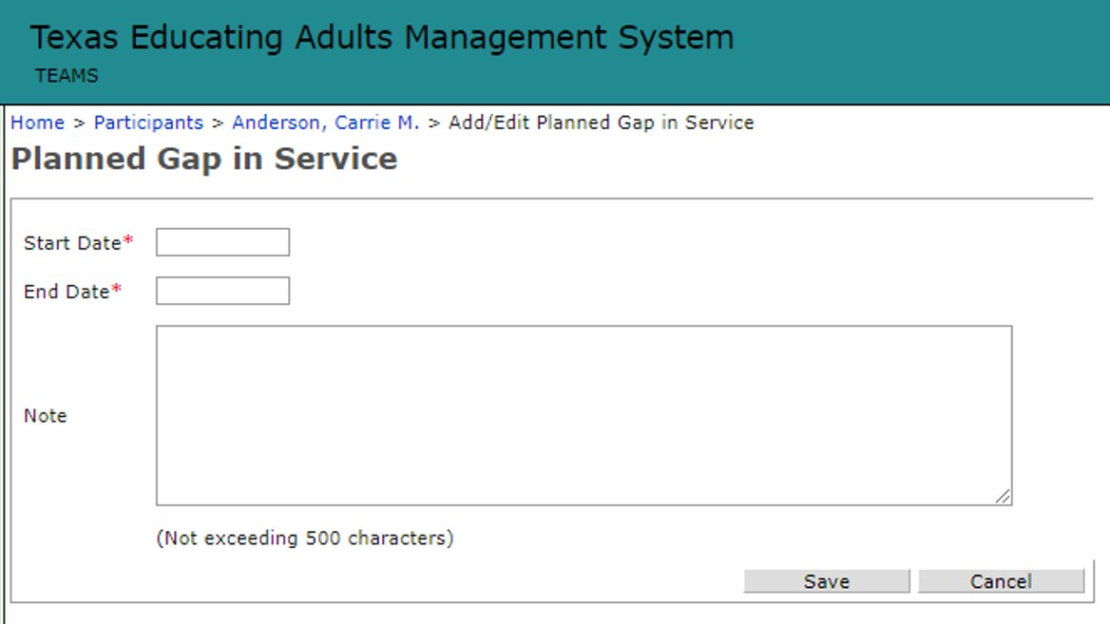

Contracted Measures: Enrollment Targets
AEL grantees must meet contracted enrollment targets, as approved by TWC’s three-member Commission (Commission) each program year, for each service delivery category. Grant awards under RFP 320-18-01 include:
- Intensive Services, which include:
  - workplace AEL activities;
  - transition to reentry and post-release services; and
  - internationally trained English language learner professionals;
- IET;
- EL Civics Program, which include:

  - Non-IET EL Civics services; and
  - IET EL Civics services; and
- Total Participants Served.
Information on these service delivery models is further detailed in the Texas AEL Guide.

Coding AEL Students in TEAMS
AEL grantees must accurately report in TEAMS the services provided to an AEL participant in order to receive credit for each enrollment target category. The following table provides an overview of the TEAMS activity codes that grantees must use for corresponding services provided to a student.

Table 2: Enrollment Targets and TEAMS Activity Codes
Target Category | Funding Codes/Activities | Description of Funding
EL Civics (Non IET) | EL Civics (EL Civics) | WIOA §243 (EL Civics)
EL Civics IET  (Integrated EL Civics) | IET (EL Civics) | WIOA §243
Intensive Services | Work-Based (AEFLA)  Work-Based (Local)  ESL for Professional (AEFLA)  ESL for Professionals (Local)  Reentry (Corrections) | WIOA §231 (AEFLA)  Local  WIOA §225 (Corrections)
IET | IET (AEFLA)  IET(Local)  IET (Corrections) | WIOA §231  Local  WIOA §225 (Corrections)
Total Participants Served (Unduplicated) | EL Civics (AEFLA)  EL Civics (EL Civics)  ESL for Professionals (AEFLA) ESL for Professionals (Local)  IET (AEFLA)  IET (Corrections)  IET (EL Civics)  IET (Local)  Local  Reentry (Corrections)  Basic AEL (AEFLA)  Transitions (Corrections) Transitions Classes (AEFLA) Transitions Classes (Local)  Work-Based (AEFLA)  Work-Based (Local)  Basic AEL (Corrections)  Math Assistance Call Center (State Leadership) | All activities and funding streams contribute to the Total Participants Served unduplicated target.

Contracted Measures: Measurable Skill Gains
MSGs and credential attainment options support targeted measurement of college readiness and transition, postsecondary education or training, and customized employer-based services. New federal guidance greatly expands ways to report a participant’s progress for AEL activities.

Who needs an MSG and when?
All AEL participants (those with 12 or more direct-contact hours and a National Reporting System (NRS)–approved pretest) who are enrolled in AEL activities are included in the calculation for the MSG contracted measure, unless the participant is excluded from this indicator. See Who is excluded from performance? for more information on which participants are excluded from MSG performance calculations.
“All participants in title II AEFLA programs are considered to be in an education program leading to a recognized postsecondary credential or employment and, as such, would be included in the measurable skill gains indicator.”—OCTAE Program Memorandum 17-2
Every AEL participant must achieve an MSG each program year. AEL grantees must ensure that each participant earns the most suitable MSG to measure the student’s progress in the AEL program in each program year.
Instructors and performance accountability leads are required to clearly understand which performance options are most appropriate to measure activities related to participants’ goals and programs of study so that they may plan and monitor services and performance accordingly. Additionally, it is important that participants are aware of the program’s plan for measuring their accomplishments.

Expanded MSG Options to Measure Outcomes
In February 2021, ED announced approved revisions for NRS reporting, which included the expansion of MSG options for participants in IET and workplace literacy programs.
Previously, Texas AEL policy defined MSGs within two broad categories: those designed primarily to measure basic education activities and those designed primarily to measure workforce training in IET. With the expanded MSG options, as outlined in this guide, Texas AEL grantees may focus efforts on measuring progress of IET and workplace literacy participants with the most appropriate and suitable MSG option.
Table 3: MSGs Overview
MSG Type | Name | Which Participants May Earn This? | Details
Type 1a | Achievement on an NRS-approved pretest or posttest | Any AEL participant | Documented achievement of at least one EFL on an approved NRS test by a participant who is receiving instruction below the postsecondary education level
Type 1b | Postsecondary enrollment | Any AEL participant | Documented post-exit enrollment in postsecondary education or training during the same program year that contains the date of exit
Type 2 | HSE achievement | Any AEL participant that lacks a US high school diploma or high school equivalency | Documented attainment of a secondary school diploma or its recognized equivalent
Type 3 | Transcript or report card | Participants enrolled in IET  (or participants enrolled in a workplace literacy program specifically approved by TWC AEL staff to show progress with this MSG) | Postsecondary transcript or report card for a sufficient number of credit hours that shows a participant is meeting the state unit’s academic standards
Type 4 | Progress toward milestones | Participants in workplace literacy or IET | Satisfactory or better progress report toward established milestones from an employer.
Type 5 | Passing an occupational exam or progress toward attaining occupational skills identified by trade-related benchmarks for specific occupations | Participants enrolled in IET  (or participants enrolled in a workplace literacy program specifically approved by TWC AEL staff to show progress with this MSG) | Successful passage of an exam that is required for a particular occupation or progress in attaining technical or occupational skills as evidenced by trade-related benchmarks, such as knowledge-based exams

Planned MSGs
The planned MSG is the MSG that AEL program staff identifies during an individual’s initial comprehensive assessment and forecasted to be the MSG most conducive to allowing the individual to make performance gains and support attainment of the individual’s goals. The planned MSG gives providers and participants a clear path forward and ensures that there is a participant-specific plan for what the participant will learn and how the participant will demonstrate the MSG. The forecast is based on the participant’s level at intake, initial objectives, goals, and the program of study selected during enrollment. Because not all aspects of a participant’s success may be forecast and a participant’s program goals may change, the planned MSG may also change.
AEL grantees must document the participant’s goals and the planned MSG in an Individual Training Education Career (ITEC) plan in the participant’s file and in TEAMS (when this feature becomes available).

MSGs in TEAMS
AEL grantees must enter the achievement of an MSG on the TEAMS Educational Outcomes screen (as shown in Figure 6) by the monthly data validation deadline. Grantees are encouraged, however, to enter and maintain proper documentation for the MSG as soon as it is earned by the participant.
If a participant achieves more than one MSG in a program year, the provider must enter each MSG into TEAMS and maintain any required documentation.
Figure 6: Educational Outcomes in TEAMS
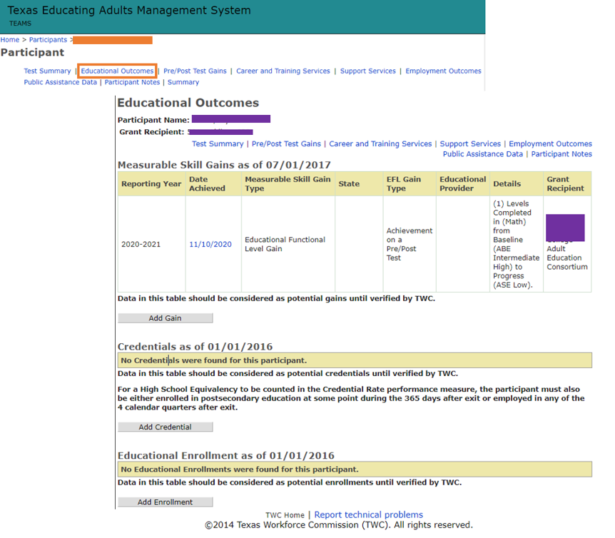

Figure 7 shows an overview of the MSG options providers may choose in TEAMS, correspond to those in Table 3.
Figure 7: MSGs in TEAMS
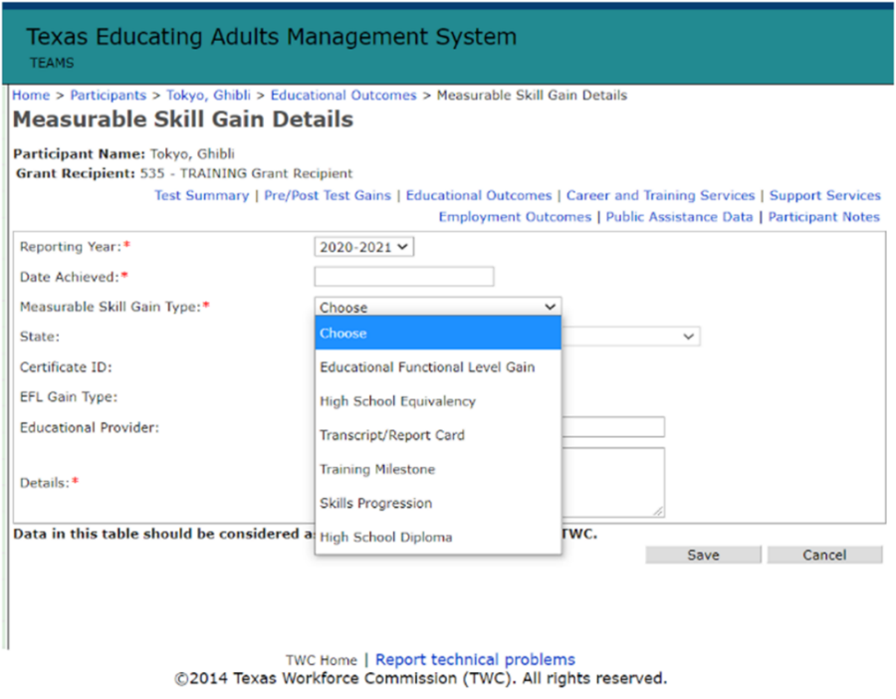

MSG Type 1—EFL MSG
This is the documented achievement of an EFL gain for participants receiving instruction below the postsecondary education level in one of the two following types of EFL measures. Typically, this is the MSG most AEL participants achieve that demonstrates basic skills or language fluency advancement.

MSG Type 1a—Achievement on a Pretest/Posttest
An MSG Type 1a is achieved by comparing a participant’s initial EFL as measured by a pretest with the participant’s EFL as measured by a posttest, using NRS-approved tests for AEL in Texas in accordance with the Texas AEL Testing Guide. The EFL may be achieved in any content area, and not just the area with the lowest score.
Numeracy descriptors are allowed for ESL participants and speaking and listening descriptors are allowed for participants in ABE and ASE, if the participants’ needs and the program’s instruction warrant such an approach. Once a participant makes a gain on a posttest, it may never be unearned by subsequent testing within the same program year.

MSG Type 1a TEAMS Entry
Achievement on a pretest/posttest MSG is documented in TEAMS by entering the test on the Pre-Posttest Gains screen in TEAMS, as required by the Texas AEL Testing Guide.

MSG Type 1b—Postsecondary Enrollment MSG
A participant earns this MSG when he or she enrolls in a postsecondary education or training program that leads to a postsecondary credential after the participant exits AEL services. To earn this MSG, the participant must do the following within the program year:
- Be below the postsecondary level in one or more content areas
- Exit AEL services and have no planned gap entered in TEAMS
- After exit but within the same program year, enroll in a postsecondary education or training program that leads to a postsecondary credential
AEL grantees must obtain and file enrollment documentation for a postsecondary education or training program. Examples of enrollment documentation include:
- official verification of enrollment;
- a transcript showing proof of enrollment;
- proof of enrollment in a Registered Apprenticeship Program, such as:
- an agreement or contract with the apprenticeship program;
- a US Department of Labor (DOL) registration card for a registered apprentice; or
- a log of contact hours, posted by the apprentice or the training instructor, that tracks 2,000 hours toward program completion;
- an employer’s documentation of enrollment in employer-led training leading to a recognized postsecondary credential; or
- other forms of documentation deemed appropriate by TWC AEL staff.

MSG Type 1b TEAMS Entry
AEL grantees must ensure that staff documents Postsecondary Enrollment in TEAMS by adding a new Educational Enrollment activity on the Educational Outcomes screen. TEAMS automatically determines if proper conditions exist for the postsecondary enrollment to count toward MSG Type 1b based on participant status and last service date. There may be a delay in the educational enrollment appearing as an MSG until official exit has been established.

MSG Type 2—HSD/HSE Achievement
MSG Type 2 is the documented attainment of a recognized English- or Spanish-language HSE credential or high school diploma (HSD) during the program year. Out-of-school participants (those not required to attend school as outlined in Texas Education Code §25.085) may obtain a state-recognized high school diploma from a school district, as authorized under Texas Education Code §28.0258 and §28.02541, or obtain either an in-state Texas Certificate of High School Equivalency (TxCHSE) or an out-of-state HSE option that is approved for use when participating in AEFLA activities for that state.

High School Diploma Achievement
TWC does not crossmatch data with the Texas Education Agency (TEA) on the attainment of an accredited high school diploma. Providers must manually enter the diploma attainment in TEAMS once proper documentation is obtained, such as:
- a photocopy of the high school diploma with an authorized entity that includes the student’s name and date of achievement; or
- a copy of an official letter of recognition from an authorized school district or education entity of the awarded diploma.
Information on graduation requirements is available on the TEA website.

TxCHSE or Out-of-State HSE Achievement
TWC crossmatches TxCHSE data from TEA and may verify TxCHSE attainment automatically, if the participant’s name, date of birth, and Social Security number (SSN) are complete and accurate in both TEA’s data system and in TEAMS. More information on crossmatching data may also be found in AEL Letter 04-21, published June 7, 2021, and titled “AEL Enrollment and Data Validation Requirements,” and any subsequent issuances.
In order for an AEL provider to document achievement of this MSG for a participant attaining an out-of-state HSE credential:
- the participant must pass an HSE exam and be awarded an HSE credential that meets the standards of the state in which the credential is earned; and
- the AEL provider must obtain and maintain in the student’s file a copy of the official documentation of the out-of-state HSE credential provided by the state in which the certification was earned.

A TxCHSE or an out-of-state credential that counts toward this MSG may, in certain circumstances, also count toward the credential attainment (credential rate). For more information, see the Credential Attainment based on HSE section.

MSG Type 2 TEAMS Entry
For HSD achievement, grantees must manually add a new record within either the Credential or MSG section in TEAMS under the participant’s Educational Outcomes screen. Once added, TEAMS will automatically ensure that the record is duplicated as a credential or MSG based on the participant’s status in the program year.

For TxCHSE entry, grantees must ensure that accurate participant data is in TEAMS in order to have an accurate crossmatch with TEA for the purposes of TxCHSE attainment. A participant’s name, SSN, and date of birth must match TEA’s records to have the best chance of a TxCHSE match. Otherwise, the provider may enter this achievement by adding a new MSG record until the credential is verified by TWC. TxCHSE credentials that are a result of direct data match with TEA will override manually entered HSE credentials.

For out-of-state HSE credentials, AEL providers must ensure that staff documents achievement of the credential by adding a new MSG record on the Educational Outcomes screen (see Figure 6). Staff must also select the state in which the HSE was achieved.

MSG Type 3—Postsecondary Transcript or Report Card
This MSG is for participants enrolled in a credit-bearing IET program of study or for participants enrolled in a preapproved workplace literacy program that awards postsecondary credits. This MSG is confirmed with a transcript or report card documenting that the participant is passing a full- or part-time college credit course load in an IET program of study that leads to a recognized postsecondary credential. Due to ED’s definition, this MSG type would exclude students participating in training programs through continuing education as part of their IET coursework.
Providers must consider the following when identifying this MSG as the planned MSG for the participant:
- Part-time college credit course load is a total of at least 12 credit hours of coursework over two completed semesters during a 12-month period. If the two semesters span two program years, the AEL grantee would not earn MSG performance under this measure in the first program year but would earn MSG performance in the second program year.
- Passing is determined by the academic standards of the postsecondary education or training provider.
In order for an AEL grantee to earn credit for a participant achieving this MSG, the provider must obtain and file a transcript or report card from the postsecondary education or training provider that awards the semester credit hours to the participant and that shows he or she is passing each course.

Example That Count
Carlos and Eduardo participated in an IET program at a local community college for certified, licensed automotive technicians. The IET program uses an alternate teaching day model that provides basic skills and workplace preparation on Tuesday and Thursday and the college’s technical courses for automotive technicians on Monday, Wednesday, and Friday with Saturday lab hours. The Workforce Training program provides four college courses and awards four credit hours for each course. This equals a full-time credit course load of 16 credit hours per semester and a part-time load of eight hours. The IET program is offered for both full-time and part-time participants due to the increased demand for automotive technicians in the local workforce area. The basic skills instruction covers reading and math related to the occupation and provides 60 hours of required, contextualized basic skills instruction each semester. Carlos attends full-time, and upon completion of the fall semester, the AEL program obtained his transcript, which shows passing grades (successful completion) for the postsecondary courses. The AEL program files the documentation in Carlos’s student file and reports an MSG Type 3 for the fall semester for the IET program.
Eduardo participated as a part-time student and completed two of the certified, licensed automotive technician courses the first semester for eight hours of credit and another two courses for the spring semester. The AEL program obtained a copy of his transcripts, which show passing grades for the postsecondary courses over the course of both semesters. Eduardo also attained an MSG 3 for completing the four courses, which was documented in his student file and reported in TEAMS at the end of the spring semester.

Why It Counts
The college maintains a postsecondary transcript for the automotive technician program of study. The transcript shows that Carlos attended a sufficient number of hours and demonstrated satisfactory progress to report an MSG 3 for his first semester. Eduardo attended sufficient instruction and demonstrated satisfactory progress as a part-time student over two semesters of coursework, which may also count for an MSG 3 gain for the program of study.

MSG Type 3 TEAMS Entry
AEL grantees must ensure that staff documents achievement of an MSG Type 3 by adding a new MSG record in TEAMS on the Educational Outcomes screen.

MSG Type 4—Progress Milestone
For participants enrolled in a workplace literacy program or IET, this gain may be documented by a report from the employer or workforce training provider that shows the participant has made satisfactory or better progress toward substantive skill development through one or more measures. AEL providers using this MSG for services with employers must have a memorandum of understanding (MOU) or letter of agreement with the employer that outlines the types of services and progress milestones AEL participants are expected to meet while enrolled in the program. Services likely fall into the following three categories:
- Workplace literacy activities
- Workplace literacy with employer-provided training that does not lead to a recognized postsecondary credential
- IET with an employer that leads to a recognized postsecondary credential, including Apprenticeship
The AEL provider, in consultation with the employer, must identify the services and apply appropriate methodologies to document satisfactory or better progress toward the milestone, based on the competencies being provided in the program.
Progress milestones, which must be identified by the employer and the AEL program that is providing the services, include, but are not limited to:
- training reports on accomplishment of milestones as the individual masters the required job skills, such as:
  - specific occupational competency; or
  - occupational or basic skill learning objectives;
- reports of successful completion of competencies necessary for completion of an on-the-job training (OJT) or Registered Apprenticeship Program;
- increases in pay resulting from the program; or
- increased performance resulting from the program as documented by the employer.
Before using the MSG Type 4 as part of the participant’s planned MSG, AEL providers must document, at a minimum, the following:
- The employer
- The progress milestones identified with the employer as a way to measure the participant’s progress in the program
- The time frames for the participant to meet the specified progress milestones, including;
- milestones attainable within the program year; and
- as applicable, milestones planned for the entire workplace literacy program
- The type of documentation from the employer or training provider that will be obtained to show that the participant met the milestone(s)
AEL providers should consider the program year timelines for measuring a participant’s progress in the workplace literacy program when planning the progress milestones for this MSG. This is so that AEL providers may plan timing for attaining an MSG within the program year.
The MSG Type 4 offers AEL providers and employer partners the opportunity to create customizable workplace literacy programs to fit the employee’s and employer’s needs by measuring the progress of the participant with evaluation methods that go beyond the traditional pretesting and posttesting measures.

Example That Counts
The director of the adult education program at a local community college gave a presentation highlighting the programs and services available to the community during a lunch-and-learn meeting sponsored by the local chamber of commerce. Shortly afterward, the program director was contacted by the manager of a local commercial uniform supply company and laundry service who had attended the presentation. The plant manager informed the director that her plant is converting many of its systems to a newer, digital format and is suffering from high employee turnover. She believes the turnover is due to a lack of digital literacy skills and English language proficiency. She would like to improve retention by offering employees opportunities to learn both general and specific digital skills and improve English proficiency, particularly related to the new digital tools at the company. This goal could improve retention and lead to career advancement opportunities with higher wages.
The AEL program began to offer customized English language acquisition courses and digital literacy training for the new electronic tracking and inventory equipment at the laundry facility. The AEL program worked with plant management to develop milestones that were adaptable and measurable and that reflected the job requirements for career advancement opportunities at the plant. Established milestones for the program included the following:
- Improve the ability to read all plant safety protocols and communicate their meaning to plant management in the event of an emergency
- Understand and demonstrate proficient use of specific digital tools for employee workstation login and time and effort reporting
- Understand and use inventory and tracking devices for commercial customer pickups, drop-offs, and deliveries
- Demonstrate proficient use of scanning tools for tracking inventory of customer product as it moves through the laundry facility
- Improve English proficiency by using job-related vocabulary and oral communication related to new procedures.
Plant management and AEL instructors developed a progress reporting tool based on a pre-knowledge check, milestones along the way to proficiency, and ways to exchange information about each employee’s progress toward the established milestones over the course of the program. Digital literacy skills are assessed before the start of classes using a commercial tool for assessing digital literacy proficiency. The post assessment tool is used to demonstrate a progress milestone for digital literacy fluency and a checklist is used that is specific to the company’s electronic devices to determine more specific skill competencies and serve as documentation of progress toward a milestone. The plant manager and the AEL program director agreed to exchange progress reports and decided how that information would be conveyed, outlining this agreement in an MOU. The AEL provider also gave all participating employees information on the overall scope of the program during recruitment. The AEL program uses the formal progress reports to determine whether each student is making sufficient progress toward the established milestones.

Why it Counts
The employer and AEL provider established five milestones that identified specific participant outcomes before the start of the program. They established a routine method for tracking progress toward the milestones through progress reports and a timeline for assessing progress. This was outlined in the course syllabi and the MOU with the employer.

MSG Type 4 Teams Entry
AEL grantees must ensure that staff documents achievement of an MSG Type 4 by adding a new MSG record in TEAMS on the Educational Outcomes screen. Only participants who are attached to a training service or a workplace literacy activity code may enter a Type 4 MSG. The workplace activity codes are Work-Based (AEFLA) and Work-Based (Local).

MSG Type 5—Skills Progression
For participants enrolled in an IET program, this MSG is attained by passing an exam that is required for a particular occupation or progress made toward attaining technical or occupational skill that is documented by trade-related benchmarks such as knowledge-based exams. This also applies to participants enrolled in a workplace literacy program that has been specifically approved by TWC AEL staff to show progress with this MSG type. Figure 8 provides a visual example of how a participant may pass several exams within a program of study—each counting as an MSG Type 5—that show the skills progression toward eventually attaining the recognized postsecondary credential.
Figure 8: MSG Type 5 Visual
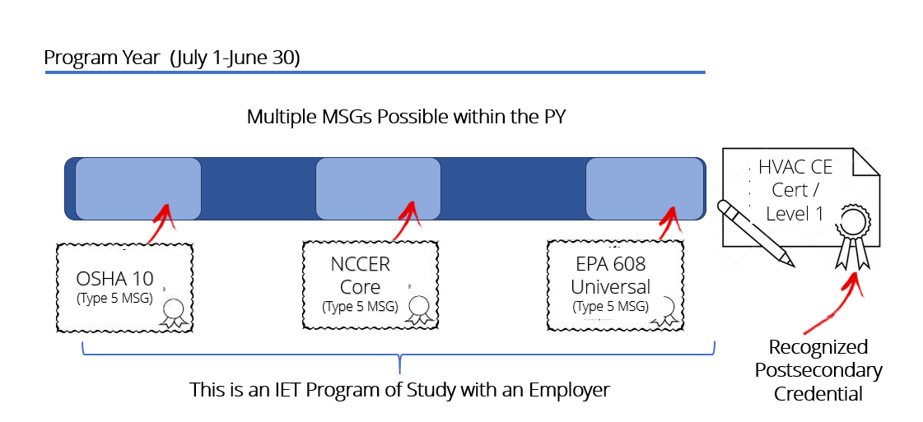
In order to achieve this MSG, AEL providers must document that the participant was able to:
- successfully pass an exam that is required for the occupation, which may include a credentialing exam required to earn a certificate, certification, or license; or
- make progress in attaining technical or occupational skills as evidenced by trade-related benchmarks, such as knowledge-based exams (for example, completing one portion of the credentialing exam required to earn a license or certification), which may include:
- completing a test necessary to obtain a credential (for example, the industry-recognized MSSC Certified Production Technician (CPT) certification has four component tests—safety, quality practices and measurement, maintenance awareness, and manufacturing processes and production—and each component test is a trade-related benchmark that counts as an MSG Type 5);
- passing an employer-required knowledge-based exam;
- passing one component of an industry or occupational competency-based assessment test; or
- passing a component exam in a Registered Apprenticeship Program.
Examples of certificates or certifications for short-term interim postsecondary credentials, which would count as progression toward attaining occupational or technical skill, may include:
- the Occupational Safety and Health Administration’s (OSHA) 10-hour course completion card;
- ServSafe (National Restaurant Association Educational Foundation) certification; or
- CPR (American Red Cross) certification.
While these certifications do not count as a recognized postsecondary credential, they could document skills progression toward gaining a credential. For example, an OSHA 10-hour course completion card could be used as an MSG Type 5 in an Apartment and Building Maintenance program in which a Level I certificate is the credential. Similarly, a ServSafe certification could be used as an MSG Type 5 in a continuing education (CE) program for Hospitality and Food Management, if the participant earns a CE credential.
Before using the MSG Type 5 option as the participant’s planned MSG, AEL providers must identify, at a minimum, the following:
- The type of exam the participant is expected to pass to show competency in the occupation (for example, a certificate, credentialing exam, or a knowledge-based exam)
- The employer or training provider that has created the knowledge-based exam parameters with the AEL provider
- An overview of the types of exams that lead to the certificate, license, certification, or recognized postsecondary credential and planned exams that the participant may take during the program to demonstrate skills progression
- The time frames for the participant to take the exam, considering the program MSG attainment requirement and the entire IET program of study
- The type of documentation from the employer or training provider that will be obtained to show the participant passed the exam

Example That Counts
A heating and air conditioning service company wants to open a new facility and needs certified technicians. The state requires training and a specific EPA certification for Commercial HVAC Technicians who are hired for government contracts. The employer cannot find sufficiently qualified applicants and contacts a local community college to develop a training program for employees of the company, all of whom had either attained a HSE or HSD but had never attended any other educational program. The employer, occupational trainers, and AEL program staff develop a workplace literacy program that includes contextual literacy skills instruction and job training. The occupational trainer adapts and customizes the competencies and learning objectives of a college training program for an HVAC Tech I program to provide entry-level skills measured through both written and hands-on, competency-based skills demonstrations. After each phase of the workplace literacy program, participants take an assessment that measures their skills mastery in that phase. Program participants are certified for the job when they successfully pass the final assessment of the three-tiered program design and pass the EPA certification exam.

Why It Counts
The IET program trains participants for a specific occupation, which requires successfully passing a multipart exam to achieve certification. Passing each part of the exam sequence demonstrates progress toward completion, and passing the final exam certifies participants for the job.

MSG Type 5 Teams Entry
AEL grantees must ensure that staff documents achievement of an MSG Type 5 by adding a new MSG record in TEAMS on the Educational Outcomes screen. Only participants who are attached to a training service or a workplace literacy activity code may enter an MSG Type 5. The workplace activity codes are Work-Based (AEFLA) and Work-Based (Local).

Contracted Measures: Exit-Based Outcomes
All exit-based measures are calculated once a participant exits the AEL program. These measures, unlike MSGs, are not based on program year calculations.
A participant with multiple POPs is counted separately for each POP in both the denominator and numerator of each applicable exit-based measure, which makes possible multiple independent outcomes for each POP.
For all exit-based employment measures, a participant is considered employed in a given quarter if wage records match from TWC’s Unemployment Insurance (UI) Division, or other records indicate, as recorded in the Employment Outcomes screen in TEAMS, that the participant was employed during the quarter.
Exit-based measures are tracked in the following two ways:
- through a TWC and UI crossmatch of a participant’s SSN
- if no SSN is available, the AEL provider tracks the participant’s post-exit activities with follow-up services and manually reports those into TEAMS each quarter
Crossmatching participants’ SSNs is the most efficient way to verify enrollment opportunities in education and workforce, social service programs, and to track coenrollment among programs like TWC-administered WIOA programs. Without an SSN, grantees must conduct significant participant follow-up to determine a participant’s outcomes.

Employed/Enrolled Q2 Post-exit—LBB Measure
This contracted measure is a Texas-specific, Legislative Budget Board (LBB) performance target, which is very similar to the WIOA exit-based measure Employment Rate – 2nd Quarter After Exit, defined as “the percentage of program participants who are in unsubsidized employment or enrolled in education and training during the second quarter after exit from the program.” More information on LBB performance is in the Texas Requirements: TWC-Set Performance section.
Table 4: Employed/Enrolled Q2 Post-exit—LBB Measure

Employed/Enrolled Q2 Post-exit
Performance Period | Exiters from July 1 to June 30
Data Source | UI crossmatch or, if no data is available due to lack of an SSN, the Educational Outcomes screen or the Employment Outcomes screen in TEAMS
Definition | The percent of exiters employed or enrolled in education or training in the second calendar quarter after exit
Methodology | The denominator is the number of program participants who exited during the performance period and who did not have a valid exclusion.  The numerator is the number of exiters from the denominator who were employed or enrolled in education or training in the second calendar quarter after exit.  Performance is calculated by dividing the numerator by the denominator.
Data Limitations | This measure focuses on employment or enrollment in education and training post-exit. UI wage records used to determine post-exit employment take time to collect from employers in Texas and other states. This means that the performance reported each year reflects the outcomes of exiters in the prior year or two years prior. Additionally, not all employers report UI wage records, and UI does not collect employment information for individuals who are self-employed or in other contract work, which makes it difficult to determine employment. Participants may exit more than once in a given year and may be counted in this measure each time they exit.
Additional Notes | Program year End Performance is reported in the June monthly performance report (MPR).  These measures are primarily based on true wage records, which are updated after the end of each calendar quarter (in October, January, April, and July) and require time to fully mature. Wage information obtained from out-of-state sources is not available until several months later. Therefore, performance results for a given quarter of exiters is generally not reported in the MPR until roughly six months after the end of the second quarter after exit.

Employed/Enrolled Q2–4 Post-exit—LBB Measure
This contracted measure is a Texas-specific, LBB performance target, which is very similar to the WIOA exit-based measure, Employment Rate – Fourth Quarter After Exit. This measure is the percentage of program participants who are in unsubsidized employment during the fourth quarter after exit from the program. More information on LBB performance is in the Texas Requirements: TWC-Set Performance.
Table 5: Employed/Enrolled Q2–4 Post-exit—LBB Measure
Employed/Enrolled Q2–4 post-exit
Performance Period | Exiters from January 1 to December 31
Data Source | UI crossmatch or, if no data is available due to lack of an SSN, the Educational Outcomes screen and Employment Outcomes screen in TEAMS
Definition | The percent of exiters employed or enrolled in education or training in Quarter 2 after exit who are also employed or enrolled in education or training in both the third and fourth calendar quarters after exit
Methodology | The denominator is the number of program participants who exited during the performance period, did not have a valid exclusion, and were employed or enrolled in education or training in the second calendar quarter after exit.  The numerator is the number of exiters from the denominator who were employed or enrolled in education or training in both the third and fourth calendar quarters after exit.  Performance is calculated by dividing the numerator by the denominator.
Data Limitations | This measure focuses on employment or enrollment in education post-exit. The UI wage records used to determine post-exit employment take time to collect from employers in Texas and other states. This means that the performance reported each year reflects the outcomes of exiters in the prior year or two years prior. Additionally, not all employers report UI wage records, and UI does not collect employment information for those who are self-employed or in other contract work, which makes it difficult to determine employment. Participants may exit more than once in a given year and may count in this measure each time they exit.
Additional Notes | Program year End Performance is reported in June MPR.  This measure is primarily based on quarterly UI wage records and federal employment records, which are updated after the end of each calendar quarter (in October, January, April, and July) and require time to fully mature. Wage information obtained from out-of-state sources is not available until several months later. Therefore, performance results for a given quarter of exiters is generally not reported in the MPR until roughly six months after the end of the fourth quarter after exit.  This measure was developed for state reporting because the WIOA measure that focuses exclusively on Quarter 4 does not provide a meaningful measurement of the longer-term success of the system. Employed/Enrolled Quarters 2–4 Post-exit serves as a retention measure that provides a longitudinal examination of exiters who had successful shorter-term outcomes (for example, employment or enrollment in education or training in Quarter 2).

Credential Attainment—WIOA/LBB Measure
The performance period for credential attainment, also known as credential rate, is during participation in the program or within one year after exit. The credential attainment measure includes both postsecondary credentials and HSE credentials. While there is one credential attainment measure, postsecondary credentials and HSE credentials have unique criteria related to the participants who are included under the measure. More information on LBB performance is in the Texas Requirements: TWC-Set Performance section.
Table 6: Credential Attainment Rate—WIOA/LBB Measure
Credential Rate
Performance Period | Exiters from January 1 to December 31
Data Source | The Educational Outcomes screen and Employment Outcomes screen in TEAMS
Definition | The percent of exiters who were enrolled in training or education, other than OJT or Employer Customized Training, and who achieved a recognized credential within one year of exit
Methodology | Achievement of either a recognized postsecondary credential or an HSE or HSD within one year of exit  This measure captures two types of credentials with certain criteria that must be met in order for exiters earning those credentials to count toward the credential rate.  The denominator is the number of participants who exited during the performance period, who did not have a valid exclusion, and who, during the POP, were either enrolled in:  - IET and attached to a training service during the program year; or  - an HSE program, meaning at the secondary level (ASE Low or ASE High in all domains in which a test was given during participation or passed at least one section of an HSE exam).  Participants in the numerator are as follows:  - IET exiters who earn a postsecondary credential either during the POP or within 365 days after exiting AEL services  - HSE or HSD exiters who lack a high school diploma or its equivalent and who:  - were at the secondary level (ASE Low or ASE High in all domains in which a test was given during participation, or passed at least one section of an HSE exam);  - earned a high school diploma or HSE credential during participation or within 365 days of exit; and  - were either enrolled in a postsecondary education and training program or employed during any quarter within one year after exit.  The numerator is the number of exiters from the denominator who during the POP or within a one year of exit have achieved either a:  - recognized postsecondary credential other than a secondary school diploma or its equivalent; or  - a secondary school diploma or its equivalent and were also either:  - employed in any of the four calendar quarters following the calendar quarter of exit; or  - enrolled in postsecondary education or training at some point during the first year (365 days) following exit.  Performance is calculated by dividing the numerator by the denominator.
Data Limitations | This measure focuses on achievement of a recognized credential within one year of exit. However, if the credential achieved is an HSD or its equivalent, it must be accompanied by employment or enrollment in education in the year following exit as well. The UI wage records used to determine post-exit employment take time to collect from employers in Texas and other states. This means that the performance reported each year reflects the outcomes of people who exited services in the year or two years prior. Additionally, not all employers report UI wage records, and employment information for those who are self-employed or in other contract work is difficult to obtain, which limits the ability to determine employment. A participant may exit more than once in a given year and may count in this measure each time they exit.
Additional Notes | Program Year End Performance is reported in June MPR.

Failure to Meet Contracted Measures
TWC, like AEL grantees, is held accountable by its federal governing agency—OCTAE—to meet federal performance measures (further described in Appendix A) and is subject to federal sanctions and/or reduced funds if AEL statewide federal performance measures are not met. Grantees should consider their performance within the greater scope of the statewide AEL program and the impact an individual AEL program’s performance may have on the rest of the state’s performance.
Both TWC Chapter 802 Integrity of the Texas Workforce System rule §802.102 and Section 5 of AEL grant awards outline the remedies that TWC may take if an AEL grantee fails to meet its contracted measures, which include technical assistance, corrective actions, payment holds, and deobligation of funding.
“The failure of Boards, AEL grant recipients, or Agency grantees to meet minimum levels of performance as referenced in their contracts may result in corrective actions, other performance review and assistance activities, or sanctions…”—Section 802.102 (e)
TWC’s process for imposing corrective actions is available at §802.121. If TWC imposes correction actions and sanctions on an AEL grantee due to its failure to meet contracted performance, such actions may impact the grantee’s ability to receive TWC grant funds and performance awards and may result in deobligation of funds from the AEL grant award; further, TWC may impose any type of appropriate remedy to correct the deficiencies of the AEL grantee.

Additional WIOA Performance Indicators

Employed Q2 Post-exit—WIOA Measure
This is a WIOA exit-based measure for which TWC negotiates a target with OCTAE.
Table 7: Employed Q2 Post-exit—WIOA Measure
Employed Q2 Post-exit
Performance Period | Exiters from July 1 to June 30
Data Source | UI crossmatch or, if no data is available due to lack of an SSN, the Employment Outcomes screen in TEAMS
Definition | The percent of exiters employed in the second calendar quarter after exit
Methodology | The denominator is the number of program participants who exited during the performance period and who did not have a valid exclusion.  The numerator is the number of exiters from the denominator who were employed in the second calendar quarter after exit.  Performance is calculated by dividing the numerator by the denominator.
Additional Notes | Program Year End Performance is reported in the June MPR.  These measures are primarily based on quarterly UI wage records and federal employment records, which are updated after the end of each calendar quarter (in October, January, April, and July) and require time to fully mature. Wage information obtained from out-of-state sources is not available until several months later. Therefore, performance results for a given quarter of exiters is generally not reported in the MPR until roughly six months after the end of the second quarter after exit.

Employed Q4 Post-exit—WIOA Measure
This is a WIOA exit-based measure for which TWC negotiates a target with OCTAE.
Table 8: Employed Q4 Post-exit—WIOA Measure
Employed Q4 Post-exit
Performance Period | Exiters from January 1 to December 31
Data Source | UI crossmatch or, if no data is available due to lack of an SSN, the Employment Outcomes screen in TEAMS
Definition | The percent of exiters employed in the fourth calendar quarter after exit
Methodology | The denominator is the number of program participants who exited during the performance period and who did not have a valid exclusion.  The numerator is the number of exiters from the denominator who were employed in the fourth calendar quarter after exit.  Performance is calculated by dividing the numerator by the denominator.
Additional Notes | Program Year End Performance is usually reported in the June MPR.  These measures are primarily based on quarterly UI wage records and federal employment records, which are updated after the end of each calendar quarter (in October, January, April, and July) and require time to fully mature. Wage information obtained from out-of-state sources is not available until several months later. Therefore, performance results for a given quarter of exiters is generally not reported in the MPR until roughly six months after the end of the fourth quarter after exit.

Median Earnings Q2 Post-exit—WIOA Measure
This is a WIOA exit-based measure and “is the median earnings of program participants who are in unsubsidized employment during the second quarter after exit from the program, as established through direct UI wage record match, Federal or military employment records, or supplemental wage information.”
Table 9: Median Earnings Q2 Post-exit—WIOA Measure
Median Earnings Q2 Post-exit
Performance Period | Exiters from July 1 to June 30
Data Source | UI crossmatch or, if no data is available due to lack of an SSN, the Employment Outcomes screen in TEAMS
Definition | The median earnings in the second calendar quarter after exit for participants employed in the second calendar quarter after exit
Methodology | Participants employed in the second quarter after exit have their aggregate earnings in that quarter sorted from low to high and then the median is identified. The median is the point in the middle where half the employed exiters earned more and half earned less.
Additional Notes | Program Year End Performance is reported in the June MPR.

Effectiveness in Serving Employers
Effectiveness in Serving Employers is one of the six WIOA primary indicators of performance. Currently, DOL and ED are piloting the best strategies for states to capture outcomes under this measure, which gathers data on all WIOA titles and not just AEL. TWC’s Information Innovation & Insight team reports on the following three approaches, outlined in the table below, by September 30 of each year.
Table 10: Effectiveness in Serving Employers Overview
Measuring effectiveness with employers | What is being measured | Purpose of the measure
Retention with the same employer | The percentage of participants who exit and are employed with the same employer in the second and fourth quarters after exit | This approach is useful in determining whether the core programs are serving employers effectively by improving the skills of their workforce and decreasing employee turnover.
Repeat business customers | The percentage of employers that receive services that use core program services more than once | This approach is useful in determining whether employers that receive services from the core programs are satisfied with those services and become repeat customers. This approach also assesses the workforce system’s ability to develop and maintain strong relationships with employers over extended periods of time.
Employer penetration rate | The percentage of employers using services out of all the employers in Texas | This approach is useful in determining whether the core programs are serving a large portion of employers in an area and meeting the area’s workforce needs.

AEL participants are included in the employer retention measure, and employers participating in AEL program services are included in the employer penetration rate.
TWC may issue future guidance on this indicator, as appropriate.

SOPs and Data Accuracy in TEAMS

Standard Operating Procedures
AEL grantees must develop and train staff on standard operating procedures (SOPs) that describe in sufficient detail a process for assessing an individual during comprehensive intake and placement into the AEL program. The SOPs must also describe establish the individual’s education, training, and career plan, which includes how the grantee will measure progress, such as with a planned MSG. A planned MSG gives providers and participants a clear path forward and must be identified for each participant shortly after he or she begins services to ensure that there is a participant-specific plan for what the participant will learn and how the participant will demonstrate MSG. Because not all aspects of a participant’s success may be forecasted, providers must assume that during the participant’s engagement in the program the Planned MSG may change based on the participant’s progress and goals.
The SOPs must:
- identify the program staff members (staff positions) who make the planned designation;
- explain how participants, instructors, and other relevant staff members are informed about a participant’s MSG status;
- explain the process for selecting an MSG type based on a participant’s performance, goals, objectives, or participation; and
- explain how plans for determining the best MSG type are modified when a participant’s performance, goals, objectives, and/or participation change.
Additionally, the SOPs must explain how, when, and by whom the appropriate documentation is collected to support the MSG entered into TEAMS.

Data Validation
MSG and credential data must be entered by the 15th of each month for activity that occurred in the previous month, or as directed by TWC in rare circumstances. However, it is recommended that data is entered soon after the activity takes place to best support data accuracy and avoid inefficiencies that could lead to a backlog of data needing to be entered before data validation and data sign off.
The table below shows the data validation dates.
Table 11: AEL Data Entry Due Dates
Data Validation | Due Date
Monthly Director-Level Validation of Data in TEAMS | The 15th of each month
Quarter 1 Data Sign-Off | October 15
Quarter 2 Data Sign-Off | January 15
Quarter 3 Data Sign-Off | April 15
Quarter 4 and Final Data Sign-Off | July 15

Monthly Performance Reports
After the monthly data validation deadline passes, the Information Innovation & Insight team develops the monthly performance report (MPR), which provides TWC’s official performance data for the period. The MPR data is currently shared with AEL grantees via a transmittal but will soon be available through a Tableau data dashboard that provides the following targets and whether a grantee is below, meeting, or exceeding each target:
  - Enrollment targets
  - Measurable Skills Gain
  - Credential achievement
  - Employed/Enrolled Q2 Post-exit
  - Employed/Enrolled Q2–4 Post-exit
The transmittal also contains reports on several other measures, such as:
  - Employed Q2 Post-exit
  - Employed Q4 Post-exit
  - Median Earnings
  - EFL Gains by Domain Report

Tableau Data Dashboards
TWC is in the process of releasing a real-time performance data dashboard—Tableau—to provide AEL grantees with data visualizations and the ability to easily search and filter options to monitor performance. Access to Tableau is found on the TWC AEL Teachers & Providers web page.

TEAMS Reports to Monitor Performance
AEL grantees may use the following TEAMS reports to monitor performance for the AEL program.
Table 12: TEAMS Reports
TEAMS Report | What is Found on This Report
POP (Period of Participation) | - Participants (12+ direct-contact hours)  - Reportable Individuals (<12 hours),  - Exiters  - Total hours  - Last date of service  - Planned GAP  - Participants with an exclusionary reason  - HSE completion
MSG (Only participants will show up on this report.) | - Exiters  - Type of MSGs earned by the participant  - Pretest date  - Pretest instrument  - EFLs  - Hours elapsed since last test  - Posttest EFL  - Posttest date  - Hours elapsed since last test date  - HSE issue date  - Workforce gains

Appendix A: Background for this Policy

Previous TWC AEL Policy
This guide replaces and updates information found in former AEL Letter 01-18, Change 1, issued September 7, 2018, and titled “Educational Outcomes in Adult Education and Literacy—Update.” Substantive revisions to AEL Letter 01-18, Change 1, and policy found in this guide relate to the new MSG options for IET and workplace literacy program participants.

This guide also incorporates policy found in former AEL Letter 01-19, issued January 29, 2019, and titled “Periods of Participation for Adult Education and Literacy.”

All active or rescinded AEL Letters may be found on the TWC Workforce Policy and Guidance Page.

Federal Regulation and Policy
WIOA §116 establishes the performance accountability indicators and performance reporting requirements for the six core WIOA programs to assess each program’s effectiveness in achieving positive workforce and educational results for participants.
In Texas, TWC administers the six WIOA core programs, which are:
- the Adult, Dislocated Worker, and Youth programs, authorized under WIOA Title I and administered by DOL;
- the AEFLA-funded program, authorized under WIOA Title II and administered by ED;
- the Employment Service program, authorized under the Wagner-Peyser Act, as amended by WIOA Title III and administered by DOL; and
- the Vocational Rehabilitation program, authorized under Title I of the Rehabilitation Act of 1973, as amended by WIOA Title IV and administered by ED.
To support the alignment of performance-related definitions and indicators, WIOA requires comparable data collection and integrated reporting across the core programs, as further outlined in regulatory and sub-regulatory guidance.

Policies on which this Guide Is Based
Requirements related to the implementation and operation of the performance accountability system are described in WIOA §116, including implementing joint regulations in 20 CFR Part 677 (reprinted in 34 CFR Parts 361 and 463). The WIOA common reporting specifications were initially developed by DOL and ED, approved by the US Office of Management and Budget (OMB) in June 2016, and most recently modified in March 2021.
ED’s OCTAE Program Memorandum (PM) 17-2, revised on August 23, 2017, and titled “Performance Accountability Guidance for Workforce Innovation and Opportunity Act (WIOA) Title I, Title II, Title III, and Title IV Core Programs,” provides sub-regulatory guidance on the performance accountability requirements for WIOA Title II, also known as the Adult Education and Family Literacy Act (AEFLA). This policy provides all the common terms, definitions, and methodologies for calculating performance for each of the primary indicators.
OCTAE PM 20-2, issued February 6, 2020, and titled “Negotiations and Sanctions Guidance for the Workforce Innovation and Opportunity Act (WIOA) Core Programs,” provides guidance on state sanctions to performance or reporting failures.
OCTAE PM 19-1, issued December 19, 2018, and titled “Guidance for Validating Jointly Required Performance Data Submitted under the Workforce Innovation and Opportunity Act (WIOA),” provides sub-regulatory guidance on data validation procedures to ensure accurate data reporting. AEL Letter 04-21, issued June 7, 2021, and titled “AEL Enrollment and Data Validation Requirements,” also provides TWC’s guidance on data validation, including for MSGs and credentials.
ED’s National Reporting System Technical Assistance Guide for Performance Accountability under the Workforce Innovation and Opportunity Act (NRS TA Guide) provides additional guidance on AEL performance accountability. Table 13 provides an overview of the primary indicators of performance, as summarized from the NRS TA Guide.
The NRS provides online resources to state agencies and program administrators regarding WIOA and performance reporting, which is available on the NRS web page.
The Texas AEL Testing Guide is also referenced throughout this guide and provides guidance on the AEL testing polices related to MSG Type 1a.
DOL’s Training and Employment Notice (TEN) 25-19, published June 8, 2020, and titled “Understanding Postsecondary Credentials in the Public Workforce System,” provides additional guidance on credentials.

Texas-Specific AEL Performance

Federal Requirements: Primary Indicators of Performance Negotiations
TWC is required to negotiate with OCTAE the levels of performance for each of the WIOA indicators of performance shown in Table 13, which OCTAE then approves for two AEL program years.
Table 13: WIOA Primary Indicators of Performance
WIOA Primary Indicator | How the Indicator is Measured
Measurable Skill Gains (MSGs) | This indicator is measured by the documented progress (academic, technical, occupational, or other) that a participant makes during participation toward obtaining basic education, a credential, or employment-related performance.  For all AEL participants:  - EFL MSG (MSG Type 1):  - Achievement on a Pretest/Posttest MSG (MSG Type 1a)  - Postsecondary Enrollment MSG (MSG Type 1b)  - HSD/HSE Achievement MSG (MSG Type 2)  For AEL participants enrolled in IET or workplace literacy:  - (IET and preapproved workplace literacy) Postsecondary Transcript or Report Card MSG (MSG Type 3)  - (IET and workplace literacy) Progress Milestone (MSG Type 4)  - (IET and preapproved workplace literacy) Skills Progression (MSG Type 5)
Employment-Related Indicators | This indicator is measured by employment and earnings for participants during the second and third through fourth quarters after exit from the program.
Credential Attainment Indicator | This indicator is measured by the number of participants who attain a recognized postsecondary credential or an HSE or HSD credential during participation or within one year after exit. Note that for an HSE or HSD credential to count in the numerator of this measure, the participant must be either:  - enrolled in postsecondary education within 365 days after the date of exit; or  - employed in one or more of the four calendar quarters after the quarter that contains the date of exit.
Effectiveness in Serving Employers | This indicator, which TWC is piloting, is measured by gauging the following three critical workforce needs of the business community:  - Retention with the same employer  - Repeat business customers  - Employer penetration rate

In May 2020, TWC and OCTAE negotiated the performance levels for the indicators shown in Table 14. TWC’s Information Innovation & Insight team, the TWC area responsible for evaluating operational, programmatic, and outcome data for the agency and its partners, considers these negotiated performance levels when developing AEL performance measures, also known as contracted measures.
Table 14: TWC AEL Negotiated Federal Performance Levels
WIOA Primary Indicator | Negotiated Levels for PY’22 | Negotiated Levels for PY’23
Employment Rate  (Second Quarter After Exit) | 37% | 39%
Employment Rate  (Fourth Quarter After Exit) | 36% | 38%
Median Earnings  (Second Quarter After Exit) | $5,150 | $5,200
Credential Attainment Rate | 35% | 41%
Measurable Skill Gains | 43% | 45%
Effectiveness in Serving Employers | To be determined | To be determined

Failure to Meet Federal Performance
If TWC fails to either 1) meet federal performance measures or 2) report these measures, OCTAE may apply a sanction and/or reduce the governor’s reserve funding from TWC.

Texas Requirements: TWC-Set Performance
Every two years, TWC submits a legislative appropriations request (LAR) to the LBB and the Office of the Texas Governor’s Budget, Planning and Policy Division for the Texas legislature to consider and approve for the following two fiscal years (biennium) under the General Appropriations Act (GAA). The LAR outlines TWC’s budget and performance strategies to meet the agency’s mission and goals, including to support a workforce system that helps employers, individuals, and communities achieve and sustain economic prosperity.
For AEL, this includes the statewide budget, overall participants served, and outcome measures that are similar to WIOA exit-based measures.
The 87th Texas Legislature, Regular Session (2021) considered and approved TWC’s LAR for State Fiscal Years (SFY) 2022–2023, which includes the measures outlined in Table 15 for SFY’22-’23. These LBB-approved measures are the TWC-specific state performance measures that will impact grantees’ AEL enrollment targets for the next two AEL program years, starting with AEL PY’21–’22. The state fiscal year is from September 1 to August 31, which is different from the AEL program year cycle of July 1 to June 30.

Table 15: LBB AEL Performance Measures
LAR Performance Measures | Texas SFY’22  (September 1, 2021–August 31, 2022) | Texas SFY’23  (September 1, 2022–August 31, 2023)
Participants Served | 72,117 | 71,820
Employed/Enrolled Q2 Post-exit | 40.00% | 46.00%
Employed/Enrolled Q2–4 Post-exit | 81.00% | 82.40%
Credential Rate | 39.00% | 39.00%

Table 16: Proposed LBB AEL Performance Measures
LAR Performance Measures | Texas SFY’24  (September 1, 2023–August 31, 2024) | Texas SFY’25  (September 1, 2024–August 31, 2025)
Participants Served | 56,128 | 53,874
Employed/Enrolled Q2 Post-exit | 56.00% | 57.00%
Employed/Enrolled Q2–4 Post-exit | 84.00% | 84.00%
Credential Rate | 45.00% | 46.00%

Commission-Approved Contracted Measures & Performance-Based Criteria
Each program year, TWC and grantees negotiate enrollment targets, which grantees may provide a justification for adjusting certain target categories. After this process is complete, DOI presents the following to the Commission for approval:
- Contracted measures, including the following:
- AEL enrollment targets, which may include carryforward targets from the previous PY
- MSG targets, as approved by OCTAE
- Exit-based outcome measures that are based on LBB-approved performance measures and OCTAE-approved measures
- Performance-based criteria
Appendix C provides an overview of the Commission-approved AEL performance and enrollment targets for the current program year, and Appendix D provides an overview of the performance-based funding criteria for the current program year.
“A Board or AEL grant recipient shall meet or exceed expenditure and performance targets as set forth in its contracts. The Commission shall determine the Boards' or AEL grant recipients' performance targets based on federal and state performance standards and by using factors that may be necessary to achieve the mission of the Commission and reflect local conditions. The Commission approves individual Board or AEL grant recipient performance targets annually, which may be adjusted based on local conditions including, but not limited to, specific economic conditions and demographic characteristics of the workforce area.”—TWC Chapter 802 Integrity of the Texas Workforce System §802.102(a)

Performance Quality Improvement Awards
Each year, TWC presents workforce awards to workforce partners whose innovations and high performance have enhanced the Texas workforce system. These awards are presented at the annual TWC Workforce Conference, which usually takes place in November or December each year. TWC Chapter 802 Subchapter I Workforce Awards rules provide TWC’s process for setting award criteria for each year, which must be approved by the Commission. Workforce awards may be monetary or nonmonetary and the Commission may set performance criteria for awards. While these performance criteria are not contracted measures, historically the performance awards are based on contracted measures in order to incentivize certain behaviors, such as student retention, timely posttesting, or year-round enrollments.
TWC staff notifies AEL grantees of workforce awards each year, with information related to performance criteria, performance period being measured, and monetary amounts distributed through a WD Letter. AEL grantees under corrective action are not eligible to receive performance awards.

Appendix B: Glossary of Terms & Acronyms

Basic AEL Services
Basic AEL services include programs and activities in the competencies of reading, writing, ESL, and mathematics.

Contracted Measures
Contracted measures are performance and enrollment targets AEL grantees are contractually required to meet, and include the following:
- enrollment targets
- achievement of primary indicators of performance under WIOA, which include the following:
- MSG every program year
- Employed Q2 Post-exit
- Employed Q4 Post-exit
- Median Earnings Q2 Post-exit
- Credential Attainment within one year of exit
- Effectiveness in Serving Employers
- achievement of state performance measures (known as LBB measures), which include the following:
- Employed/Enrolled Q2 Post-exit
- Employed/Enrolled Q2–4 Post-exit
- Credential Rate
- achievement of performance-based funding (PBF) measures

Credential
Refers to both postsecondary credentials and HSD or HSE credentials.

Credential Attainment
Credential attainment is the number of exiters who are not excluded from the WIOA primary indicators of performance and who were:
- in an IET (excluding OJT or Customized Training) and achieved a postsecondary credential during participation or within one year of exit;
- enrolled in education at or above the secondary level at any time during a POP, either by being at ASE high in all content areas or passing one HSE test, and achieved an HSE or HSD credential during participation or within one year of exit; and
- either:
  - enrolled in a postsecondary education or training program leading to a recognized postsecondary credential at some point during the 365 days after exiting the program; or
  - employed in any of the four calendar quarters after exiting the program.

Demonstrated Effectiveness
This is an eligibility requirement set by federal regulations at 34 CFR Part 463 for entities applying for AEL core grant awards. Entities must provide performance data on the content domains of reading, writing, math, English language acquisition, and other subject areas relevant to the services outlined in the grant application, as well as participant outcomes for employment, attainment of secondary school diploma or its recognized equivalent, and transition to postsecondary education and training. OCTAE provides more guidance on this topic in the Determining Applicant Eligibility When Conducting a State Competition for Adult Education and Family Literacy Act Funds Technical Assistance Guide.

Direct-Contact Hours
Direct-contact hours involve interaction between the participant and instructional staff in real time. Direct-contact hours may be a combination of direct, face-to-face contact as well as contact through phone, video, teleconference, or online communication in which the identity of the participant and the amount of time expended on the activity may be verified. Live online discussions, telephone conference calls, and live video broadcasts to remote locations are examples of direct-contact hours that are countable under this definition. All AEL participants with at least 12 direct-contact hours are included in performance measures, unless otherwise excluded.

Educational Functioning Level (EFL)
This is one type of MSG that measures the levels of an individual’s reading, writing, speaking, and listening skills as measured by an NRS-approved test.

Effectiveness in Serving Employers
This is one of the six primary indicators of performance under WIOA.

Employment Rate—Q2 Post-exit
This is one of the six primary indicators of performance under WIOA and is the percentage of participants who are in unsubsidized employment during the second quarter after exit from the AEL program.

Employment Rate—Q4 Post-exit
This is one of the six primary indicators of performance under WIOA and is the percentage of participants who are in unsubsidized employment during the fourth quarter after exit from the AEL program.

Exit
This is the last day that a participant receives a participatory service. This date may not be determined until 90 days after the participant last received participatory services and there are no future services arranged under a planned gap. After 90 days of inactivity (and in the absence of a planned gap), exit is retroactively established as the last day of participatory service. AEL grantees may not initiate exit by removing a participant from the class roster and adding an end date for the participant in TEAMS. This only makes participants inactive for the class, but it does not exit them from services.

Exit-Based Outcome Measures
These are assigned to grantees and are based on performance projections submitted by TWC in the LAR. Two of the three exit-based outcome measures are similar to federal measures negotiated with OCTAE, and one is identical. Essentially, the Texas exit-based outcomes assigned to grantees support the federal measures; these are sometimes referred to as WIOA exit-based outcomes.

Integrated Education and Training (IET)
IET is an overall scope of services designed for a specific occupation or occupational cluster for the purpose of educational and career advancement. IET services include the three components delivered through integrated services—ensuring that participants gain the skills needed to succeed in the workforce training program by:
- attaining a recognized postsecondary credential;
- entering or advancing in employment; or
- advancing in postsecondary education and training.
The three required IET components are:
- AEL activities contextualized for workforce training;
- workforce preparation activities; and
- workforce training for a specific in-demand or targeted occupation or occupational cluster, as determined by the Local Workforce Development Board (Board).
AEL Letter 02-16, Change 1, issued October 13, 2016, and titled “Implementing the Integrated Education and Training Service Approach—Update,” including any subsequent issuances, provides TWC’s policy on implementing IET programs.

Integrated EL Civics
This is a program funded under WIOA §243 for adult English language learners, including professionals with degrees and credentials in their native countries. This program must include
instruction in literacy and English language acquisition and instruction on the rights and responsibilities of citizenship and civic participation as well as workforce training through an approved IET, which should consider linkages to existing and emerging in-demand and target occupations through partnerships with local Workforce Solution Offices. AEL Letter 04-16, Change 2, issued July 21, 2021, and titled “Implementing Integrated Education and Training English Literacy and Civics Education—Update,” and any subsequent issuances, provides TWC’s policy on implementing this program service.

Intensive AEL Services
This is a career pathways service model that includes one or more of the following:
- Workplace AEL activities
- Services for internationally trained English language learner professionals
- Transition to re-entry and post-release services
Intensive AEL Services is one of the enrollment target categories with which grantees may negotiate with TWC each year during the development of the contracted measures.

Legislative Budget Board (LBB)
The LBB is the Texas legislative body that approves TWC’s budget and performance for its programs. The LBB website states that it is “a permanent joint committee of the Texas Legislature that develops budget and policy recommendations for legislative appropriations, completes fiscal analyses for proposed legislation, and conducts evaluations and reviews to improve the efficiency and performance of state and local operations.”

Measurable Skill Gains (MSGs)
This is one of the six primary indicators of performance under WIOA. MSGs are a measure of the documented progress (academic, technical, occupational, or other) that a participant makes toward obtaining basic education, a credential, or reaching employment-related performance indicators.

MSG Type 1—EFL MSG
This MSG is the documented achievement of a gain in an EFL for participants receiving instruction below the postsecondary education level in one of the following types of EFL measures:
- MSG Type 1a
- MSG Type 1b

MSG Type 1a—Achievement on a Pretest/Posttest
This MSG is earned by comparing a participant’s initial EFL, as measured by a pretest, with the participant’s EFL, as measured by a posttest, using tests approved for AEL in Texas in accordance with the Texas AEL Testing Guide. The EFL may be achieved in any content area.

MSG Type 1b—Postsecondary Enrollment MSG
This MSG is earned when the participant enrolls in a postsecondary education or training program that leads to a postsecondary credential after a participant exits AEL services. The participant must be below the postsecondary level in one or more domains, have no planned gap, and enroll in the postsecondary education or training program after exit but within the same program year in which the exit occurred.

MSG Type 2—HSE/HSD Achievement
This MSG is the documented attainment of a recognized English- or Spanish-language HSE credential or HSD during the program year. Participants may obtain either an in-state Texas Certificate of High School Equivalency (TxCHSE) or an out-of-state HSE option that is approved for use when participating in AEFLA activities for that state.

MSG Type 3—Postsecondary Transcript or Report Card
This MSG applies to participants enrolled in an IET or preapproved workplace literacy program who have a transcript or report card from a postsecondary education or training program provider documenting that the participant is passing a full- or part-time college credit course load in a program of study that leads to a recognized postsecondary credential.

Type 4 MSG—Progress Milestone
This MSG applies to participants enrolled in an IET or a preapproved workplace literacy program and is the documented attainment of a participant’s satisfactory or better progress toward substantive skill development reported by an employer or training provider through one or more measures, including, but not limited to:
- training reports on accomplishment of milestones as the individual masters required job skills, such as:
  - specific occupational competency; or
  - occupational or basic skill learning objectives;
- reports of successful completion of competencies necessary for completion of an OJT or Registered Apprenticeship Program;
- increases in pay resulting from the program; or
- increased performance resulting from the program as documented by the employer.

Type 5 MSG—Skills Progression
This MSG applies to participants enrolled in an IET or workplace literacy program and may be attained by a participant passing an exam that is required for a particular occupation, or progress made toward attaining technical or occupational skills, as evidenced by trade-related benchmarks, such as knowledge-based exams.

Measurable Skill Gains (MSG) Targets
Federally required performance targets that TWC negotiates with OCTAE for each of the 12 EFLs. MSG targets assigned to each AEL grantee are a result of the case mix across the EFL cohorts, as calculated by TWC’s Information Innovation & Insight team, and subsequently approved by the Commission to create the contracted measures.
Median Earnings—Q2 Post-exit
This is one of the six primary indicators of performance under WIOA and refers to the median earnings of participants who are in unsubsidized employment during the second quarter after exit from the AEL program.
Monthly Performance Report (MPR)
TWC’s primary tool for monitoring and evaluating Board and AEL grantee performance.

Participant
A participant is an individual who has taken an NRS–approved pretest that establishes basic education eligibility and accrued 12 direct-contact hours or maintains a POP from a previous program year. To receive credit toward participant enrollment targets, grantees must correctly code participants in TEAMS using the activity codes found in Table 2: Enrollment Targets and TEAMS Activity Codes.

Participants-Served Target
A TWC-set measure based on the overall AEL participants-served figure that TWC submits in the Legislative Appropriations Request (LAR) and is pending Legislative Budget Board (LBB) approval or has been approved by the LBB in the General Appropriations Act (GAA).

Participatory Service
An activity or service that extends a POP after an individual becomes eligible for AEL services. A participatory service begins a POP after a participant is found eligible by taking a pretest and accruing 12 direct-contact hours.
After eligibility is determined, the following services are considered participatory services:
- Testing (excluding official HSE tests)
- Direct-contact (“D”) or proxy-contact (“P”) hours
- For IET participants, workforce training hours in isolation up to 60 days after the end of accruing direct-contact or proxy-contact hours (workforce training hours must be entered into TEAMS as “T” to extend the IET and the POP, but will only do so for up to 60 days after the “D” or “P” hours end)

Performance-Based Criteria
These are criteria that an AEL grantee must meet in order to access a certain percentage of the AEL allocation holdback, as allowed under TWC Chapter 800 General Administration rule §800.68. The Commission must approve the performance-based criteria each program year, and there must be criteria related to the enrollment and credential achievement in HSE or postsecondary Ability-to-Benefit programs. Appendix D outlines the performance-based criteria for the program year.

Performance Measures (also Contracted Measures)
These measures include state and federal measures; all performance measures are part of an AEL grantee’s contracted measures. Certain measures are also referred to as post-exit or exit-based measures and are calculated only after a participant exits.
The six federal WIOA indicators of performance are the following:
- MSGs
- Employment Rate—Employed Q2 Post-exit
- Employment Rate—Employed Q4 Post-exit
- Median Earnings Q2 Post-exit
- Credential Attainment Post-exit
- Effectiveness in Serving Employers, which comprises the following three sub-measures (components):
- Component 1: Retention with the same employer in Q2 and Q4 post-exit
- Component 2: Repeat business customers
- Component 3: Employer penetration rate
The two state measures include the following:
- Employed/Enrolled Q2 Post-exit
- Employed/Enrolled Q2–Q4 Post-exit
Section 800.2 (15) defines performance target as “a contracted numerical value setting the acceptable and expected performance outcome or result to be achieved for a performance measure, including Core Outcome Formal Measures. Achievement between 95 and 105 percent of the established target is considered meeting the target.”

Period of Participation (POP)
A POP is an interval of measurement that begins every time an individual is found eligible for the AEL program through a pretest and accrues 12 direct-contact hours and ends each time an individual has not received a participatory service that has been entered into TEAMS for 90 days. POPs may span across program years, and a participant may have multiple POPs in one program year. POPs add an additional period of measurement that is used to calculate participation, contact hours, testing intervals, and exit-based performance measure calculations within and across program years.

Planned Gap
This is a break in service with a specific date on which the participant will return for services. A planned gap is more than 90 days but fewer than 180 days. A participant who has an active planned gap entered into TEAMS will not exit after 90 days unless the participant fails to return to services by the end of the planned gap. Examples of instances that may require a planned gap include the following:
- A participant has a medical procedure that requires the participant to be out of class for a certain period of time, but the participant expects to return to class on a particular date.
- A participant must leave class to care for a family member but will return to class on a particular date.
- In May, a participant registers for an IET that begins the next fall but needs to work full time over the summer and cannot continue AEL services.
If a participatory service does not occur within 14 days of the last day of a planned gap and 90 or more days have passed since the last participatory service, exit will be calculated as of the date of the individual’s last participatory service.
Planned MSG
This is the MSG that an AEL provider identifies and forecasts during a participant’s initial comprehensive assessment to be the MSG most conducive to allowing the individual to make performance gains. The forecast is based on the participant’s level at intake, initial objectives, goals, and the program of study selected during enrollment. Because not all aspects of a participant’s success may be forecast and a participant’s program objectives may change, the planned MSG may change.

Postsecondary Education or Training (also Workforce Training)
This means any program that leads to a recognized postsecondary credential that is awarded by one or more of the following entities:
- A state educational agency or a state agency responsible for administering vocational and technical education within a state
- An institution of higher education that is qualified to participate in financial assistance programs. This includes community colleges, proprietary schools, and all other institutions of higher education that are eligible to participate in federal financial aid programs.
- An institution of higher education that is formally controlled, or has been formally sanctioned or chartered, by the governing body of an American Indian tribe or tribes
- An organization or a product manufacturer or developer that uses a valid and reliable technique for assessing an individual’s knowledge, skills, and abilities as an outcome measure of a training program. An organization is a professional, industry, or employer organization, such as the National Institute for Automotive Service, which offers a certificate of excellence, and the National Institute for Metalworking Skills, Inc., which offers a Machining Level I Credential. Product manufacturers or developers include Microsoft, which offers recognized Microsoft Information Technology certificates (such as a certificate for a Microsoft Certified IT Professional) and Novell, which offers certificates for a Certified Novell Engineer and a Sun Certified Java Programmer.
- The DOL Education and Training Administration (DOLETA) Office of Apprenticeship or a state apprenticeship agency
- A public regulatory agency that awards a credential when an applicant meets the educational, work experience, or skill requirements that are legally necessary for an individual to use an occupational or professional title or to practice an occupation or profession (for example, a Federal Aviation Administration aviation mechanic license, or a state-licensed asbestos inspector)
- A program that has been approved by the US Department of Veterans Affairs to offer education benefits to veterans and other eligible individuals
- Job Corps, which issues certificates for completing career training programs that are based on industry skills standards and certification requirements
Developmental education, including college English for Speakers of Other Languages and student development courses, does not meet the requirement for a postsecondary education or training program, as these courses are prerequisites to postsecondary education or training.

Educational Enrollment
Educational enrollment is recorded in TEAMS to:
- document completion of one of the required post-exit options to qualify an HSE credential for the Credential Attainment measure; and
- document achievement of a Postsecondary Enrollment MSG that requires a participant to be enrolled in postsecondary education or training at some point after exiting but during the program year.

Primary Indicators of Performance
This refers to the six primary indicators of performance required under WIOA §116(b)(2)(a), which includes the following:
- Employment Rate—Q2 Post-exit
- Employment Rate—Q4 Post-exit
- Median earnings—Q2 Post-exit
- Credential Attainment
- MSGs
- Effectiveness in Serving Employers

Proxy-Contact Hours
Proxy-contact hours differ from direct-contact hours in that the identity of the participant and/or the exact amount of time spent on a learning activity cannot always be verified. Proxy-contact hours are tied to an approved curriculum for distance learning and are entered into TEAMS (as “P”) separately from direct-contact hours. All proxy-contact hours must be documented using the method described by the approved distance learning curriculum. Participants that have more proxy-contact hours than direct-contact hours are considered distance learners and reported as such in OCTAE performance reports.

Program Year
The AEL program year is July 1 to June 30.

Recognized Postsecondary Credential
This is defined in WIOA §3(52) as “a credential consisting of an industry-recognized certificate or certification, a certificate of completion of an apprenticeship, a license recognized by the State involved or Federal Government, or an associate or baccalaureate degree.” This term describes any type of traditional or nontraditional credential awarded for education, training, or employee development.
Recognized postsecondary credentials for AEL include the following:
- Industry-recognized occupational certificates or certifications that are nontraditional awards, which demonstrate, through examination, an individual’s proficiency and knowledge in a specific industry or trade—not necessarily on completion of an education or training program. Candidates for certification are evaluated by national, independent, third-party professional, and industry-based organizations. These organizations develop and maintain relevant proficiency standards that are assessed and sanctioned by industry-approved examinations facilities, independent of any educational institution or training program. Examples of certificates and certifications include:
- Certified Nurse Aide (Texas Health and Human Services Commission);
- Certified Logistics Associate (Manufacturing Skill Standards Council or MSSC);
- Level I Entry Welder (American Welding Society);
- A+, Network+, Server+, Security+ (Computing Technology Industry Association);
- Microsoft Office Specialist (Microsoft); and
- Heavy Equipment Operator (National Center for Construction Education and Research)
- Apprenticeship certificate of completion issued by TWC or by the DOLETA Office of Apprenticeship
- Occupational licenses, generally awarded by a government-regulated agency (usually state-regulated, but sometimes federal). Occupational licenses are mandatory for professional practice in their jurisdiction. A license is more heavily regulated and restrictive due to its governmental association, and it signals that an individual has completed or achieved certain standards. Licenses are often required for careers in the fields of health, public education, law, and finance and in the trades. Examples of occupations that require an individual to have a valid license include plumbers, electricians, real estate brokers, and nurses.
- Recognized state occupational credit certificates and degrees awarded by institutions of higher education that are qualified to participate in federal or state financial aid programs. Such certificates include occupational skills awards, Level I or Level II certificates, and associate or baccalaureate degrees. See the Texas Higher Education Coordinating Board Guidelines for Instructional Programs in Workforce Education for more information.
- Recognized noncredit continuing education credentials (CE credentials) awarded by institutions of higher education. The continuing education program must:
  - teach the same workforce-related content and skills as for-credit postsecondary education and training programs;
  - be listed in the college’s approved inventory of programs; and
  - provide graduates with an official transcript.

Examples of noncredit CE credentials include occupational skills awards, as defined in the Texas Higher Education Coordinating Board Guidelines for Instructional Programs in Workforce Education. Noncredit continuing education programs that do not meet the criteria, however, may meet the criteria for an industry-recognized occupational certificate or certification. For example, Certified Nurse’s Aide training typically does not have a for-credit postsecondary education and training program option; however, this training leads to an industry recognized certification.
The following certificates and certifications are not considered credentials, because they do not document the measurable technical or industry or occupational skills necessary to find employment or advance within an occupation:
- Certificates awarded by Boards
- Work-readiness certificates
- Certificates of completion that are awarded for attendance or for meeting criteria (for example, a certificate of completion awarded by a noncredit community college for a Microsoft Office preparation course is not a postsecondary credential unless the course curriculum meets the criteria of a CE credential)

Reportable Individual
As provided in 34 CFR §463.150, this is “an individual who has taken action that demonstrates an intent to use program services and who meets specific reporting criteria of the program, including:
- Individuals who provide identifying information;
- Individuals who only use the self-service system;
- Individuals who only receive information-only services or activities.”
Additionally, a reportable individual has not accrued 12 direct-contact hours to achieve participant status.

Texas Educating Adults Management System (TEAMS)
TEAMS is the statewide data management information system where AEL grantees enter and track data on the AEL program.

Trade-Related Benchmarks
This refers to a variety of knowledge-based and competency-based exams that are administered to measure the participant’s skills gained, as related to specific postsecondary education or training. These benchmarks include the following:
- Completion of a test necessary to obtain a credential
- Completion of an employer-required knowledge-based exams
- Satisfactory attainment of one component of an industry or occupational competency-based assessment test
- Passing a component exam in a Registered Apprenticeship Program
Trade-related benchmarks are not tests or exams administered by an educational institution for completion of coursework, such as a community college semester exam, but rather knowledge-based or competency-based exams required for a particular occupation. These exams must be given or validated by a third-party organization that issues certifications or licenses for the occupation for which the participant is testing.

Workforce Training
See postsecondary education or training.

Appendix C: Program Year Contracted Measures and Performance-based Funding
The Commission must approve contracted measures; Figure 10 provides an overview of the various stages of the contracted measures development process. In previous program years, TWC has published AEL Letters that outline the program year allocations and performance targets, which may be found on the Workforce Policy and Guidance web page.
Figure 9: Contracted Measures Development
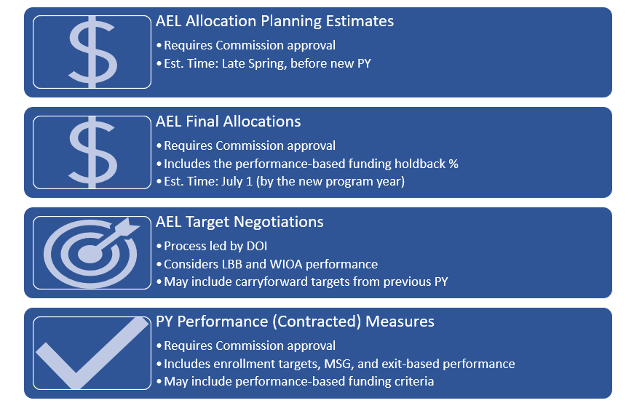
Allocations are composed of a performance-based funding (PBF) holdback, as authorized in TWC Chapter 800 General Administration rule §800.68. AEL grantees must meet PBF criteria, as approved by the Commission each program year, in order to access the holdback of funds. Additionally, Texas Labor Code §315.007 includes specific criteria that TWC must consider.
AEL grantees may locate information on program year allocations, contracted measures, and performance-based criteria on TWC’s Adult Education & Literacy Teachers & Providers web page.

Appendix D: List of Revisions

Revisions to the Performance Guide
Table 16 lists all the major revisions to the Performance Guide, which was first published January 12, 2022.
Table 17: Performance Guide Revisions
Contracted Measures: Enrollment Targets | 10/2022: Updated TEAMS Activity codes in Table 2
Appendix C | 10/2022: Removed Program Year–specific performance measures
Appendix D (Formerly Program Year Performance-Based Funding Criteria) | 10/2022: Modified Appendix D to show a list of guide revisions; information in the former Appendix D on PBF was added to Appendix C
Contracted Measures: Enrollment Targets | 6/2023: Updated TEAMS Activity codes in Table 2

The Career Pathways section on page 40 of the Texas AEL Guide, provides descriptions of each of these models.
OCTAE Program Memorandum 17-2, Performance Accountability Guidance for Workforce Innovation and Opportunity Act (WIOA) Title I, Title II, Title III, and Title IV Core Programs
OMB 1830-0027
More information on comprehensive assessment may be found in the Texas AEL Guide.
Type 1b in OCTAE Program Memorandum 17-2 is listed as Type 1c. TWC uses Type 1b to avoid a confusing skip from Type 1a to Type 1c. OCTAE’s Type 1b MSG (awarding high school credits or Carnegie units) applies to states that implement adult high schools and does not apply in Texas.
OCTAE Program Memorandum 17-2
Data limitations are described in TWC’s LAR Schedule for Fiscal Year 2022–2023.
Language provided in this table is outlined in OCTAE Performance Memorandum 17-2.
Information in this table is summarized from the Summary of NRS Indicators, Measures, and Definitions, Exhibit 1.1, which is found in the NRS TA Guide.
Type 1b in OCTAE Program Memorandum 17-2 is listed as Type 1c. TWC uses Type 1b to avoid a confusing skip from Type 1a to Type 1c. OCTAE’s Type 1b MSG (awarding high school credits or Carnegie units) applies to states that implement adult high schools and does not apply in Texas.
OCTAE Program Memorandum 20-2, Negotiations and Sanctions Guidance for the Workforce Innovation and Opportunity Act (WIOA) Core Programs
The TWC Legislative Appropriations Request for Fiscal Years 2022 and 2023 is available on the Legislative Appropriations Request page of the TWC website.
Type 1b in OCTAE Program Memorandum 17-2 is listed as Type 1c. TWC uses Type 1b to avoid a confusing skip from Type 1a to Type 1c. OCTAE’s Type 1b MSG (awarding high school credits or Carnegie units) applies to states that implement adult high schools and does not apply in Texas.

