Texas Workforce Commission
Complaint Procedures Guide
March 11, 2026

Table of Contents
Introduction 4
Overview of Texas Workforce Commission Complaint Procedures 4
Confidentiality and Privacy Statement 4
Retaliation Protection 4
Complaints Policy 4
Requirement to Provide Notice 5
Identification of Complaints 5
Guidance Rescinded by the Complaints Guide 5
Workforce Program Complaints and Determination Appeals 6
Types of Program Complaints and Determination Appeals 6
Program Complaints 6
Program Determination Appeals 7
Filing a Program Complaint 7
Filing a Program Determination Appeal 8
Right to Appeal Decisions 8
Board Responsibilities 9
Board Informal Resolution Procedures 10
Board Reviews 11
Texas Workforce Commission Responsibilities 11
Federal Appeal Process 12
Wagner-Peyser Complaint System—Employment Service and Employment-Related Law Complaints 14
Employment Service and Employment-Related Law Complaint Procedures 14
Complaints against Out-of-State Employers or American Job Centers 15
Filing Employment Service and Employment-Related Law Complaints 15
Complaints Regarding the Employment Service Regulations 16
Complaints Regarding Employment-Related Laws 17
Wagner-Peyser Complaint System—Migrant and Seasonal Farmworker Complaints 19
Types of Migrant and Seasonal Farmworker Complaints 19
Discrimination Complaints Filed by Migrant and Seasonal Farmworkers 19
Filing a Complaint as a Migrant and Seasonal Farmworker 20
Migrant and Seasonal Farm Worker Complaints Regarding Employment-Related Laws 20
Migrant and Seasonal Farm Worker Complaints Regarding the Employment Service Regulations 21
Complaint Log 22
Informal Resolutions 23
TWC Complaint Determination Notice 23
Apparent Violations 24
Appendices 25
Appendix A: Complaints Procedures Not Included in This Guide 25
EO and WIOA Discrimination Complaints 25
Unemployment Benefits Appeals 26
Appendix B: Definitions 26
Appendix C: Required Posters 32
Employment Service and Employment-Related Law Complaint System Poster 32
U.S. Department of Agriculture Notice: And Justice for All 33
Appendix D: Complaint Forms 34
Form ETA-8429, Complaint/Apparent Violation Form 34
Employment Service Complaint System Log 35
ES Complaint System Log 35
Wagner-Peyser: Employment Service (ES) Complaint Process Map 36
Program Complaint and Determination Appeal Process Map 38

Introduction
This guide serves as a resource for Local Workforce Solutions Boards (Boards) to address complaints and appeals related to various programs and services provided by and through the Texas Workforce Commission (TWC). This guide also seeks to clarify complaint procedures for the ES and Employment-Related Law Complaint System, including oversight of Migrant and Seasonal Farmworker (MSFW) populations in Texas, for Workforce Solutions Office staff members, including Wagner-Peyser Employment Service (ES) staff members.

Overview of Texas Workforce Commission Complaint Procedures
TWC’s complaint procedures ensure consistent process application and promotes a fair and efficient resolution for all individuals. Through Texas Workforce Solutions, TWC and its partners address various types of complaints, including those related to:
- Workforce Program Services—Complaints and determination appeals regarding the delivery of services under TWC and Board-administered programs and services, including:
- subsidized child care;
- the Temporary Assistance for Needy Families (TANF) Employment and Training program (Choices);
- Supplemental Nutrition Assistance Program Employment and Training (SNAP E&T);
- WIOA Title I programs; and
- WIOA-eligible training providers.
- Wagner-Peyser Complaint System, ES and Employment-Related Law—Complaints involving failure to comply with ES regulations, complaints against employers to which applicants were referred, and apparent violations of ES regulations by employers
  - MSFW—Complaints regarding ES and employment-related law specific to MSFW populations and participants.

Confidentiality and Privacy Statement
TWC is committed to protecting the confidentiality of individuals who file complaints. Personal information provided in a complaint will be used only for the purpose of investigating and resolving the complaint.

Retaliation Protection
TWC prohibits retaliation against individuals who file complaints. This means that individuals must not experience any adverse action (such as a denial of services or a termination of employment) because of filing a complaint.

Complaints Policy
Boards must ensure that they develop and maintain local complaint policies that fully comply with the requirements and procedures included in this guidance. Local complaint policies must identify requirements for the training of Workforce Solutions Office staff on applicable local complaint procedures.

Requirement to Provide Notice
Boards must ensure that the Equal Opportunity Notice detailed in Title 29, Code of Federal Regulations (CFR) §38.35 is prominently displayed in available and conspicuous locations in Workforce Solutions Offices and on Board websites, provided to staff members, and included in employee and participant handbooks, as applicable
Boards must ensure information about the Wagner-Peyser Complaint System is made available to the public, including (but not limited to) the prominent display of the ES and Employment-Related Law Complaint System Poster in each Workforce Solutions Office. A sample of the Wagner-Peyser (ES) Complaint System Poster is included in Appendix C of this guide.
Additionally, Boards must ensure that Workforce Solutions Office staff provide each program applicant or participant with the Orientation to Discrimination Complaint Procedures (OTDC), in English or Spanish, as appropriate. Staff members must store a signed OTDC in each participant's case file. The OTDC must be maintained in any applicable paper or electronic files, as practicable, including WorkInTexas.com.

Identification of Complaints
Boards must ensure that Workforce Solutions Office staff identify the complaint type and follow the appropriate complaint procedure based on the information provided by a complainant.

Guidance Rescinded by the Complaints Guide
This guide incorporates and rescinds the following TWC guidance:
- WD Letter 14-24, issued September 16, 2024, and titled “Training Provider Complaint Procedures”
- WD Letter 03-24, issued April 16, 2024, and titled “Employment Service Complaint Determination Appeals”

Workforce Program Complaints and Determination Appeals

Types of Program Complaints and Determination Appeals
Regulations at Title 40, Texas Administrative Code (TAC), Part 20, Chapter 823 set out the procedures to be followed by Boards and TWC regarding complaints and determination appeals related to TWC and Board-administered programs.
Applicable programs are limited to the following:
- Subsidized child care
- Choices
- SNAP E&T
- WIOA Title I (Adult, Dislocated Worker, and Youth programs)
- WIOA eligible training providers (ETPs)
Regulations at 40 TAC §823.1(c) clarify those complaints and determination appeals not managed under the program complaints process. The exceptions to these procedures include (but are not limited to):
- ES and employment-related law complaints, including apparent violations
- Alleged violations of nondiscrimination and EO requirements, including those made by participants in the above programs
- Denial of benefits administered through Texas’ Health and Human Services Commission for recipients of TANF and SNAP E&T services
- Criminal violations
- Contract disputes, including between Boards and Board contractors

Program Complaints
Program complaints allege a violation of law, regulation, or rule relating to any applicable workforce program or service. Purely programmatic complaints do not include a prohibited basis for discrimination and are processed according to the regulations that apply to the relevant program. Pursuant to 29 CFR, Part 38, the TWC EO Officer does not have jurisdiction over purely programmatic complaints.
Pursuant to 40 TAC §823.10(d), Boards must provide information about complaint procedures to individuals, ETPs, and subrecipients. Additionally, Boards must provide information about complaint procedures to any individual upon request, to workforce program applicants and participants, and by posting such procedures in a prominent area in each Workforce Solutions Office.
Program complaints must be filed within 180 calendar days of the alleged violation.

Program Determination Appeals
Individuals may file an appeal of a determination (made by a Board or designee or TWC) affecting the type and level of services or benefits to be provided. Program determinations may be appealed by any individual directly affected by the determination.
Pursuant to 40 TAC §823.11, Boards must provide notice of a determination and information about determination appeal procedures to any individual directly affected. Training providers may appeal a determination related to denial or termination of eligibility as an ETP or provider of other WIOA training services. Training providers may not appeal a determination relating to eligibility for training services of a workforce program participant.
Program determination appeals must be filed within 14 calendar days of the mailing date of the determination.

Filing a Program Complaint
The following individuals have the right to file program complaints:
- Workforce Solutions Office customers
- Previously employed individuals who believe they were displaced by a Workforce Solutions Office customer participating in work-based programs
- Training providers, including WIOA ETPs
- Other interested individuals affected by the Texas Workforce system, including subrecipients
In accordance with 40 TAC, Chapter 823, complaints must be filed within 180 calendar days of the alleged violations and can be filed:
- in person at a Workforce Solutions Office;
- by facsimile;
- online; or
- by mail.
Complainants must provide their name, contact information, and a brief description of the complaint in writing.
If a complainant chooses to take part in the Board Informal Resolution Procedure to resolve a program complaint, they must notify the Board in accordance with the Board’s written program complaint procedure.
If the Board Informal Resolution Procedure results in final agreement between parties to address a program complaint, the Board will issue a Notice of Final Agreement within 60 calendar days of the filing date of the complaint, and no further action will be taken.
If a complainant does not choose to take part in the Board Informal Resolution Procedure, or it does not lead to final agreement, the Board will initiate a formal review, including hearings with the parties to the complaint.
The Board will send the parties a written decision setting forth the results of the hearing within 60 calendar days of the filing of the complaint.

Filing a Program Determination Appeal
The following individuals have the right to appeal program determinations:
- Workforce Solutions Office customers
- Training providers, including WIOA ETPs
- Other interested individuals affected by the Texas workforce system, including subrecipients
In accordance with 40 TAC, Chapter 823, determination appeals must be filed within 14 calendar days of the mailing date of the determination notice and can be filed in writing:
- in person at a Workforce Solutions Office;
- by facsimile;
- online; or
- by mail.
Affected individuals must provide their name, contact information, and a brief description of the reason for determination appeal in writing.
If an affected individual chooses to take part in the Board Informal Resolution Procedure to resolve a determination appeal, they must notify the Board in accordance with the Board’s written procedure.
If the Board Informal Resolution Procedure results in final agreement between parties to address a program determination appeal, the Board will issue a Notice of Final Agreement within 60 calendar days of the filing date of the determination appeal, and no further action will be taken.
If an affected individual does not choose to take part in the Board Informal Resolution Procedure, or it does not lead to final agreement, the Board will initiate a formal review, including hearings with the parties to the determination appeal.
The Board will send the parties a written decision setting forth the results of the hearing within 60 calendar days of the filing date of the determination appeal.

Right to Appeal Decisions
Within 14 calendar days of the mailing date of a Board decision, affected parties have the right to file a written appeal with the TWC Special Program Appeals department.
If a timely appeal is not filed, the Board decision will be considered final.
If no Board decision is mailed within the 60 calendar days of initial filing of the complaint or determination appeal, a party may file an appeal in writing with the TWC Special Program Appeals department. The appeal must be filed no later than 90 days after the filing date of the original complaint or appeal.
Complainants and affected parties have a right to appeal to DOL when decisions are not issued within the time prescribed or when an adverse final decision is issued by the Board or TWC. An appeal must be submitted in writing to the Secretary and the U.S. Department of Labor Employment and Training Administration (DOLETA) Regional Office Administrator. Copies must also be provided to opposing parties in the complaint or appeal.
Appeals to DOL regarding Board decisions must be filed within 120 calendar days of the initial filing or timely appeal to TWC. Appeals to DOL regarding TWC decisions must be filed within 60 calendar days of receipt of TWC’s decision.
All TWC decisions regarding training provider complaints or determination appeals are considered final and complete. Training providers do not have a right to appeal to DOL.

Board Responsibilities
Boards must develop and approve written policies that ensure local program complaint and determination appeals procedures comply with requirements included in 40 TAC, Chapter 823 and any subsequent formal requirements provided to Boards by TWC in accordance with existing state and federal laws and regulations, as applicable.
Boards and Board subrecipients must make program complaint and determination appeals policies available upon request to TWC, program applicants and participants, and other interested individuals. This information must include any applicable time frames relating to program complaints and determination appeals.
Boards must ensure that individuals are notified that program complaints or determination appeals must be submitted in writing and must include any relevant information that forms the basis of the complaint or determination appeal.
Boards must designate an individual to be responsible for investigating, documenting, monitoring, and following up on program complaints and determination appeals. That individual may be the Board Equal Opportunity (EO) Officer.
Boards’ designated complaint officers must maintain a log of program complaints and determination appeals, and all complaint-related materials in a secure file for a period of three years after final resolution. They must comply with all requirements including those found in local complaints and appeals policies, including 40 TAC, Chapter 823 and 20 CFR §683.630(b) regarding contracted training providers and WIOA ETPs.
Boards must inform individuals of the:
- right to file a program complaint;
- right to appeal a determination;
- opportunity for informal resolution and a Board review;
- time frame in which to either reach informal resolution or to issue a Board decision; and
- right to file an appeal to TWC, including providing information on where to file the appeal.
Boards must accept written complaints that are filed in writing within 180 calendar days of the alleged violation of law, regulation, or rule relating to any applicable workforce program or service. Complaints must include at a minimum:
- the complainant’s name and current mailing address; and
- a brief statement, including facts pertinent to the complaint.
Boards must ensure that Board or Workforce Solutions Office staff members provide a written notice by mail of a determination affecting the type and level of program services or benefits, including denial or termination of eligibility, to an individual directly affected under any program identified in 40 TAC §823.1(b), including a training provider. The notice of determination must include:
- a description of action taken by the Board, including the date;
- the mailing date of notice;
- an explanation of the right of the individual (which may be a training provider) to a determination appeal;
- the procedure to request informal resolution or request a hearing (including time frames);
- the right to representation; and
- the mailing address and fax number to send an informal resolution request or appeal.
Boards must accept written determination appeals relating to program eligibility determinations (including those affecting training providers) that are filed within 14 calendar days of the mailing date of the determination notice. Determination appeals must include at a minimum:
- the complainant’s name and current mailing address; and
- a brief statement of the denial or termination of eligibility, including facts pertinent to the determination appeal.
Boards must ensure that any program complaints and determination appeals remanded from TWC to the Board for resolution are handled in a manner following established Board policies and time frames.

Board Informal Resolution Procedures
Boards must offer complainants an opportunity for informal resolution of program complaints or determination appeals. Local Board Informal Resolution Procedures may include (but are not limited to):
- meetings with case managers or supervisors;
- case file reviews;
- phone calls or conference calls;
- in-person interviews; and
- written explanations of laws and regulations.
Each Board must ensure that the process to request a Board Informal Resolution Procedure is included in the Board’s written program complaint policy and information on this procedure is provided to each party to a program complaint or determination appeal.
If the informal resolution procedure results in a final agreement between the parties, the Board must issue a Notice of Final Agreement within 60 calendar days of the filing date of the complaint or appeal. The Board may then consider the program complaint or determination appeal resolved.

Board Reviews
If informal resolution fails or does not result in a final agreement between the parties, the Board must conduct a formal review and issue a written decision no later than 60 calendar days of the original filing date of the complaint or determination appeal.
Boards must designate adjudicators to conduct Board hearings, document actions taken, and render decisions regarding program complaints and determination appeals. Adjudicators act under the authority of the Board, but Boards should ensure that adjudicators—whether Board staff or a third party—do not have any conflicts of interest, or appearance thereof, that would predispose the adjudicator toward the Board or a specific complainant.
The formal review process must include a hearing conducted by a Board adjudicator. The Board adjudicator will issue a written decision following the hearing that must be mailed within 60 calendar days of the original filing date of the complaint or determination appeal.
The Board’s written decision must contain clear directions for the complainant, or other parties to the complaint or determination appeal, informing them of their right to appeal the decision to TWC and the appeals process. The directions must clearly state that the party has 14 calendar days from the date the decision was mailed to file an appeal.

Texas Workforce Commission Responsibilities
Complaints filed with TWC must be submitted using one of the following methods:
- Mail
TWC Special Program Appeals
101 East 15th Street, Room 414
Austin, Texas 78778-0001
- Email: specialprogram.appeals@twc.texas.gov
- Fax: (512) 463-9318
Note: The appellant should keep the appeal fax confirmation.
TWC may redirect program complaints relating to Board actions to the appropriate Board for processing.
TWC will offer an informal resolution for state-level complaints before setting a hearing date. TWC will set a hearing date when:
- an appeal of a Board decision or TWC eligibility determination is received from an appellant; or
- TWC’s informal resolution process does not result in a satisfactory resolution for the complainant in a state-level complaint, and the state-level complaint has not been remanded to the Board.
TWC must issue notice of a hearing to affected parties at least 10 calendar days before the hearing date.
Following the conclusion of the hearing, the hearing officer must promptly issue a written decision on behalf of TWC. Decisions issued on state-level complaints and grievances, TWC eligibility determinations, or appeals of local-level complaints and grievances, will be issued within 60 calendar days of the filing of the complaint, grievance, or appeal, whichever comes later.
A party has 14 calendar days from the hearing officer’s decision mailing date to file a motion for rehearing (MR). To be granted, an MR must allege new evidence, explain why the evidence was not presented earlier, and explain how considering the new evidence would change the outcome of the case. If granted, a new hearing will take place and a separate decision issued based on all of the evidence presented, including the evidence at the rehearing. A hearing officer decision regarding a program complaint or determination appeal is final after 14 calendar days following the mailing date of the latest decision.
Contracted training provider and WIOA ETP complaints and determination appeals regarding a Board or TWC decision are not appealable to DOL under the federal appeal process described in this guidance.
Complaints filed directly with TWC may be remanded to the appropriate Board to be processed in accordance with the Board’s policies for resolving complaints.

Federal Appeal Process
An appeal must be submitted in writing to the Secretary and the DOLETA regional office administrator. Copies must also be provided to opposing parties in the complaint or appeal.
DOL will investigate program complaint or determination appeals when any of the following circumstances apply:
- A decision on a complaint or determination appeal has not been reached within 60 calendar days of receipt of the grievance or complaint.
- A decision on a complaint or determination appeal has not been reached within 60 calendar days of receipt of the request for appeal of a Board grievance and either party appeals to DOL.
- A TWC decision on a complaint or determination appeal has been reached, and the party to which such decision is adverse appeals to the U.S. Secretary of Labor.
This federal appeals process applies solely to noncriminal complaints and determination appeals regarding WIOA Title I or other DOL-administered programs.

Wagner-Peyser Complaint System—Employment Service and Employment-Related Law Complaints

Employment Service and Employment-Related Law Complaint Procedures
Regulations at 20 CFR, Part 658, Subpart E sets out the procedures to be followed by the ES and Employment-Related Law Complaint System (Complaint System) required under the Wagner-Peyser Act. The Complaint System processes complaints about employers, employment services provided by Workforce Solutions Office staff, and complaints involving the failure to comply with the ES regulations.
The Complaint System:
- addresses complaints involving failure to comply with ES regulations;
- addresses complaints against an employer about the specific job to which the applicant was referred through the ES;
- accepts, refers, and (under certain circumstances) tracks complaints involving employment-related law; and
- addresses apparent violations (suspected or observed violations of employment-related laws or ES regulations by an employer).
Complaints related to the type and quality of services provided by a Workforce Solutions Office include those submitted to TWC regarding staff member actions or omissions under ES regulations.
Individuals may file complaints related to ES or employment-related law, including:
- terms and conditions of a job order;
- ES services provided at a Workforce Solutions Office;
- employment practices;
- working conditions;
- wages; and
- other issues such as human trafficking or sexual harassment.
Appropriately trained Workforce Solutions Office staff members may accept complaints and refer a complaint to a local Complaint System Representative when a complainant visits a Workforce Solutions Office to file an ES or employment-related law complaint.
Boards must ensure that local complaint policies address the need to ensure Workforce Solutions Office staff members are trained and available to accept Wagner-Peyser complaints in all Workforce Solutions Offices. Local Complaint System Representatives must be assigned to each Workforce Solutions Office.

Complaints against Out-of-State Employers or American Job Centers
In instances where the employer is located out of state, the local Complaint System Representative must send the complaint to TWC’s Complaint System Coordinator, who will route the complaint to the appropriate official in the state in which the employer is located, with a copy of the complaint sent to the DOLETA Regional offices with jurisdiction over TWC and the sending and receiving state workforce agency.
In instances where the complaint is alleged against an out-of-state one-stop center, the local Complaint System Representative must send the complaint to TWC’s Complaint System Coordinator, who will route the complaint to the appropriate one-stop center in the state the complaint names, with a copy of the complaint to the DOLETA Regional offices with jurisdiction over TWC and the state named in the complaint.

Filing Employment Service and Employment-Related Law Complaints
Complainants may file an ES or employment-related law complaint online, by mail, fax, or in person at a Workforce Solutions Office.
To be processed, a complaint or apparent violation must adhere to the following requirements:
- Complaints must be in writing and be documented using Form ETA-8429.
Note: A written (letter or email) complaint that includes sufficient information to initiate an investigation and is signed by the complainant must also be accepted in place of Form ETA-8429.
- Complaints must contain the following information:
- The complainant’s name and address (or another means of contacting the complainant)
- The respondent’s contact information (employer or state agency)
- A description of the complaint or apparent violation
- Whether the complainant is an MSFW
- The signature of the complainant or the complainant’s authorized representative
If an individual or their representative indicates interest in filing an ES or employment-related law complaint, appropriately trained Workforce Solutions Office staff members receiving the complaint must:
- offer to explain the Complaint System;
- offer to take the complaint in writing using Form ETA-8429;
- make every effort to obtain all necessary information to investigate the complaint;
- request all the physical addresses, email addresses, telephone numbers, and any other helpful methods of contact during the investigation of the complaint;
- facilitate access to the nearest Complaint System Representative before the complainant leaves the office or area (if possible, including virtually) and explain the need to maintain contact during the investigation;
- ensure the complainant signs and submits the complaint using Form ETA-8429; and
- offer to assist the complainant in completing Part I of the form and submitting all necessary information and provide such assistance if the complainant desires such assistance.

Complaints Regarding the Employment Service Regulations
TWC, Boards, and local Complaint System Representatives must ensure that when an ES complaint is filed against an employer the Workforce Solutions Office serving the area where the employer is located processes the complaint.
Additionally, Boards and local Complaint System Representatives must ensure that when an ES complaint is filed against a Workforce Solutions Office, the complaint is processed by the Workforce Solutions Office where the alleged violation occurred. If a Workforce Solutions Office receives an ES complaint against another Workforce Solutions Office, and the alleged violation did not occur in the receiving office’s Workforce Development Area, the complaint must be referred to the appropriate supervisory staff of that Workforce Solutions Office. Complaints submitted by MSFWs, or their representatives, must be processed in accordance with the MSFW Complaints section of this guidance.
Complaints filed at the Workforce Solutions Office or TWC regarding failure to comply with ES regulations must be addressed as follows:
- When an individual indicates their interest in filing an ES complaint, Workforce Solutions Office staff members must offer to:
  - explain the Complaint System; and
  - assist the complainant in filling out Part I of Form ETA-8429.
- Workforce Solutions Office staff members must accept a hard copy or electronic complaint from the complainant or their representative using Form ETA-8429, which describes the alleged violation and desired outcome, and complete Part II of Form ETA-8429.
- Once the form is completed and signed, Workforce Solutions Office staff members must immediately send the form, along with all pertinent documentation, to the Complaint System Representative for processing.
- If the complaint alleges discrimination or reprisal for protected activity in violation of nondiscrimination laws, the local Complaint System Representative must log the allegation on the Complaint Log and immediately refer such a complaint to the TWC EO Officer and notify the complainant of this referral.
- The local Complaint System Representative must:
  - log the complaint on the Complaint Log;
  - investigate the complaint; and
  - attempt to resolve the complaint immediately.
- Once received, the local Complaint System Representative must attempt to resolve the complaint informally at the local level, unless:
  - it alleges unlawful discrimination or reprisal for protected activity in violation of nondiscrimination laws;
  - the complaint was submitted to TWC, and the TWC Complaint System Coordinator determines that immediate action or referral is necessary; or
  - informal resolution at the local level would be detrimental to the complainant.
- If the complaint is not resolved within 15 business days, the Complaint System Representative must send the complaint to the TWC Complaint System Coordinator for resolution.
- The local Complaint System Representative must notify the complainant and the respondent in writing of the informal resolution to which all parties have arrived or referral of the complaint to TWC.
- Once received, the TWC Complaint System Coordinator must investigate immediately and make a determination within 30 business days of receipt.
- All ES complaint determinations must be sent to the parties or their representatives by certified mail, and a copy of the TWC Determination Notice will be sent via email (when available).
If TWC determines that the employer violated ES regulations and the complaint is connected to a job or clearance order, TWC will initiate procedures for discontinuation of services immediately. TWC will notify both the complainant and the employer of this action.
A complaint regarding ES regulations must be processed to resolution under the above procedures only if it is made within two years of the alleged occurrence.

Complaints Regarding Employment-Related Laws
When a complaint is filed regarding an employment-related law, the Workforce Solutions Office staff member receiving the complaint must determine if the complainant is an MSFW. Complaints submitted by MSFWs, or their representatives, must be processed in accordance with the MSFW Complaints section of this guidance.
Complaints submitted by non-MSFWs must be addressed as follows:
- When an individual indicates their interest in filing an employment-related law complaint, Workforce Solutions Office staff members must offer to:
  - explain the Complaint System; and
  - assist the complainant in filling out Part I of Form ETA-8429.
- Workforce Solutions Office staff members must accept a hard copy or electronic complaint from the complainant or their representative using Form ETA-8429, which describes the alleged violation of the employment-related law and desired outcome, and complete Part II of Form ETA-8429.
- Once the form is completed and signed, Workforce Solutions Office staff members must immediately send the form along with all pertinent documentation to the local Complaint System Representative for processing.
- Once received, the local Complaint System Representative must record the complaint in the Complaint Log and immediately refer the complaint to the appropriate enforcement agency, another public agency, a legal aid organization, and/or a consumer advocate organization, as appropriate. Referrals must include the Form ETA-8429 and all related documentation and must be transmitted by the local Complaints System Representative using the method prescribed by the receiving entity.
- Complaints regarding employment-related laws may be referred as follows:
  - Refer complaints alleging violation of employment-related laws (such as the Fair Labor Standards Act and wage and hour issues) to TWC’s or DOL’s Wage and Hour Division.
  - Refer complaints alleging unsafe working conditions to DOL’s Occupational Safety and Health Administration (OSHA).
  - Refer complaints alleging discrimination or reprisal for a protected activity in violation of nondiscrimination law by an employer that did not have an internal job order in WorkInTexas.com to TWC’s EO Office.
  - Refer complaints alleging employer behavior associated with human or labor trafficking to the appropriate law enforcement agency.
- The local Complaint System Representative must notify the complainant in writing of the referral.
- No follow-up is required once the complaint has been sent to the proper enforcement agency.

If an enforcement agency makes a final determination that the employer violated an employment-related law and the complaint is connected to a job or clearance order, TWC will initiate procedures for discontinuation of services immediately. TWC will notify both the complainant and the employer of this action.

Wagner-Peyser Complaint System—Migrant and Seasonal Farmworker Complaints

Types of Migrant and Seasonal Farmworker Complaints
MSFW protections in the Complaint System allow for a shorter period to conduct investigations leading to resolutions. If an MSFW or their representative wishes to submit an employment-related law complaint, the local Complaint System Representative at the Workforce Solutions Office nearest to the employer in question must attempt informal resolution within five business days of receipt of the complaint. The local Complaint System Representative must keep the MSFW informed of progress on the complaint no less than once each 30-day period until the complaint is resolved. The local Complaint System Representative must also offer to refer the MSFW to other ES services if they are interested.
MSFWs or their representatives may file complaints related to ES or employment-related law, including:
- terms and conditions of a job order;
- ES services provided at a Local Workforce Solutions Office;
- employment practices;
- working conditions;
- wages;
- housing;
- transportation; and
- other issues such as human trafficking or sexual harassment.
Appropriately trained Workforce Solutions Office staff members may accept Wagner-Peyser complaints and refer the complaint to the local Complaint System Representative when a complainant visits a Workforce Solutions Office to file an ES or employment-related law complaint.
Boards must ensure that local complaint policies address the need to ensure Workforce Solutions Office staff members are trained and available to accept Wagner-Peyser complaints in all Workforce Solutions Offices.

Discrimination Complaints Filed by Migrant and Seasonal Farmworkers
Complaints alleging unlawful discrimination or reprisal for protected activity in violation of WIOA §188 and 29 CFR, Part 38 protections, or in violation of the Immigration and Nationality Act’s anti-discrimination provision, must be addressed as follows:
- Workforce Solutions Office staff members accept a hard copy or electronic complaint from the MSFW or their representative using Form ETA-8429 that describes the alleged unlawful discrimination.
- The complaint is referred to the local Complaint System Representative.
- Once received, the local Complaint System Representative must record in the Complaint Log and immediately refer the complaint to the TWC EO Officer via email.
- The local Complaint System Representative must notify the MSFW or their representative of the referral to the TWC EO Officer in writing via letter or email.

Filing a Complaint as a Migrant and Seasonal Farmworker
MSFWs or their representatives may file an ES or employment-related law complaint online, by mail, fax, or in-person at a Workforce Solutions Office.
Workforce Solutions Office staff members receiving an MSFW complaint must:
- offer to explain Complaint System operations;
- offer to take the complaint in writing using Form ETA-8429;
- make every effort to obtain all necessary information to investigate the complaint;
- request all physical addresses, email addresses, telephone numbers, and any other relevant contact information needed to investigate the complaint;
- request that the MSFW or their representative contact the nearest local Complaint System Representative before leaving the area (if possible) and explain the need to maintain contact during the investigation;
- ensure the MSFW or their representative submits the complaint using either Form ETA-8429 or a written (letter or email) complaint signed by the MSFW or their representative; and
- offer to assist the MSFW or their representative in filling out Part I of the complaint form and submitting all necessary information and assist if the MSFW complainant desires such help.

Local Complaint System Representatives will provide monthly updates to MSFWs or their representatives on the status of their complaints.

Migrant and Seasonal Farm Worker Complaints Regarding Employment-Related Laws
Complaints filed at a Workforce Solutions Office or with TWC regarding an employment-related law must be addressed as follows:
- When an MSFW or their representative indicates their interest in filing an employment-related law complaint, Workforce Solutions Office staff members must offer to:
  - explain the Complaint System; and
  - assist the complainant in filling out Part I of Form ETA-8429.
- Workforce Solutions Office staff members must accept a hard copy or electronic complaint from the complainant or their representative using Form ETA-8429 which describes the alleged violation of the employment-related law and desired outcome and complete Part II of Form ETA-8429.
- Once the form is completed and signed, Workforce Solutions Office staff members must immediately send the form along with all pertinent documentation to the local Complaint System Representative for processing.
- If the complaint alleges discrimination or reprisal for protected activity in violation of nondiscrimination laws, the local Complaint System Representative must log the allegation on the Complaint Log and immediately refer such a complaint to the TWC EO Officer and notify the complainant of this referral.
- The local Complaint System Representative must:
  - log the complaint on the Complaint Log;
  - investigate the complaint; and
  - attempt to resolve the complaint immediately.
- Once received, the local Complaint System Representative must attempt to resolve the complaint informally at the local level, unless:
  - it alleges unlawful discrimination or reprisal for protected activity in violation of nondiscrimination laws;
  - the complaint was submitted to TWC, and the TWC Complaint System Coordinator determines that immediate action or referral is necessary; or
  - informal resolution at the local level would be detrimental to the MSFW.
- If the complaint is not resolved between the parties within five business days, the local Complaint System Representative must forward the employment-related law complaint to the appropriate enforcement agency, another suitable public agency, legal aid organization, or consumer advocate organization for further assistance. Referrals must include the Form ETA-8429 and all related documentation and must be transmitted by the local Complaints System Representative using the method prescribed by the receiving entity.
If an enforcement agency makes a final determination that the employer violated an employment-related law and the complaint is connected to a job or clearance order, TWC will initiate procedures for discontinuation of services immediately. TWC will notify both the MSFW and the employer of this action.

Migrant and Seasonal Farm Worker Complaints Regarding the Employment Service Regulations
When an ES complaint is filed against an employer or Workforce Solutions Office, the local Complaint System Representative must process the complaint.
Complaints filed at a Workforce Solutions Office or TWC regarding failure to comply with ES regulations must be addressed as follows:
- When an MSFW or their representative indicates their interest in filing an ES complaint, Workforce Solutions Office staff members must offer to:
  - explain the Wagner-Peyser Complaint System; and
  - assist the complainant in filling out Part I of Form ETA-8429.
- Workforce Solutions Office staff members must accept a hard copy or electronic complaint from the complainant or their representative using Form ETA-8429 which describes the alleged violation of the employment-related law and desired outcome and complete Part II of Form ETA-8429.
- If the complaint alleges discrimination or reprisal for a protected activity in violation of nondiscrimination laws, the local Complaint System Representative must immediately refer such complaint to the TWC EO Officer and notify the complainant of this referral.
- Once the form is completed and signed, Workforce Solutions Office staff members must immediately send the form along with all pertinent documentation to the local Complaint System Representative for processing.
- If the complaint alleges discrimination or reprisal for protected activity in violation of nondiscrimination laws, the local Complaint System Representative must log the allegation on the Complaint Log and immediately refer such a complaint to the TWC EO Officer and notify the complainant of this referral.
- Once received, the local Complaint System Representative must:
  - log the complaint on the Complaint Log;
  - investigate the complaint; and
  - attempt to resolve the complaint immediately.
- If the complaint is not resolved between the parties within five business days, the local Complaint System Representative must send the complaint to the TWC Complaint System Coordinator for resolution.
- The local Complaint System Representative must notify both the MSFW who filed the complaint (or their representative) and the respondent in writing of the informal resolution to which all parties have arrived or referral of the ES complaint to TWC.
- Once received, the TWC Complaint System Coordinator must investigate the complaint immediately and make a determination within 20 business days of receipt.
- All ES complaint determinations must be sent to the parties or their representatives by certified mail, and a copy of the TWC Determination Notice will be sent via email (when available).
If TWC determines that the employer violated ES regulations and the complaint is connected to a job or clearance order, TWC will initiate procedures for discontinuation of services immediately. TWC will notify both the complainant and the employer of this action.
A complaint regarding the ES regulations from an MSFW complainant or their representative must be received within two years of the alleged occurrence to be timely received and processed to resolution under the above procedures.

Complaint Log
The statewide record of ES and employment-related law complaints and apparent violations is maintained by the State Administrator and by each Board. Boards must ensure that appropriate supervisors and local Complaint System Representatives maintain the Complaint Log in accordance with TWC requirements, with all information regarding local complaints (including those received and resolved at the local level without referral to the TWC Complaint System Coordinator) and apparent violations. An electronic copy must be transmitted to the State Monitor Advocate at least once per calendar quarter as established under 20 CFR §658.410
At a minimum, the Complaint Log must include the following:
- Date complaint filed or apparent violation identified
- Complainant name
- Respondent name
- Complainant address (when available)
- Whether the complaint is made by an MSFW or representative, or if the apparent violation affects an MSFW
- Whether the complaint or apparent violation concerns an employment-related law or the ES regulations
- Complaint description (to include notation of supplemental documentation provided by the complainant or their representative)
- Actions taken and dates of actions, including updates provided and/or informal resolution
- Status of complaint
- Date of outcome

Informal Resolutions
Complaints System Representatives at Workforce Solutions Offices may facilitate, as appropriate, discussion between the parties to a complaint to reach an informal resolution. The local Complaints System Representative must act as an impartial facilitator and may not propose a solution or dictate terms of a settlement to the parties. If the parties reach an informal resolution to the complaint, the local Complaints System Representative must ensure that both parties affirm the terms of the agreement through written signature (including electronically) and document the informal resolution and record the outcome on the Complaint Log.
Boards are responsible for ensuring that appropriate supervisors and local Complaint System Representatives maintain an activity log that includes all actions and documents relating to local ES or employment-related law complaints received. At a minimum this log must include all relevant information on complaint referrals from MSFWs, a notation of the type of complaint, a copy of the original complaint form, a copy of any ES-related reports, any relevant correspondence, a list of actions taken, a record of pertinent telephone calls, and all correspondence relating to the complaint. This information must be documented and maintained in accordance with TWC’s approved Record Retention Schedule.

TWC Complaint Determination Notice
The determination notice provided by TWC Complaint System Coordinator to all parties to ES complaints, will be delivered by certified mail, and copies via email, as practicable.
The TWC Determination Notice will include:
- the results of the investigation;
- the conclusions reached on the allegations of the complaint;
- confirmation that TWC will initiate procedures for the discontinuation of services to the employer when there is a final determination indicating a violation of ES regulations by the employer;
- an explanation of why the complaint was not resolved if a resolution was not reached; and
- a statement advising the complainant or employer of their right to appeal and informing them that requests for appeal hearings must be made within 20 business days after the certified date of receipt of the TWC Determination Notice.
If TWC receives a written request of a hearing, the appeal proceedings under 20 CFR §658.411(d)(5) will be followed.

Apparent Violations
The Complaint System also addresses apparent violations. Regulations at 20 CFR §658.419 set out the procedures for documenting apparent violations. If Workforce Solutions Office staff members (including MSFW outreach staff) have reason to believe there is, or otherwise receive information regarding, a suspected violation of employment-related laws or ES regulations by an employer, they must document the suspected violation as an apparent violation using Form ETA-8429. The violation must then be referred to the appropriate supervisory staff member to ensure that it is documented in the Complaint Log. Once the apparent violation is documented, the supervisory staff member will ensure the apparent violation is received by the local Complaint System Representative, who then:
- attempts informal resolution following the same process used to resolve complaints for employers who have filed a job order with the Workforce Solutions Office during the previous 12 months; or
- refers the apparent violation to the appropriate enforcement agency in writing for employers who have not filed a job order with the Workforce Solutions Office during the previous 12 months.
Additionally, apparent violations based on discrimination must be processed as complaints based on discrimination and be immediately referred by the local Complaint System Representative to the TWC EO Officer.

Appendices

Appendix A: Complaints Procedures Not Included in This Guide
Complaint procedures related to Equal Opportunity (EO) and Workforce Innovation and Opportunity Act (WIOA) Discrimination protections and unemployment benefits decision appeals are not included in this guidance.

EO and WIOA Discrimination Complaints
EO and WIOA discrimination complaints include complaints alleging discrimination that is based on race, color, religion, sex, national origin, age, disability, or political affiliation or belief, or, for beneficiaries, applicants, and participants only, on the basis of citizenship status or participation in a Board or TWC program or activity.
Individuals alleging discrimination related to a Board or TWC program or activity can submit a written complaint of alleged discriminatory acts within 180 calendar days from the date of the alleged discriminatory act.
Complainants may submit EO Discrimination complaints in writing to Board EO officers, to TWC Equal Opportunity Compliance Department (EOCD), or to the Department of Labor’s Civil Rights Center (CRC):
Texas Workforce Commission
Equal Opportunity Compliance Department
101 East 15th Street, Room 556
Austin, Texas 78778-0001
E-mail: EO.complaint@twc.texas.gov
Phone: 512-463-2400
Director, Civil Rights Center (CRC)
U.S. Department of Labor
200 Constitution Ave NW, Rm N-4123
Washington, DC 20210
Or electronically as directed on the U.S. DOL CRC website
Board EO Officers must ensure that Workforce Solutions Office staff advise individuals of their right to file a discrimination complaint and of the discrimination complaint procedure. Individuals who express an interest in filing a discrimination complaint should be referred to the Board’s EO Officer or TWC’s Equal Opportunity Compliance Department (EOCD).
Additional guidance for Boards is available in Workforce Development Letter 18-07, Change 2 (et seq.), issued January 30, 2019, and titled “Discrimination Complaint Procedures—Update.”

Unemployment Benefits Appeals
Individuals may learn more about appealing an unemployment benefit decision on the Appeals section of TWC’s Apply for Unemployment Benefits web page.

Appendix B: Definitions
The following are common terms used in this guide and relating to complaint procedures.
Adjudicator: An impartial individual designated by a Workforce Solutions Board (Board) to participate in a Board Informal Resolution Procedure and to review and issue Board decisions regarding program complaints.
Aid, benefit, service, or training: Services—financial or other aid, training, or benefits—provided by a recipient including through a contract or other arrangements. These include (but are not limited to) the following:
- Career services
- Education or training
- Health, welfare, housing, social service, rehabilitation, or other supportive services
- Work opportunities
- Cash, loans, or other financial assistance to individuals
- Any aid, benefits, services, or training provided in or through a facility that has been constructed, expanded, altered, leased, rented, or otherwise obtained, in whole or in part, with federal financial assistance under Workforce Innovation and Opportunity Act (WIOA) Title I
Apparent violation: A suspected violation of employment-related laws or Employment Service (ES) regulations by an employer, which Workforce Solutions Office staff members observe, have reason to believe occurred, or about which they receive information (other than a complaint)
Appeal: A written request for a review filed with a Board, TWC, or the appropriate agency by an individual in response to a determination or decision
Applicant: An individual who is interested in being considered for any aid, benefit, service, or training by a recipient, and who has submitted personal information to the recipient; this may include an individual who applies for employment with the recipient
Board Informal Resolution Procedure: An informal resolution procedure determined by written Board policy that is provided to a complainant for a workforce program or services complaint or appeal, covered by 40 TAC Chapter 823. Regulations at 40 TAC §823.12 provide examples of applicable actions that may be included in a Board Informal Resolution Procedure, including informal meetings with case managers or supervisors, meetings with affected parties, and written explanations of laws or regulations relating to the complaint
Civil Rights Center (CRC): A division of the U.S. Department of Labor (DOL), the mission of the CRC is to promote nondiscrimination and EO by enforcing various civil rights laws. These laws include (but are not limited to) the following:
- WIOA §188
- Title VI of the Civil Rights Act of 1964, as amended
- Sections 504 and 508 of the Rehabilitation Act of 1973, as amended
- Age Discrimination Act of 1975, as amended
- Title IX of the Education Amendments of 1972, as amended
- Title II, Subpart A of the Americans with Disabilities Act of 1990, as amended
EO Discrimination complainants may be submitted in writing to the address below or electronically as directed on the U.S. DOL CRC website:
Director, Civil Rights Center (CRC)
U.S. Department of Labor
200 Constitution Avenue Northwest, Room N-4123
Washington, DC 20210
Code of Federal Regulations (CFR): The codification of the general and permanent rules published by federal departments and agencies
Complainant: The individual, employer, organization, association, or entity (including the designated representative of any of these) filing a complaint or program determination appeal
Complaint: A representation made or referred to TWC or a Workforce Solutions Office of an alleged violation of ES regulations, WIOA nondiscrimination prohibitions, or other federal laws enforced by federal, state, or local agencies
Complaint System: The system established by the Wagner-Peyser Act (and further described in 20 CFR, Part 658) that processes complaints about employers and jobs to which the applicant is referred by Workforce Solutions Office staff members or through WorkInTexas.com and complaints involving the failure to comply with ES regulations and employment-related laws. All staff at Workforce Solutions Offices must be able to take complaints using Form ETA-8429, the Complaint/Apparent Violation Form. Assigned and trained Complaint System Representatives must be Workforce Solutions Office staff members, and they are responsible for processing complaints.
Local Complaint System Representative: A trained Workforce Solutions Office staff member who is responsible for processing complaints at their assigned Workforce Solutions Office
Complaint System Coordinator: A trained TWC staff member who is responsible for processing complaints at the TWC level
Decision: A written finding issued by a Board adjudicator, or TWC hearing officer, following a hearing in response to a complaint or appeal
Determination: A written order issued to a Workforce Solutions Office customer by a Board, its designee, or the TWC relating to an adverse action or to a provider or contractor relating to denial or termination of eligibility under programs administered by TWC or a Board listed in 40 TAC §823.1(b)
Discrimination: Unlawful activities identified under 29 CFR, Part 38. This includes any decisions about admittance or access to a program or services, treatment of a person regarding a program or services, denial of benefits, and denial of employment by a recipient based on any of the following:
- Race, color, or national origin, including limited English proficiency (42 USC §2000d et seq.)
- Religion (42 USC §2000d et seq.)
- Sex (except as otherwise permitted under 20 USC §1681 et seq.)
- Age (42 USC §6101 et seq.)
- Disability (29 USC §794)
- Political affiliation or belief
Employment-Related Laws: Those laws that relate to the employment relationship, such as those enforced by the U.S. Department of Labor’s Wage and Hour Division (WHD), Occupational Safety and Health Administration (OSHA), or other federal, state, or local agencies
Employment Service (ES) Staff: Workforce service provider and state merit staff members responsible for providing ES services required under the Wagner-Peyser Act to job seekers and employers in a Workforce Solutions Office

EO Compliance Department (EOCD): Unit within TWC’s Fraud Deterrence and Compliance Monitoring (FDCM) Division led by the state-level EO Officer, and with responsibility to implement the provisions of WIOA §188 and 29 CFR, Part 38, to:
- provide technical assistance and training to all parties about those requirements;
- monitor compliance by TWC, Boards, and other recipients;
- receive and process complaints; and
- take other necessary steps to accomplish those requirements
Equal Opportunity (EO) Officer: Individual responsible for coordinating the recipients’ responsibilities under the nondiscrimination and equal opportunity provisions of WIOA §188 and 29 CFR, Part 38. EO Officer responsibilities include (but are not limited to):
- serving as the liaison with TWC or the DOL and Civil Rights Center (CRC);
- monitoring recipients’ activities and the activities of the entities that receive WIOA funds from the recipient to ensure these entities are not violating nondiscrimination and EO provisions of WIOA §188;
- reviewing recipients’ written policies to ensure the policies are not discriminatory;
- developing and publishing procedures for processing discrimination complaints and ensuring those procedures are followed;
- reporting directly to the appropriate official (TWC, the governor, or other appropriate authority) about EO matters; and
- undergoing training to maintain competency
Filing Date: The filing date for a complaint or an appeal. In accordance with 40 TAC §823.3, the filing date is:
- the postmark date or the postal meter date, if there is only one;
- the postmark date if there is both a postmark date and a postal meter date;
- the date the document was delivered to a common carrier, which is equivalent to the postmark date;
- three business days before receipt by the Board or TWC, if the document was received in an envelope bearing no legible postmark, postal meter date, or date of delivery by a common carrier;
- the date of the document itself, if the document date is fewer than three days earlier than the date of receipt and if the document was received in an envelope bearing no legible postmark, postal meter date, or date of delivery by a common carrier;
- the date of the document itself, if the mailing envelope containing the complaint or appeal is lost after delivery to the Board or TWC; or
- the date of receipt by the Board or TWC if the document was filed by fax.
For ES and employment-related law complaints, the filing date may be the date received documented on Form ETA-8429, if later than the above.
One-Stop Partner: An entity that carries out a program or activities in a Board area that is included in WIOA §121(b) or identified in Title 40, Texas Administrative Code, Chapter 801.
Regional Office Administrator: The U.S. Department of Labor Employment and Training Administration (DOLETA) maintains six regional offices whose staff members monitor programs, services and benefits provided under WIOA, Unemployment Insurance, Trade Adjustment Assistance, and targeted grants. Complainants who submit a program-related appeal to the Secretary of the Department of Labor must also provide the DOLETA Regional Office Administrator a written copy of the appeal.

DOLETA Regional Administrator contact information:

525 S Griffin St
Room 317
Dallas, TX 75202-5002
Phone: 972-850-4600
Fax: 972-850-460
Email: RO4-RA-DAL@dol.gov
Respondent: The individual, company, agency, or entity against whom a complaint is filed
Secretary: Secretary of the DOL
Complainants may mail program appeals to:
Secretary, U.S. Department of Labor
200 Constitution Avenue Northwest
Washington, DC 20210
Attention: ASET
Service Provider: Defined in 29 CFR, Part 38.4. Any operator or provider of WIOA Title I–financially assisted aid, benefits, services, or training. Does not include TWC, Boards, or one-stop operators. State and Board EO Officers are responsible for ensuring service provider nondiscrimination compliance, as appropriate.
State Monitor Advocate: Senior-level TWC staff member responsible for monitoring TWC and Board-area employment service delivery and protections for MSFWs and appropriateness of informal resolution of complaints and apparent violations under ES and employment-related law complaint system. The State Monitor Advocate serves as a liaison to the TWC EO Officer
TWC Special Program Appeals: TWC department responsible for conducting agency-level hearings relating to ES, child care, and other program appeals not relating to equal opportunity and nondiscrimination protections. More information about these appeals is available on TWC’s Appeals Program webpage.
Mail
TWC Special Program Appeals
101 East 15th Street, Room 414
Austin, TX 78778-0001
Email, specialprogram.appeals@twc.texas.gov
Fax, 512-463-9318
United States Code (USC): The codification of the general and permanent laws of the United States. The USC does not include federal court decisions, treaties, laws enacted by state or local governments, or regulations issued by executive branch agencies (which may be found in CFR).
Vocational Rehabilitation (VR) Liaison: Individual designated at each local VR office to record complaints in writing and assist complainants with filling out forms. Each facility where a VR program operates (whether stand-alone or integrated into a Workforce Solutions Office) must have a designated VR Liaison.
Wagner-Peyser Act: The Wagner-Peyser Act of 1933, as amended by WIOA, is the federal law that established a nationwide system of public employment offices to provide labor exchange services. Provided primarily through WorkInTexas.com, these services are designed to increase employment opportunities for all workers through the provision of basic career services and to meet the needs of employers through recruitment assistance and referral of well-qualified candidates. Federal regulations governing ES functions include 20 CFR, Parts 651–654, 20 CFR, Part 658, and 29 CFR, Part 75.
Wagner-Peyser Employment Service (ES): The national system of public ES offices described under the Wagner-Peyser Act. In Texas, ES services are delivered through the Texas Workforce Solutions network by staff members who work primarily at Workforce Solutions Offices.
Workforce Solutions Office Staff: Staff members providing services (including ES services) at a Workforce Solutions Office, including workforce service providers and state merit staff members, or staff members of other partner programs co-located within a Workforce Solutions Office.
Workforce Solutions Office Supervisory Staff: Workforce Solutions Office staff who direct other Workforce Solutions Office staff, including workforce service provider staff and state merit staff providing ES under the Wagner-Peyser Act. Workforce Solutions Office Supervisory staff may coordinate staffing, workflow, and customer service activities across all programs and partners collocated within the Workforce Solutions Office to support an integrated, seamless service delivery environment.

Appendix C: Required Posters
TWC’s Business Operations Division maintains a Required Notices SharePoint folder (which is not available to the general public) with printable versions of all required posters specific to the agency. Boards must follow instructions from the Business Operations Risk and Security Management department regarding the annual compliance review.

Employment Service and Employment-Related Law Complaint System Poster
Training and Employment Notice 08-23, issued October 10, 2023, titled “Required Employment Service and Employment-Related Law Complaint System Posters,” includes approved posters for the ES and Employment-Related Law Complaint System in English and Spanish. Additionally, the posters with Texas’ State Monitor Advocate information included are published on TWC’s Employment Service Program web page.

Required Employment Service and Employment-Related Law Complaint System Poster
(English and Spanish)
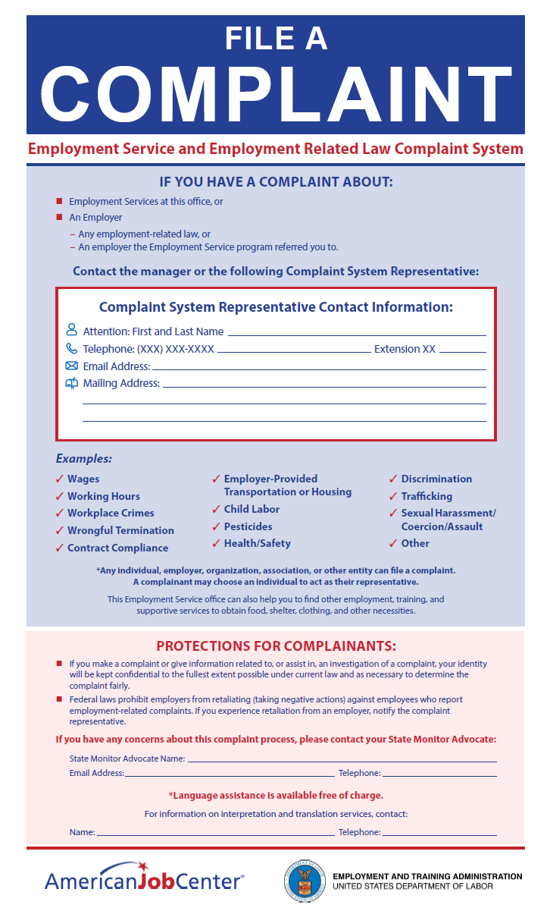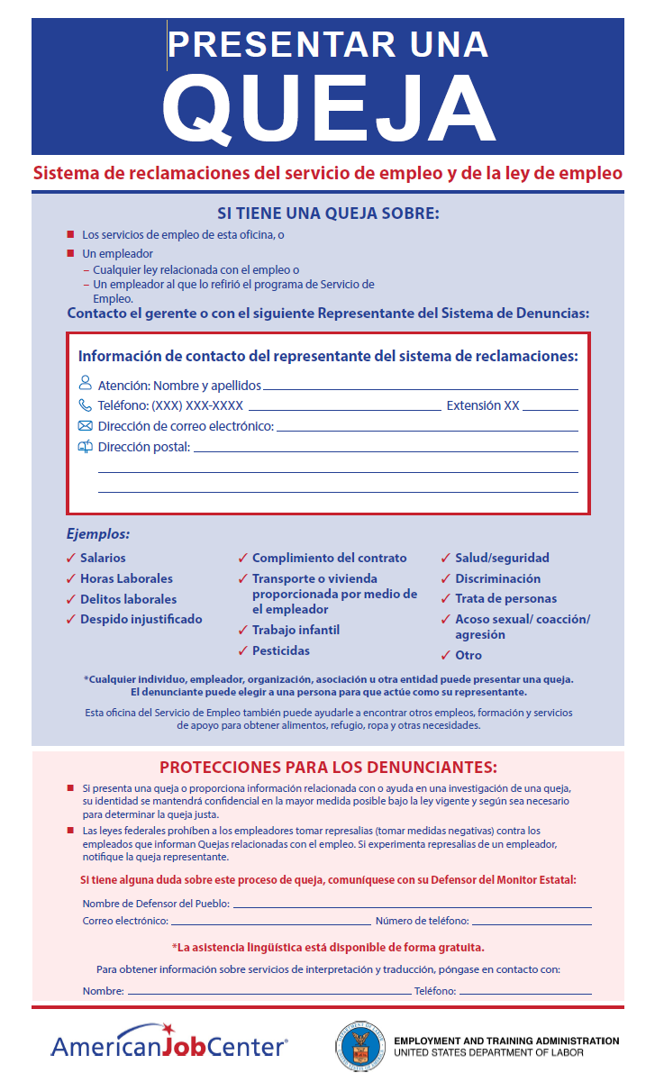

U.S. Department of Agriculture Notice: And Justice for All
The U.S. Department of Agriculture (USDA) And Justice for All poster will be the primary method used to inform customers of their EO rights except when appropriate substitutes for outdoor areas are necessary. Boards that need additional posters or posters in additional languages may contact wfpolicy.clarifications@twc.texas.gov.
And Justice for All Poster (English and Spanish)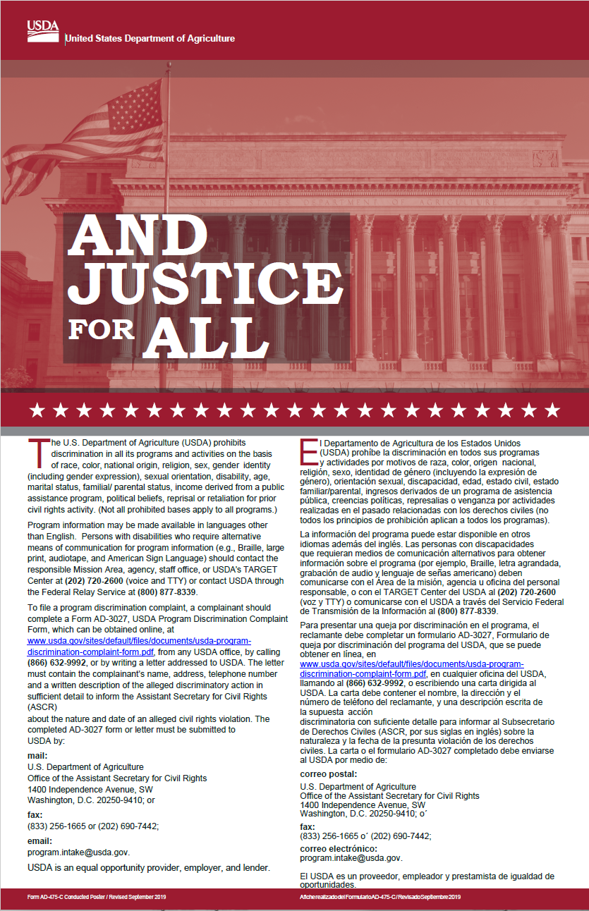

Appendix D: Complaint Forms

Form ETA-8429, Complaint/Apparent Violation Form
Individuals (farmworkers and non–farmworkers), employers, organizations, associations, or their designated representatives can file ES and employment-related law complaints using Form ETA-8429, Complaint/Apparent Violation Form. DOL’s Monitor Advocate System Resources web page includes this form (in PDF and Word formats) and TWC’s Migrant & Seasonal Farmworker Resources web page also includes a link to this form. Additionally, complainants and Workforce Solutions Office staff may complete the form in WorkInTexas.com.
Form ETA-8429, Complaint/Apparent Violation Form
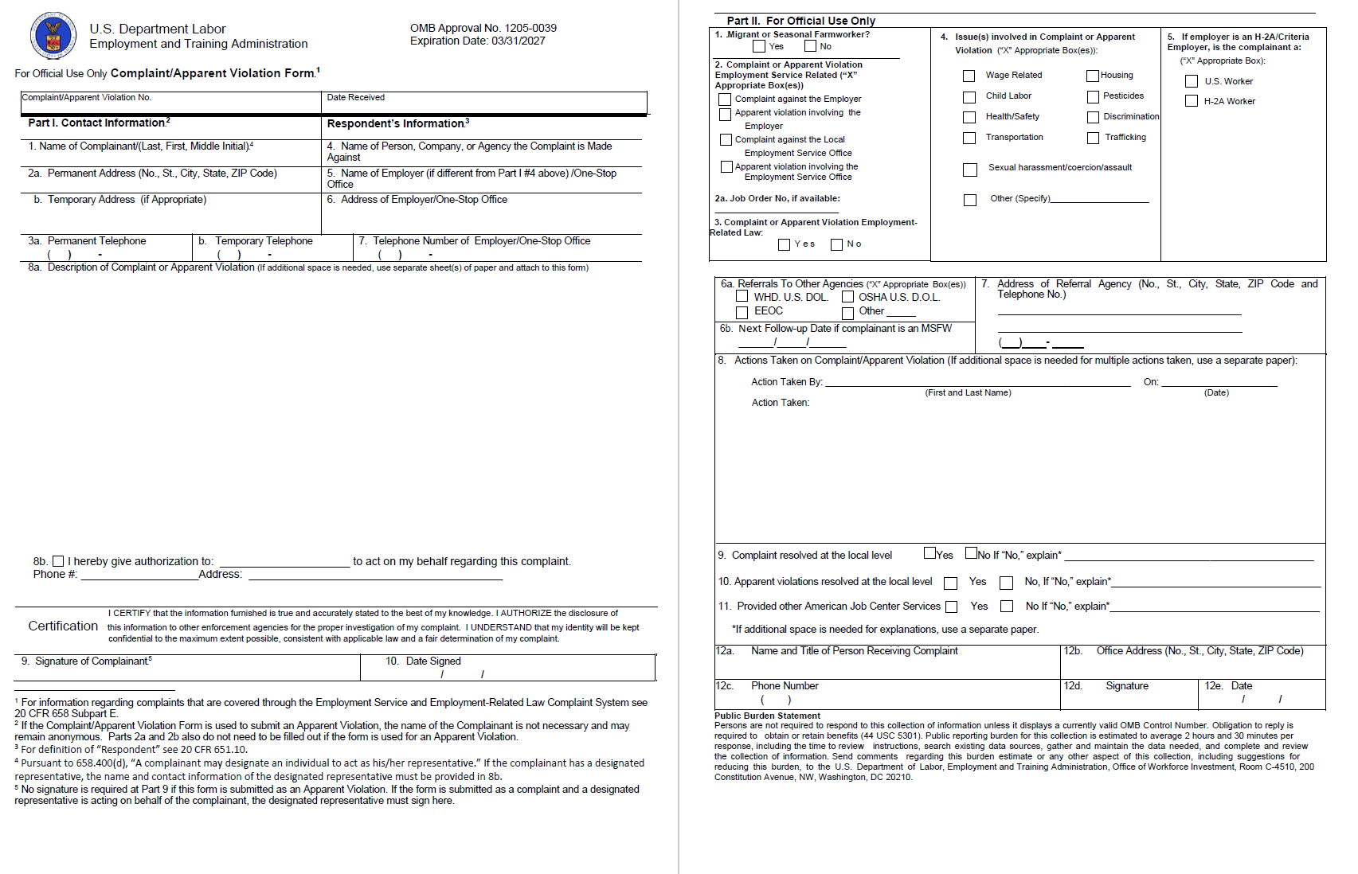

Employment Service Complaint System Log
The Complaint System Log is used by Workforce Solutions Office staff, VR Liaisons, and Complaint System Representatives to track the status of ES and employment-related law complaints and apparent violations. Local Complaint System Representatives are responsible for maintenance of the ES Complaint System Log.
ES Complaint System Log
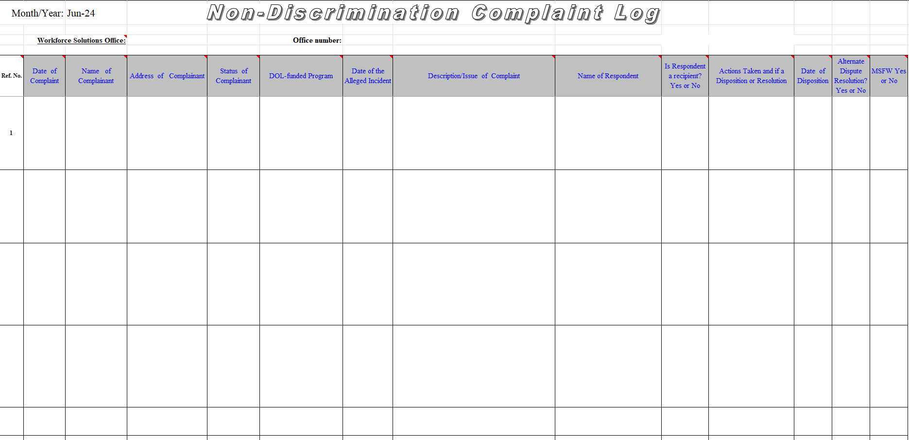
Appendix E: Complaint Workflows

Wagner-Peyser: Employment Service (ES) Complaint Process Map
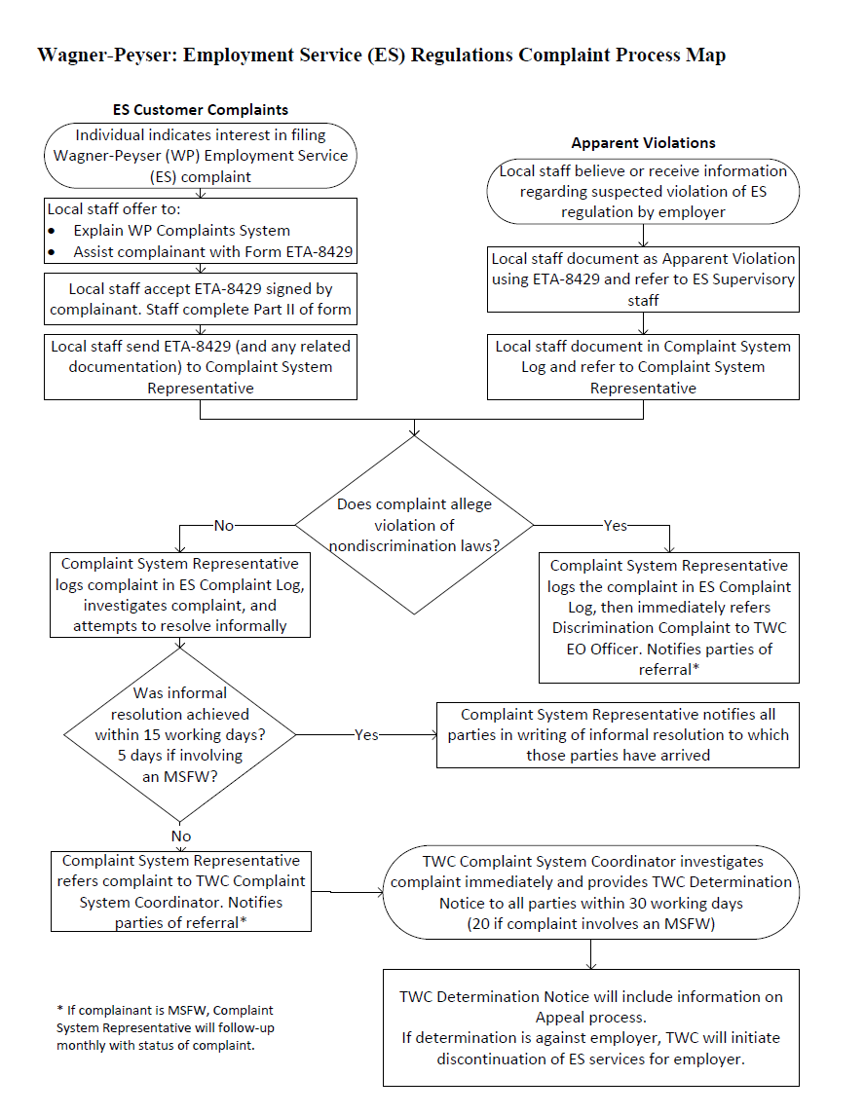
Wagner-Peyser: Employment-Related Law Complaint Process Map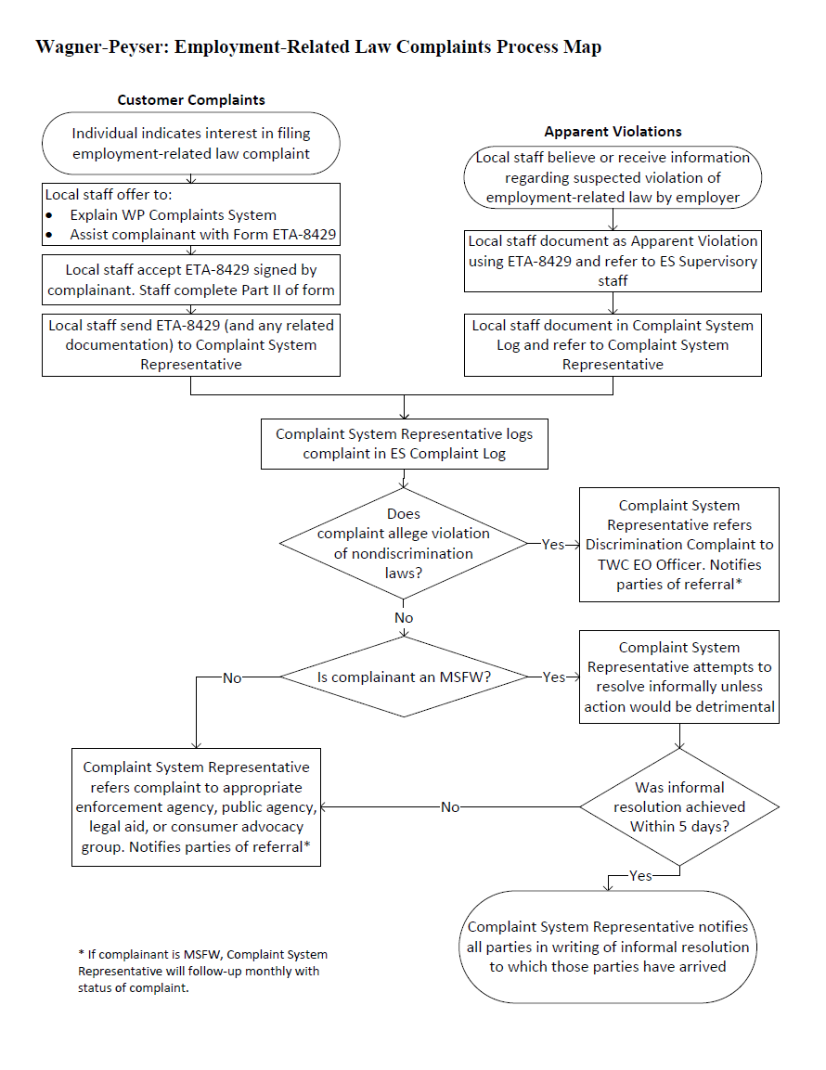

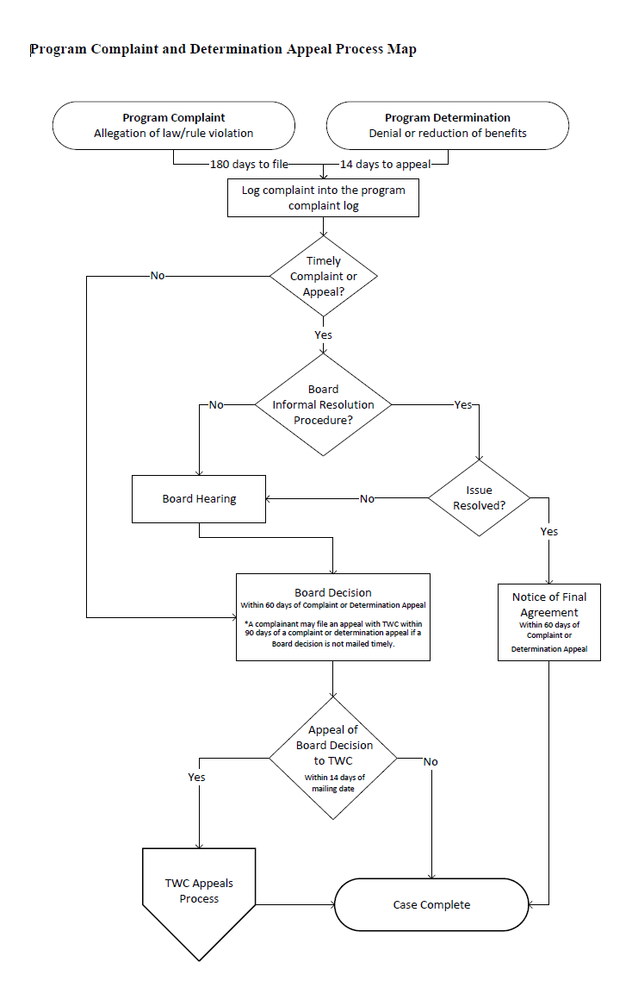
Program Complaint and Determination Appeal Process Map

