Child Care Quality Expenditure & Activity Report Desk Aid



Revised: October 2025
Texas Workforce Commission | Child Care & Early Learning Division

Child Care Quality Expenditure and Activity Report Overview
The Child Care Quality Expenditure and Activity Report (CCQ Report) has four main components. This desk aid will walk staff through the completion of each component and provide some tips on how to ensure each Local Workforce Development Board (Board) is accurately reporting the activities and/or initiatives completed for the fiscal year with its Board Contract Year funding.
Below is a graphic model of the four components and how this process is cyclical each fiscal year.

Select the following topics to access the component or specific tab within the CCQ Report for more information and tips:
- Instructions and Due Dates
- Examples and Definitions
- Texas Rising Star Staffing
- Annual Expenditure Plan
- Quarterly Data
- Quarterly Narrative
- End of Year Report
A webinar reviewing the CCQ Report is available for additional support and is accessible on the Texas Workforce Commission (TWC) YouTube channel. This webinar will be updated to include the new report template.

Instructions Tab
In the Instructions tab, each Board is to select its Board name from the drop-down menu and place the correct fiscal year within the Annual Steps section. By doing this, the information will auto populate into applicable tabs.
Staff members who complete this report (as well as those who provide the data for this report) should read through the Instructions tab prior to completing each tab or report.
Below is a snapshot of a section of the Instructions tab.
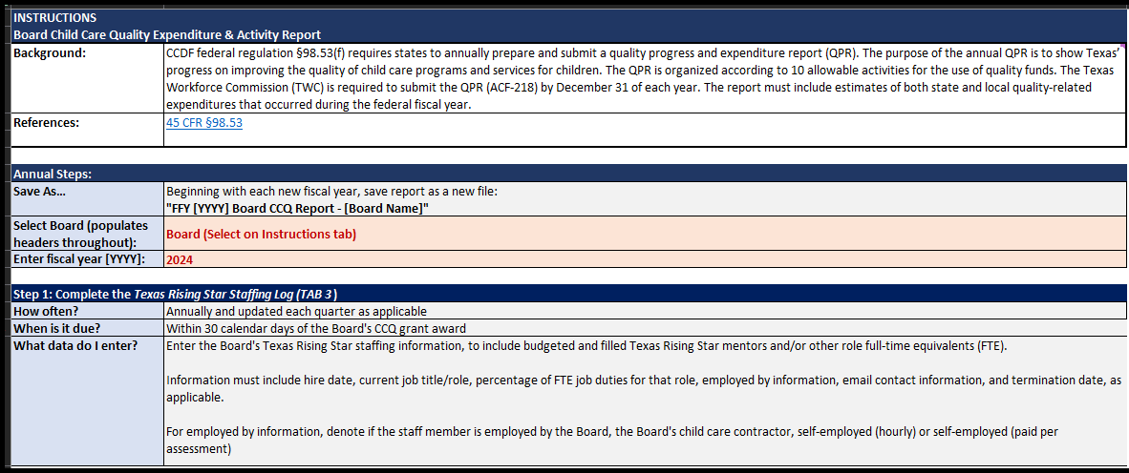

Due Dates
Annual Expenditure Plan | Within 30 days of the grant
Texas Rising Star Staffing | Within 30 days of the grant, then with every quarter, as applicable
Quarterly Data and Narrative | Within 30 days of the end of the quarter. Quarterly report due dates are as follows:  - Quarter 1—January 30  - Quarter 2—April 30  - Quarter 3—July 30  - Quarter 4—October 30
End of Year Report | Within 60 days of the end of the quarter

Errors and Revisions
If a Board realizes that there is an error in what was already submitted to TWC, or that Board would like to revise its Annual Expenditure Plan, it must do the following:
- For errors: Within the email that is sent to submit the quarter’s report, indicate which line was modified for which tab and quarter. Place those revisions in RED TEXT.
- For revisions to the plan: Within the email that is sent to submit the quarter’s report, indicate which line was modified for what category. Strikethrough any activity that was not conducted with a brief explanation why and/or what will replace it and place new activities and revisions in RED TEXT. In the narrative, Boards must denote the quarter the update was made in, why the update was made, and if funding was moved how much and to what activity (for example, Update Q2: Board was unable to execute this activity due to low interest. $30,000 from this activity was moved to the Materials and Equipment activity in the Texas Rising Star category). Changes in funding only need to be formally reported when the difference is more than 10 percent of the funding amount.
- For revisions in the Cash Draw and Expenditure Reporting (CDER) system: If TWC identifies an error in the Quarterly Narrative tab regarding an activity placement, the Board must ensure that all funding placed in CDER is adjusted accordingly.

Examples and Definitions Tab
In the Examples and Definitions tab, definitions and examples of activities and measurable outcomes are given for each of the following Child Care and Development Fund categories within the CCQ Report:
- Infant & Toddler (Including Professional Development)
- Professional Development
- Texas Rising Star/Quality Improvement
- Supporting Health & Safety Standards
- Evaluation & Assessment
- Supporting National Accreditation
- Other Activities (Shared Services, Prekindergarten [Pre-K] Partnership Supports, and Other Supports to Child Care Providers)
Staff members who complete this report (as well as those who provide the data for this report) are encouraged to read through the Examples and Definitions tab prior to completing each tab and report.
Below is a snapshot of a section of the Examples and Definitions tab.
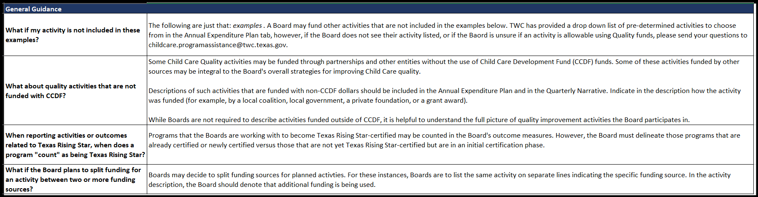

Texas Rising Star Staff Tab
In the Texas Rising Star Staff tab, each Board will enter its Texas Rising Star staffing information, including budgeted vacant and filled Texas Rising Star mentors and/or other full-time equivalents (FTEs).
For each employee, this information must include:
- hire date;
- current job title and/or role;
- percentage of FTE job duties for that role;
- “employed by” information;
- email contact information; and
- termination date, as applicable.
Staffing reported in this tab should also include the Board’s Texas Early Childhood Professional Development System (TECPDS) subject matter expert and/or the designated Infant Toddler Specialist(s). Boards must not indicate vacant positions within the main table, as this information is placed in the “Budgeted Vacant Positions” table.
The following are some quick tips for reporting the data needed on this tab:
- To determine staff’s FTE percentage, Boards indicate how much of the staff member’s time is spent doing the following duties:
  - Mentor—providing mentoring services to child care programs
  - Other—performing duties that do not fall under assessing or mentoring
Note: “Other” could include provider services, supervisory activities, or administrative tasks such as completing TWC- or Board-required reports.
(For example, if a staff member is dual role with an equal distribution of duties, Boards would input 0.5 for “Mentor FTE” and 0.5 for “Other FTE.” This will automatically convert the data to a percentage of 50 percent.)
- For “employed by” information, Boards denote if the staff member is employed by one of the following options:
  - The Board
  - The Board’s child care contractor
  - Self-employed (hourly)
  - Self-employed (paid per assessment)
- If a termination date is applicable, Boards do not remove the staff member’s information but instead zero out their FTE and input the termination date and/or last date of employment.
- In the “Budgeted Vacant Positions” table, Boards indicate the percentage of FTE that is vacant for each role (for example, if a Board is hiring a dual role employee with an equal distribution of duties, input 0.5 for “Mentor FTE” and 0.5 for “Other FTE”).
Boards update this tab each quarter as needed to indicate the staffing as of the date the report is submitted (not the quarter time frame). When submitting the end-of-quarter report, Boards indicate in their emails if the Texas Rising Star Staff tab has been updated.
Below is a snapshot of the Texas Rising Star Staff tab in its entirety.
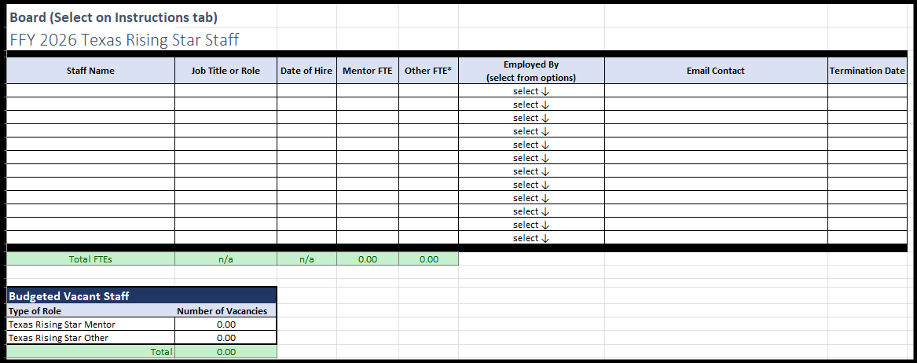

Annual Expenditure Plan Tab
In the Annual Expenditure Plan tab, Boards will report the overall narrative for each activity, including the type of funding to be used, estimated planned expenditures, the quarter the activity will begin, and measurable outcomes and estimated reach, within each applicable allowable category for the following:
  - Infant & Toddler (Including Professional Development)
  - Professional Development
  - Texas Rising Star/Quality Improvement (Except Professional Development; Including Texas Rising Star Personnel)
  - Supporting Health & Safety Standards (Except Professional Development)
  - Evaluation & Assessment (Tools to Measure Effective Practice or Child Development/Progress)
  - Supporting National Accreditation
  - Other Activities (Shared Services, Pre-K Partnership Supports, Supports for Child Care Providers in Response to COVID-19)
At the top of this report, the Board’s total funding allotment will be auto populated into the applicable field for Board reference. This will only auto populate when the Board selects their name within the Instructions tab.
Boards will input the total number of CCS Child Care Programs currently being served and select who administers the CCQ funds (the Board, the Board’s contractor, or both) from the drop-down menu. If a Board’s response is “both,” the Board will describe in the applicable field how it coordinates the implementation of funds with its contractor.
Boards must complete a narrative of their yearly plan. This narrative must include how the needs were assessed or determined, how success will be measured for the plan, and how the plan aligns with each Board’s Strategic Plan.
Below is a snapshot of the top section of the Annual Expenditure Plan tab.
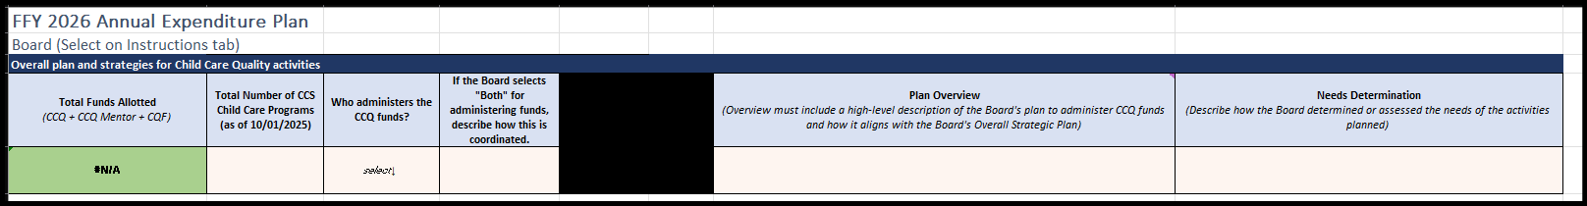
Within the next section of the Plan, Boards will input each of the activities they plan to implement. For each activity, the Board will select from the drop-down menu the applicable Activity Category the activity falls under. Boards will:
- select from the drop-down menu the activity type/name;
- indicate the estimated planned expenditures amount;
- select the type of funding that will be used for the activity (such as CCQ, CQF, or other);
Note: Should the Board decide to split funding sources for a planned activity, the Board must list the same activity on separate lines indicating each of the specific funding sources and the funding allocated. In the activity description, the Board should denote that additional funding is being used.
- indicate the quarter the Board anticipates the activity to begin;
- provide a detailed, yet succinct, description of the activity to be implemented, how it aligns to the Board’s Strategic Plan, and the activity’s target outreach (the goal for participants served); and
- describe how the Board will measure success and/or what outcome is expected as a result of the activity.
Note: The Board will refer to the measurable outcomes when completing the End of the Year Report.
Below is a snapshot of this section of the Annual Expenditure Plan tab.
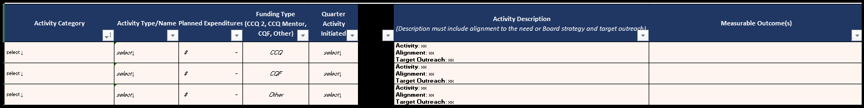

Quarterly Data Tab
In the Quarterly Data tab, Boards will verify the data related to the activities and/or initiatives implemented within the applicable quarter. Quarters are organized in columns with an auto calculated year-to-date (YTD) total. The data will be auto populated based on the Board’s Quarterly Narrative report. The Board will not make any edits or changes to this tab.
Because the CCQ Report is cumulative, all quarters must be entered within the same report when submitting it quarterly. This eliminates the need for a separate end-of-year report, as the data will be used to inform the Board in completing the End of Year tab.
All data reported on this tab has been pulled from the Quarterly Narrative tab. Therefore, if there is an error or issue, the Board will need to review the Quarterly Narrative tab for revisions.
Below is a snapshot of a section of the Quarterly Data tab.
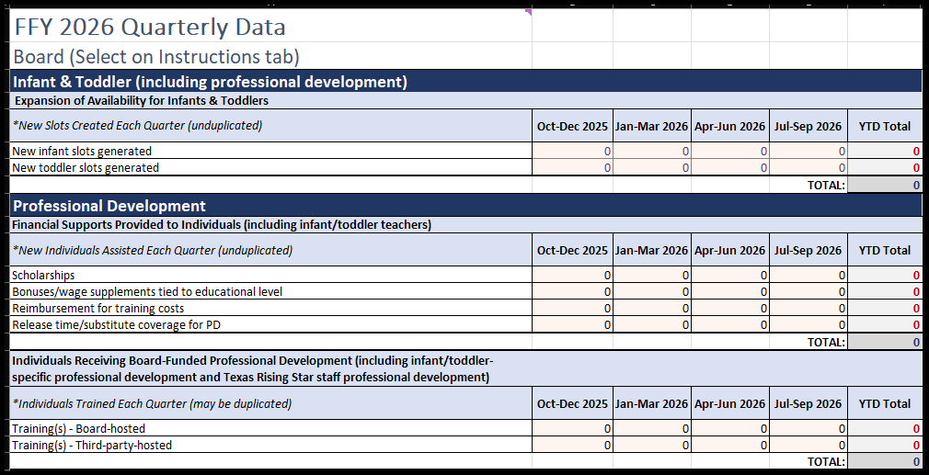

Quarterly Narrative Tab
All numbers documented in the Quarterly Narrative tab will be automatically reported in the Quarterly Data tab. The Quarterly Data tab serves as a check and balance against what has been reported in the Quarterly Narrative tab. The Board will review the Quarterly Data tab to confirm that the data reported for the quarter is accurate.
Within each correlating tab for the quarter being reported, each activity noted within the Annual Expenditure Plan tab for that quarter (or prior quarters) will be auto populated for the Board to provide an update.
Boards will report all activities implemented by doing the following:
- Use the drop-down menu to indicate the project’s status at the time of reporting. This helps TWC understand that an activity may roll over into another quarter but have new participants or has yet to begin despite the original plan.
- Provide details in the Project Update column about what or how the project was implemented in the quarter. Details should include additional information from the Activity Description column to support the implementation explanation.
- Indicate the number of participants. Numeric values are required, as the description of the activity will indicate if the participants are individuals, staff members, parents, or child care programs. If the number is unknown or not applicable, Boards must denote N/A. This numerical data will be used to complete the Quarterly Data tab.
Below is a snapshot of the Quarterly Narrative tab for one quarter.
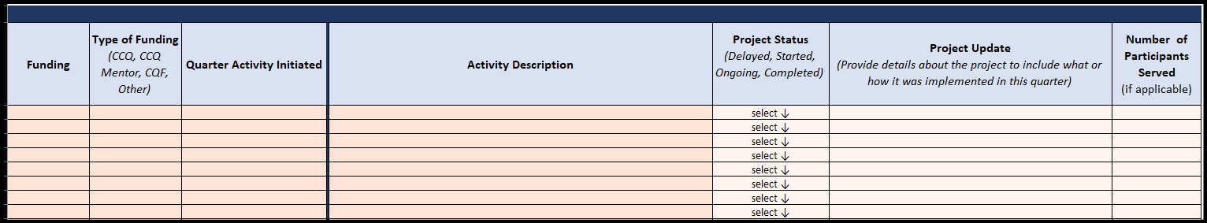
Activity Narrative Reminders:

Infant & Toddler (Including Professional Development)
When reporting the expansion of Texas Rising Star availability for infants and toddlers, it must only include new (not previously available) slots that were added during the quarter within Texas Rising Star programs (Entry Level or certified). Note: “Infant” is considered 0–17 months of age, while “Toddler” is considered 18–35 months of age.

Professional Development
When reporting Professional Development, Boards must consider the following:
- Excluding a Board’s Texas Rising Star staff, the number of unduplicated financial supports provided to individuals must include:
- the number of scholarships awarded to individuals to support attainment of higher education such as a Child Development Associate credential, an associate’s degree, or a bachelor’s degree;
Note: This can include apprenticeship scholarships.
- the number of bonuses or wage supplements tied to education achieved awarded to individuals;
- the number of individuals who received a reimbursement for training costs (this is strictly for those who were reimbursed); and
- the number of individuals who received paid release time or substitute coverage to support the attainment of higher education or participation in professional development.
Note: Financial supports provided to individuals receiving specific infant and toddler professional development and health and safety professional development (as described in the respective sections) are not to be reported within this category. Instead, Boards report these individuals in the Infant & Toddler category and the Health & Safety category, as applicable.
- The number of individuals receiving Board-funded professional development (excluding infant and toddler-specific professional development) includes:
  - the number of individuals who participated (either in person or virtually) in a Board-funded conference or training class/course; and
  - the number of individuals who participated in a conference hosted by a third party. (For example, if a conference was hosted by an entity other than a Board, but registration or fees for participants were funded by the Board, the participants who were reimbursed would be reported in the financial support type “reimbursement for training costs.”)

Note: Professional development provided to a Board’s Texas Rising Star staff is not reported in this category.

Texas Rising Star/Quality Improvement
When reporting Texas Rising Star/Quality Improvement, the Boards will indicate Texas Rising Star staff personnel activities, which may include staff professional development, travel, certifications, and job-role responsibilities (such as monthly mentoring supports).
- Budgeted Texas Rising Star Mentor FTEs represents the number of staff a Board plans to support, including vacant positions.
- Filled Texas Rising Star Mentor FTEs represents the number of staff the Board currently supports, not including vacant positions.

Supporting Health & Safety Standards
When reporting Supporting Health & Safety Standards, the Boards will indicate the number of unduplicated providers receiving health and safety supports, including:
- the number of new providers that received defibrillators (AED machines) and/or security systems, cameras, or coded entry systems;
- the number of individuals who attend CPR/First Aid classes; and
- the number of new providers that received other health and safety materials such as personal protective equipment, anti-choking devices, and other supports that are not considered professional development.

This section does not include reporting any other professional development (excluding First Aid and CPR, food handlers, or specific transportation training), as that is reported in the Professional Development section.

Evaluation & Assessment
When reporting Evaluation & Assessment supports, Boards will indicate which evaluation or assessment tool was purchased or used and indicate the number of new providers that were supported with this tool. The following tools are considered as formal evaluation or assessment tools:
      - Environmental Rating Scales (ERS), such as the Infant and Toddler ERS (ITERS), Early Childhood ERS (ECERS), or School-Age ERS (SCERS)
      - The Classroom Assessment Scoring System (CLASS)
      - Program Administration Scale (PAS) or Business Administration Scale (BAS)
      - Language Environment Analysis (LENA)
      - Teaching Strategies Gold (TS Gold)
      - Ages and Stages Questionnaire (ASQ)
      - Devereux Early Childhood Assessment (DECA)
This does not include reporting any professional development, as that is reported in the Professional Development section.

Supporting National Accreditation
When reporting Supporting National Accreditation, Boards will indicate the number of unduplicated providers assisted each quarter in pursuit or maintenance of National Accreditation. Within the narrative, the Boards must specify the number of center-based providers versus home-based providers.

This does not include reporting any professional development, as that is reported in the Professional Development section, or any membership fees to national organizations, as that is reported in the Texas Rising Star section.

Other Allowable Activities
When reporting Other Activities, Boards will indicate the following unduplicated data for each quarter:
- New formal partnerships (unduplicated), including:
  - the number of new formal partnerships developed in a Pre-K setting; and
  - the number of new formal partnerships developed in a Head Start (HS)/Early Head Start (EHS) setting.
- Shared Services, including the number of unduplicated providers supported with Shared Services
- Other supports, including:
  - the number of new unduplicated providers that received wage supplements for child care program staff;
  - the number of new unduplicated providers that received mental health supports; and
  - the number of new unduplicated providers that received stabilization or supply-building stipends.
This does not include reporting any professional development, as that is reported in the Professional Development section.

End of the Year Report (EOY)
Once per year, Boards will submit an End of the Year (EOY) report. The EOY Report will be due within 60 days of the end of the last quarter (November 30). The majority of this report will be auto populated based on the Board’s Annual Expenditure Plan tab. The Board will only be required to complete specified fields, documenting the measurable outcomes achieved, actual expenditures, and lessons learned for each activity.
Note: TWC is currently in the process of creating this report and will update the report template and this Desk Aid once this has been finalized.

Quantitative Data to Be Reported
The chart below provides a quick reference guide to what type of data should be reported in the number of participants field in the Quarterly Narrative tab, for the type of activity conducted.
Each Board may choose to capture additional data for the activity, such as number of classrooms supported or number of children impacted, and this data can be reported within the narrative portion of the activity description.
Activity Category | Quantitative Data Reported
Infant & Toddler | Slots generated: number of children  Professional development: number of individual participants  Equipment & materials: number of early learning programs served
Professional Development | number of individual participants
Texas Rising Star/Quality Improvement | Equipment & materials: number of early learning programs served
Health & Safety | First aid and/or CPR training: number of individual participants  Equipment & materials: number of early learning programs served
Evaluation & Assessment | Assessment tools purchased: number of early learning programs served  Classroom assessments conducted: number of early learning programs served
National Accreditation | number of early learning programs served
Other Activities  (Shared Services, Pre-K Partnership Supports) | New formal partnerships developed—Pre-K: number of individual partnerships developed  New formal partnerships developed—HS/EHS: number of individual partnerships developed  Wage supports for child care program staff: number of individuals awarded wage supports  Mental health supports: number of individual participants  Start-up funds for new programs: number of early learning programs served  Stabilization and/or supply-building stipends: number of programs awarded stipend  Shared Services: number of programs given supports with Shared Services

