Child Care Quality Expenditure & Activity Report Desk Aid



Revised: October 2026
Texas Workforce Commission | Child Care & Early Learning Division

Child Care Quality Expenditure and Activity Report Overview
The Child Care Quality Expenditure and Activity Report (CCQ Report) has four main components. This desk aid will walk staff through the completion of each component and provide some tips on how to ensure each Local Workforce Development Board (Board) accurately reports the activities and/or initiatives completed for the fiscal year with its Board Contract Year funding.
Below is a graphic model of the four components illustrating how this process is cyclical each fiscal year.

Select the following topics to access the component or specific tab within the CCQ Report for more information and tips:
- Instructions and Due Dates
- Examples and Definitions
- Texas Rising Star Staffing
- Annual Expenditure Plan
- Quarterly Data
- Quarterly Narrative
- End of Year Report

Instructions Tab
In the Instructions tab, each Board selects its Board name from the drop-down menu and places the correct fiscal year within the Annual Steps section. This ensures the information auto-populates into applicable tabs.
Staff members who complete this report (as well as those who provide the data for this report) should read through the Instructions tab before completing each tab or report.
Below is a snapshot of a section of the Instructions tab.
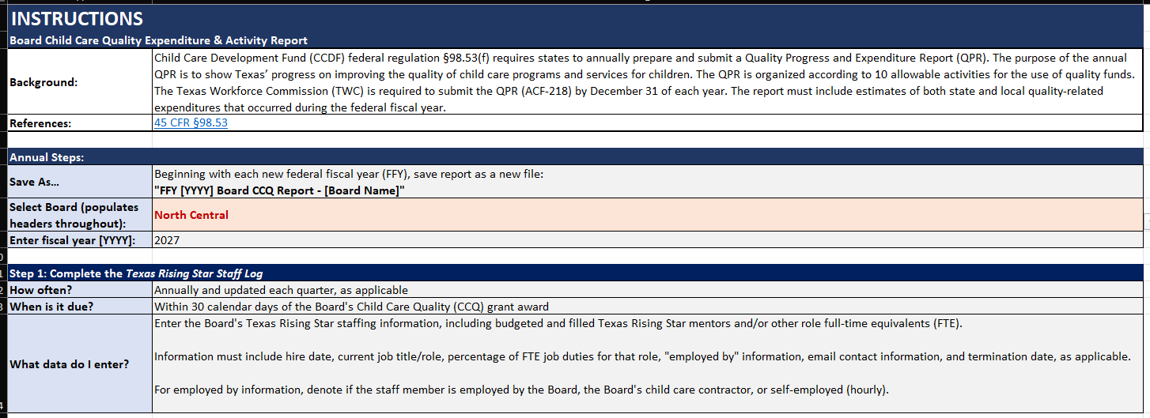

Due Dates
The Annual Expenditure Plan is due within 60 days of TWC’s three-member Commission (Commission) approving budget allocations. Texas Rising Star staffing reports are due within 60 days of the Commission’s budget allocation approval and within 30 days of each quarter’s end. Please refer to the due dates listed below.

Report | Quarter End Date | Due Date
Annual Expenditure Plan | NA | Within 60 days of TWC’s three-member Commission (Commission) approving budget allocations
Texas Rising Star Staffing | NA | Within 60 days of the Commission approving budget allocations, then update each quarter as applicable
Quarter 1 (Q1) Report | December 30 | January 30
Texas Rising Star Staffing | December 30 | January 30
Quarter 2 (Q2) Report | March 30 | April 30
Texas Rising Star Staffing | March 30 | April 30
Quarter 3 (Q3) Report | June 30 | July 30
Texas Rising Star Staffing | June 30 | July 30
Quarter 4 (Q4) Report | September 30 | October 30
Texas Rising Star Staffing | September 30 | October 30
End of Year Report | September 30 | Within 60 days of the end of the quarter

Errors and Revisions
If a Board needs to correct an error in what was submitted, or revise its Annual Expenditure Plan, it should use the following instructions:
- Reporting errors: When notifying TWC that the quarterly report is ready for review, indicate which tabs and lines were modified in the body of the email. Mark all revisions in RED TEXT within the spreadsheet.
- Revisions to the Annual Expenditure Plan: Within the body of the email notifying TWC the quarterly report is ready for review, indicate which categories and lines have been modified. Within the spreadsheet, use RED TEXT for all new activities or revisions. Strike through any activity that was not conducted with a brief explanation why it was canceled and/or what will replace it. Within the narrative, denote the quarter in which the update was made, the reason for the modification, and the specific amount of funding moved and to what activity as applicable. Example: Update Q2: Board was unable to execute this activity due to low interest. $30,000 from this activity was moved to the Materials and Equipment activity in the Texas Rising Star category. Changes in funding need to be reported only when the difference is more than 10 percent of the original funding amount.
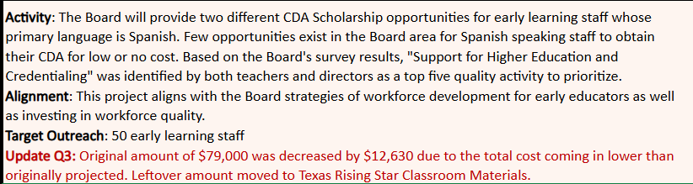
- Revisions in the Cash Draw and Expenditure Reporting (CDER) system: If TWC identifies a supplemental mismatch, the Board is responsible for ensuring that all funding entries in the CDER system are adjusted to align with reported expenditures.

Examples and Definitions Tab
In the Examples and Definitions tab, definitions and examples of activities and measurable outcomes are given for each of the following Child Care and Development Fund categories within the CCQ Report:
- Infant & Toddler (Including Professional Development)
- Professional Development
- Texas Rising Star/Quality Improvement
- Supporting Health & Safety Standards
- Evaluation & Assessment
- Supporting National Accreditation
- Other Activities (Shared Services, Prekindergarten [Pre-K] Partnership Supports, and Other Supports to Child Care Providers)
Staff members who complete this report (as well as those who provide the data for this report) are encouraged to read through the Examples and Definitions tab before completing each tab and report.
Below is a snapshot of a section of the Examples and Definitions tab.

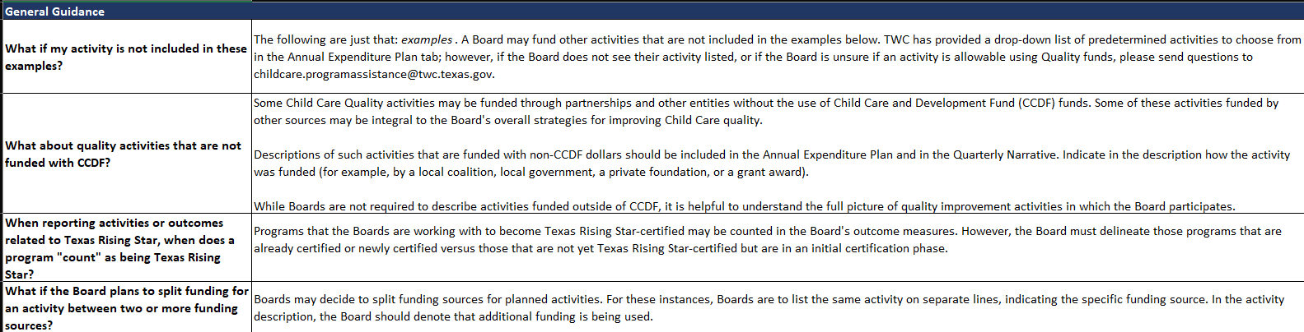

Texas Rising Star Staff Tab
In the Texas Rising Star Staff tab, each Board will enter its Texas Rising Star staffing information for each employee, including information for budgeted, vacant, and filled Texas Rising Star mentors and/or other full-time equivalents (FTEs).
Information for each employee must include:
- the employee’s hire date;
- the current job title or role;
- the percentage of FTE job duties for that role;
- “employed by” information;
- the employee’s email contact information; and
- a termination date, as applicable.
Staffing reported in this tab should also include the Board’s Texas Early Childhood Professional Development System (TECPDS) Specialists and/or the designated Infant and Toddler Specialists. Boards must not indicate vacant positions within the main table, as this information is placed in the “Budgeted Vacant Positions” table.
The following are some quick tips for reporting the data needed on this tab:
- To determine staff’s FTE percentage, Boards indicate how much of the staff member’s time is spent doing the following duties:
  - Mentor—providing mentoring services to child care programs
  - Other—performing duties that do not fall under mentoring
Note: “Other” could include provider services, supervisory activities, Infant and Toddler Specialists, TECPDS Specialists, or administrative tasks such as completing TWC- or Board-required reports. (For example, if a staff member is dual-role with an equal distribution of duties, Boards would input 0.5 for “Mentor FTE” and 0.5 for “Other FTE.” This will automatically convert the data to 50 percent.)
- For “employed by” information, Boards denote if the staff member is employed by one of the following options:
  - The Board
  - The Board’s child care contractor
  - Self-employed (hourly)
  - Self-employed (paid per assessment)
- If a termination date is applicable, Boards do not remove the staff member’s information but instead zero out their FTE and input the termination date and/or last date of employment.
- In the “Budgeted Vacant Positions” table, Boards indicate the percentage of FTE that is vacant for each role (for example, if a Board is hiring a dual-role employee with an equal distribution of duties, input 0.5 for “Mentor FTE” and 0.5 for “Other FTE”).
Boards update this tab quarterly as needed to indicate the staffing as of the date the report is submitted (not the quarter time frame). When submitting the end-of-quarter report, Boards indicate in their emails if the Texas Rising Star Staff tab has been updated.
Below is a snapshot of the Texas Rising Star Staff tab in its entirety.
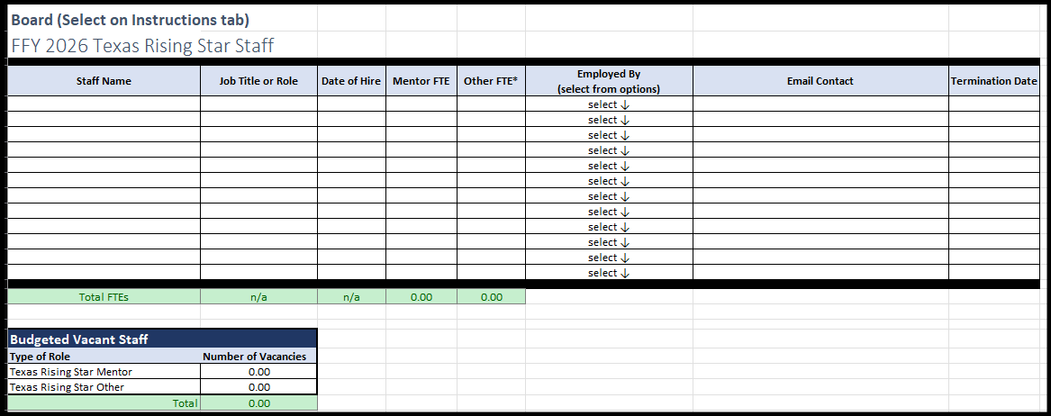

Annual Expenditure Plan Tab
In the Annual Expenditure Plan tab, Boards will report the overall narrative for each activity, including the type of funding to be used, estimated planned expenditures, the quarter the activity will begin, and measurable outcomes and estimated reach, within each applicable allowable category for the following:
  - Infant & Toddler (Including Professional Development)
  - Professional Development
  - Texas Rising Star/Quality Improvement (Except Professional Development; Including Texas Rising Star Personnel)
  - Supporting Health & Safety Standards (Except Professional Development)
  - Evaluation & Assessment (Tools to Measure Effective Practice or Child Development/Progress)
  - Supporting National Accreditation
  - Other Activities (Shared Services, Pre-K Partnership Supports, Wage Supplements, Mental Health Supports, and Stabilization/ Supply Building Stipends)
At the top of the Annual Expenditure Plan, the Board’s CQF Plan Status, funding year, total funding allotment, and total funding the Board has planned will auto-populate into the applicable fields for Board reference. This will only auto-populate when the Board selects their name within the Instructions tab.
Boards will input the total number of CCS Programs currently being served and select from the drop-down menu whether the Board, the Board contractor, or both will administer the CCQ funds. If a Board’s response is “both,” the Board will describe in the applicable field how it coordinates the implementation of funds with its contractor.
Boards must complete a narrative of their yearly plan. This narrative must include how the needs were assessed or determined, how success will be measured for the plan, and how the plan aligns with each Board’s Strategic Plan.
Below is a snapshot of the top section of the Annual Expenditure Plan tab.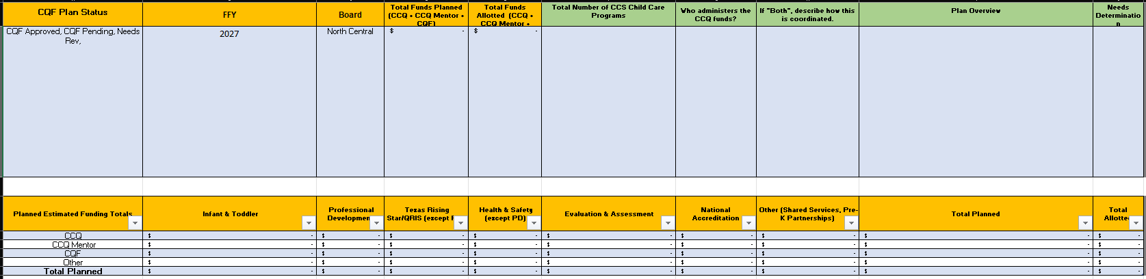
The next section of the Annual Expenditure Plan is the Planned Estimated Funding Totals, which will auto-populate for the Board’s reference.
Within the next section of the Annual Expenditure Plan, Boards will input each of the activities they plan to implement. For each activity, the Board will select from the drop-down menu the applicable Activity Category the activity falls under. Boards will:
- select from the drop-down menu the activity type/name;
- indicate the estimated planned expenditures amount;
- select the type of funding that will be used for the activity (such as CCQ, CQF, or other);
Note: Should the Board decide to split funding sources for a planned activity, the Board must list the same activity on separate lines indicating each of the specific funding sources and the funding allocated. The Board should denote in the Activity Description that additional funding is being used.
- indicate the quarter the Board expects the activity to begin;
- provide a detailed, yet succinct, description of the activity to be implemented;
- describe how the activity aligns with the Board’s Strategic Plan;
- specify the activity’s target outreach (the goal for participants served); and
- describe how the Board will measure success and/or what outcome is expected
Note: The Board will refer to the measurable outcomes when completing the End of Year Report.
Below is a snapshot of this section of the Annual Expenditure Plan tab.

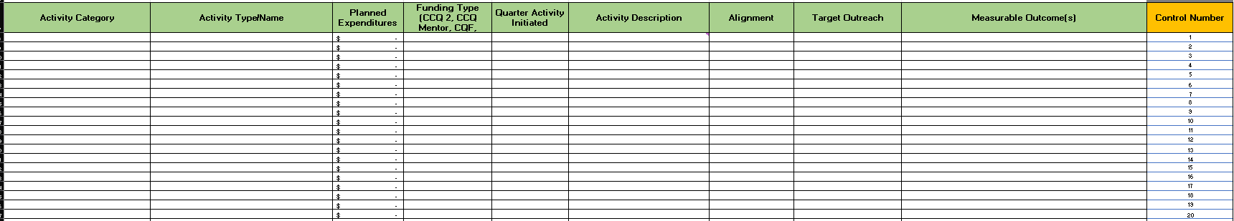

Quarterly Narrative Tabs
Within each correlating tab for the quarter being reported, each activity noted within the Annual Expenditure Plan tab for that quarter (or prior quarters) will be auto-populated for the Board to provide an update. The areas that auto-populate will have gold headings and the Board should not attempt to manipulate any data in these cells. If the Board needs to make a change to the Annual Expenditure Plan, this should be done in the Annual Expenditure Plan tab.
Boards must report all activities implemented by doing the following:
- Use the drop-down menu to indicate the project’s status at the time of reporting. This helps TWC understand that an activity may roll over into another quarter but have new participants or has yet to begin despite the original plan.
- Provide details in the Project Update column about what or how the project was implemented in the quarter. Details should include additional information from the Activity Description column to support the implementation explanation.
- Indicate the number of participants. Numeric values are required, as the description of the activity will indicate if the participants are individuals, staff members, parents, or child care programs. If the number is unknown or not applicable, Boards must denote N/A. This numerical data will be used to complete the Quarterly Data tab.
Below is a snapshot of the Quarterly Narrative tab for one quarter.
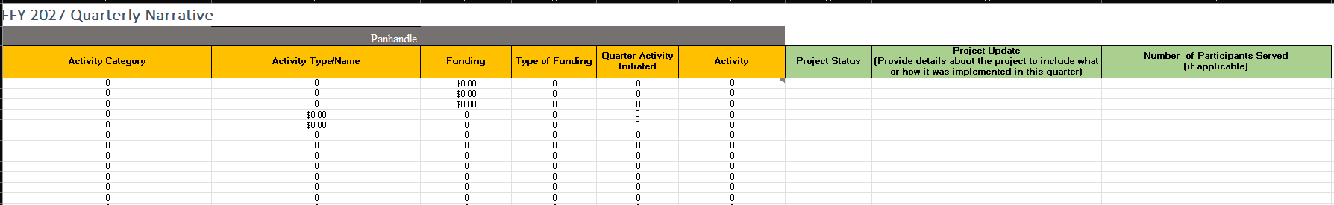

Activity Narrative Reminders

Infant & Toddler (Including Professional Development)
When reporting the expansion of Texas Rising Star availability for infants and toddlers, it must only include new (not previously available) slots that were added during the quarter within programs.
Note: “Infant” is defined as 0–17 months of age, and “Toddler” is defined as 18–35 months of age.

Professional Development
When reporting Professional Development, Boards must consider the following:
- Excluding a Board’s Texas Rising Star staff, the number of unduplicated financial supports provided to individuals must include:
- the number of scholarships awarded to individuals to support attainment of higher education such as a Child Development Associate credential, an associate’s degree, or a bachelor’s degree;
Note: This can include apprenticeship scholarships.
- the number of bonuses or wage supplements tied to education achieved awarded to individuals;
- the number of individuals who received reimbursement for training costs (this is strictly for those who were reimbursed); and
- the number of individuals who received paid release time or substitute coverage to support the attainment of higher education or participation in professional development.
Note: Financial supports provided to individuals receiving specific infant and toddler professional development and health and safety professional development (as described in the respective sections) are not to be reported within this category. Instead, Boards report these individuals in the Infant & Toddler category and the Health & Safety category, as applicable.
- The number of individuals receiving Board-funded professional development (excluding infant- and toddler-specific professional development) includes:
  - the number of individuals who participated (either in person or virtually) in a Board-funded conference or training class/course; and
  - the number of individuals who participated in a conference hosted by a third party. (For example, if a conference was hosted by an entity other than a Board, but registration or fees for participants were funded by the Board, the participants who were reimbursed would be reported in the financial support type “reimbursement for training costs.”)
Note: Professional development provided to a Board’s Texas Rising Star staff is not reported in this category.

Texas Rising Star/Quality Improvement
When reporting Texas Rising Star/Quality Improvement, the Boards will indicate Texas Rising Star staff personnel activities, which may include staff professional development, travel, certifications, and job-role responsibilities (such as monthly mentoring supports).
- Budgeted Texas Rising Star Mentor FTEs represents the number of staff a Board plans to support, including vacant positions.
- Filled Texas Rising Star Mentor FTEs represents the number of staff the Board currently supports, not including vacant positions.

Supporting Health & Safety Standards
When reporting Supporting Health & Safety Standards, the Boards will indicate the unduplicated number of providers receiving health and safety supports, including:
- the number of new providers that received automated external defibrillators (AEDs) and/or security systems, cameras, or coded entry systems;
- the number of programs that attend CPR/First Aid classes;
- the number of new providers that received other health and safety materials such as personal protective equipment, anti-choking devices, and other supports that are not considered professional development; and
- the number of new programs that received other materials excluding personal protective equipment.
This section does not include reporting any other professional development (excluding First Aid and CPR, food handlers, or specific transportation training), as that is reported in the Professional Development section.

Evaluation & Assessment
When reporting Evaluation & Assessment supports, Boards will indicate which evaluation or assessment tool was purchased or used and indicate the number of new providers that were supported with this tool. The following tools are considered as formal evaluation or assessment tools:
      - Environment Rating Scales (ERS), such as the Infant and Toddler ERS (ITERS), Early Childhood ERS (ECERS), or School-Age ERS (SCERS)
      - The Classroom Assessment Scoring System (CLASS)
      - Program Administration Scale (PAS) or Business Administration Scale (BAS)
      - Language Environment Analysis (LENA)
      - Teaching Strategies Gold (TS Gold)
      - Ages and Stages Questionnaire (ASQ)
      - Devereux Early Childhood Assessment (DECA)
This does not include reporting any professional development, as that is reported in the Professional Development section.

Supporting National Accreditation
When reporting Supporting National Accreditation, Boards will indicate the number of unduplicated providers assisted each quarter in pursuit or maintenance of National Accreditation. Within the narrative, the Boards must specify the number of center-based providers versus home-based providers.
This does not include reporting any professional development, as that is reported in the Professional Development section, or any membership fees to national organizations, as that is reported in the Texas Rising Star section.

Other Allowable Activities
When reporting Other Activities, Boards will indicate the following unduplicated data for each quarter:
- New formal pre-K partnerships (unduplicated), including:
  - the number of new formal partnerships developed in a child care setting; and
  - the number of new formal partnerships developed in a Head Start (HS)/Early Head Start (EHS) setting.
- Shared Services, including the number of unduplicated providers supported with Shared Services
- Other supports, including:
  - the number of new unduplicated providers that received wage supplements for child care program staff;
  - the number of new unduplicated providers that received mental health supports; and
  - the number of new unduplicated providers that received stabilization or supply-building stipends.
This does not include reporting any professional development, as that is reported in the Professional Development section.

End of Year Report
Once per year, Boards will submit an End of Year (EOY) Report. The EOY Report is due within 60 days of the end of the last quarter. Most of this report will be auto-populated based on the Board’s Annual Expenditure Plan tab. The Board will only be required to complete the following:
- Measurable Outcomes—Boards will select if the measurable outcome set by the Board in the Annual Expenditure Plan was Met, Not Met, or Partially Met.
- Will the Board Repeat Next Year?—The Board will select from the drop-down menu if they plan to continue the activity for the next fiscal year.
- Additional Information—The Board will denote any information that may be helpful for themselves or other Boards if trying to replicate the activity.

Quantitative Data to Be Reported
The chart below provides a quick reference guide to what type of data should be reported in the number of participants field in the Quarterly Narrative tab, for the type of activity conducted.
Each Board may choose to capture additional data for the activity, such as number of classrooms supported or number of children impacted, and this data can be reported within the narrative portion of the activity description.
Activity Category | Quantitative Data Reported
Infant & Toddler | Slots generated: number of children  Professional development: number of individual participants  Equipment & materials: number of early learning programs served
Professional Development | number of individual participants
Texas Rising Star/Quality Improvement | Equipment & materials: number of early learning programs served
Health & Safety | First aid and/or CPR training: number programs  Equipment & materials: number of early learning programs served
Evaluation & Assessment | Assessment tools purchased: number of early learning programs served  Classroom assessments conducted: number of early learning programs served
National Accreditation | number of early learning programs served
Other Activities  (Shared Services, Pre-K Partnership Supports) | New formal partnerships developed—Pre-K: number of individual partnerships developed  New formal partnerships developed—HS/EHS: number of individual partnerships developed  Wage supports for child care program staff: number of individuals awarded wage supports  Mental health supports: number of individual participants  Start-up funds for new programs: number of early learning programs served  Stabilization and/or supply-building stipends: number of programs awarded stipend  Shared Services: number of programs given supports with Shared Services

