Child Care Quality Expenditure & Activity Report Desk Aid



Revised March 2023

Texas Workforce Commission | Child Care & Early Learning Division

# Child Care Quality Expenditure and Activity Report Overview

The Child Care Quality (CCQ) Expenditure and Activity Report has five main components. This desk aid guides staff members through the process of completing each component and provides tips on how to ensure that the Local Workforce Development Boards (Boards) accurately report the activities and initiatives completed for the fiscal year with their Board Contract Year funding.

Below is a graphic model of the five components that make up this cyclical process each fiscal year.

For more information and tips, select the following links to access the component or specific tab within the CCQ Report:

* Instructions and Due Dates
* Examples and Definitions
* Texas Rising Star Staffing
* Annual Expenditure Plan
* Quarterly Data
* Quarterly Narrative
* Year-to-Date Summary

# Instructions Tab

In the Instructions tab, the Board selects its Board name from the drop-down menu and enters the correct fiscal year in the Annual Steps section. The information will auto-populate in every applicable field.

Any staff member completing this report, as well as those who provide the data for this report, must read the information on the Instructions tab before completing each tab/report.

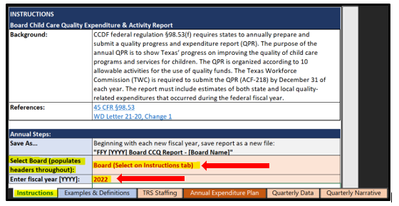

## Due Dates

|  |  |
| --- | --- |
| **Annual Expenditure Plan** | Within 30 days of the grant |
| **Texas Rising Star Staffing** | Within 30 days of the grant, then with every quarter, as applicable |
| **Quarterly Data and Narrative** | Within 30 days of the end of the quarter Quarter 1 = January 30  Quarter 2 = April 30  Quarter 3 = July 30  Quarter 4 = October 30 |
| **Year-to-Date (End-of-Year Summary)** | None—This is completed when the Quarter 4 Report is submitted. |

## Errors and Revisions

If a Board realizes that there has been an error in what has already been reported to TWC, or if a Board would like to revise its Expenditure Plan, the Board must do the following:

* Errors: In the email that is sent to submit the quarter’s report, indicate which line was modified for which tab/quarter. Insert revisions in **red text**.
* Revisions to the Plan: In the email that is sent to submit the quarter’s report, indicate which line was modified for which category. Strike through any activity that was not conducted with a brief explanation why and/or what will replace it, and insert the new activities and/or revisions in **red text**.

# Publication of Board CCQ Plans and Reports

In January of each year, the Board’s Annual CCQ Expenditure Plan is published on the [TWC website](https://twc.texas.gov/programs/child-care) and updated as the quarterly CCQ reports are received. If a Board needs to revise its Expenditure Plan or update its most recent quarterly report, it must follow the guidance provided in the Errors and Revisions section and resubmit the report to [BCM@twc.texas.gov](mailto:BCM@twc.texas.gov).

# Examples & Definitions Tab

In the Examples & Definitions tab, definitions and examples of activities and measurable outcomes are given for each of the following Child Care Development Fund categories in the CCQ Expenditure and Activity Report:

* Infant & Toddler (including Professional Development)
* Professional Development
* Texas Rising Star/Quality Improvement
* Supporting Health & Safety Standards
* Evaluation & Assessment
* Supporting National Accreditation
* Other Activities (Shared Services, Pre-K Partnership Supports, Support to Child Care Providers in Response to the Impacts of COVID-19)

Any staff member completing this report, as well as those who provide the data for this report, should read the Examples & Definititions tab before completing each tab/report.

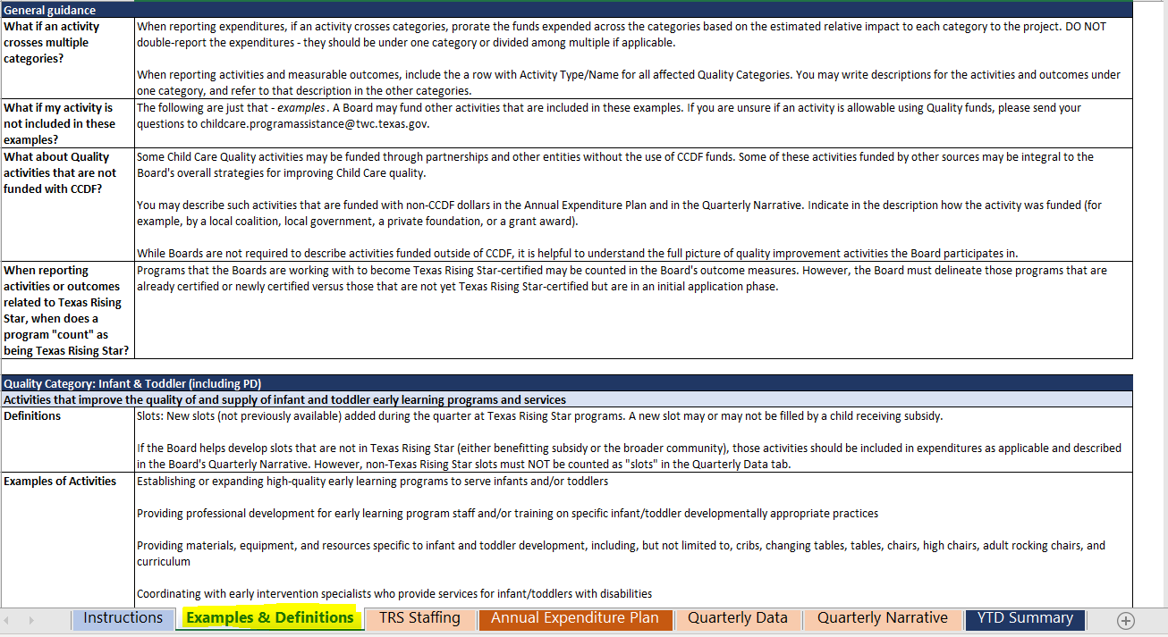

# TRS Staffing Tab

In the TRS Staffing tab, the Board will enter its Texas Rising Star staffing information to include budgeted, vacant, and employed Texas Rising Star mentors, assessors, and/or other full-time equivalents (FTEs).

Information must include hire date, current job title/role, percentage of FTE job duties for that role, employer information, the employer’s email contact information, and termination date, as applicable. Do not indicate vacant positions in the main table, as this information is entered in the Budgeted Vacant Positions table.

The following is a list of quick tips for reporting the data required on this tab:

* To determine a staff member’s FTE percentage, indicate how much of the staff member’s time is spent performing the following duties:
  + Mentor: Providing mentoring services to child care programs
  + Assessor: Conducting assessments of child care programs
  + Other: Performing duties that are not mentor or assessor duties, including:
    - provider services; and
    - supervisory or administrative duties (such as completing TWC- and/or Board-required reports)

Example: If a staff member is in a dual-role position, with equal distribution of duties, enter 0.5 for mentor FTE and 0.5 for assessor FTE. It will automatically convert to a percentage of 50 percent.

* For Employed By information, denote whether the staff member is:
  + employed by the Board;
  + employed by the Board’s child care contractor;
  + self-employed (hourly); or
  + self-employed (paid per assessment).
* For the termination date, do not remove the staff member’s information but instead zero out the FTE and enter the termination date (last date) of employment.
* For budgeted vacant staff, indicate the percentage of FTE that is vacant for each role. (For example: If you are hiring an individual in a dual-role position with equal distribution, enter 0.5 for mentor and 0.5 for assessor.)

Update this tab each quarter as needed. When submitting the end-of-quarter report, indicate in the email whether the TRS Staffing tab has been updated.

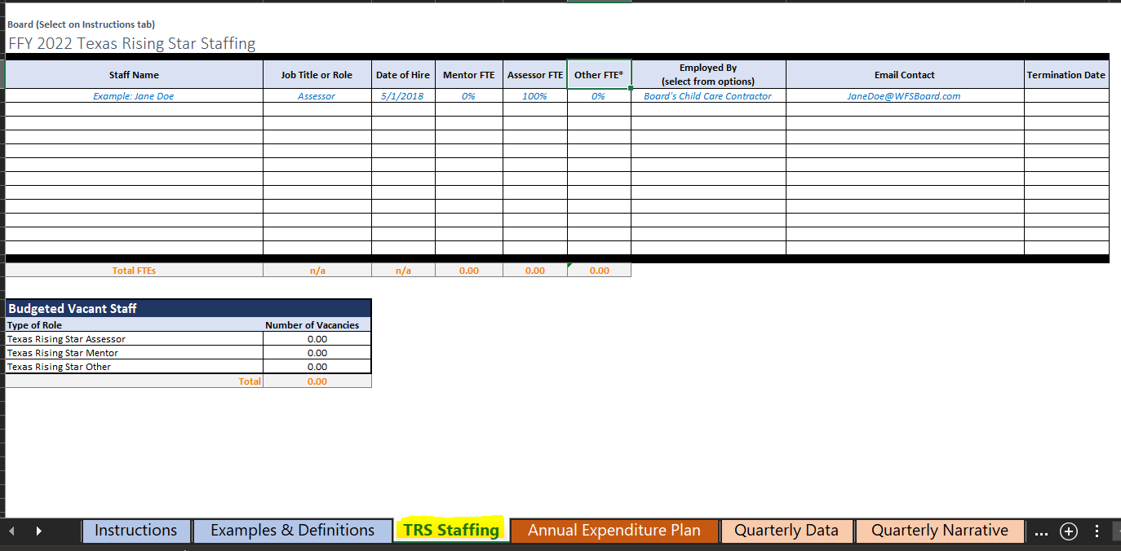

# Annual Expenditure Plan

In the Annual Expenditure Plan tab, the Board will report the overall narrative and each activity, including planned expenditures (CCQ 4 percent plus funding for Texas Rising Star staff), measurable outcomes, and estimated reach (goal of participants served), in one of the following applicable allowable categories:

* 1. Infant & Toddler (including professional development)
  2. Professional Development
  3. Texas Rising Star/Quality Improvement (except professional development, including Texas Rising Star personnel)
  4. Supporting Health & Safety Standards (except professional development)
  5. Evaluation & Assessment (tools to measure effective practice or child development/progress)
  6. Supporting National Accreditation
  7. Other Activities (Shared Services, Pre-K Partnership Supports, Supports to Child Care Providers in Response to COVID-19)

At the beginning of the report, Boards must include an overall narrative of their year’s plan. This narrative must explain how the needs were assessed or determined, how success will be measured for the plan as a whole, and how this plan aligns with the Board’s Strategic Plan.

In addition to outlining the budget for each category, Boards will also describe each activity or project planned for its applicable category. Please include the activity type/name along with a detailed yet succinct description and its estimated reach (goal of participants served). Please note that the percentage of the total Planned Expenditures for each category will auto-calculate and must **not** be manually entered. Boards may split activities expenditures across categories but must ensure that they do not double-report these activities.

At the end of the Annual Expenditure Plan tab, the Total Planned amount will auto-calculate. This amount must match the total amount the Board has planned to expend for the entire fiscal year.

The following is a list of quick tips for reporting the data required on this tab:

* In the Texas Rising Star/Quality Improvement category, Boards must include Texas Rising Star staff funding and costs, including salaries, fringe benefits, and supporting costs (that is, the Board’s additional staffing funding).
* All activities must have an estimated reach and measurable outcome or goal described.

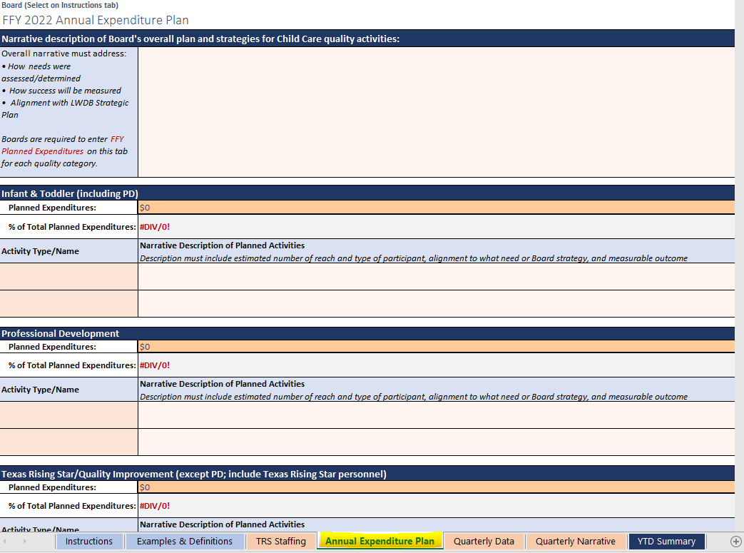

# Quarterly Data Tab

In the Quarterly Data tab, Boards will enter expenditures and data related to the activities and/or initiatives that they implemented in the applicable quarter. Imagine a vertical line creating two sides in the Quarterly Data Tab (as indicated by the red arrow in the screenshot below). The left side reports money expended, and the right side reports participants (individuals and/or providers) assisted in each quarter.

The following is a list of quick tips for reporting the data required on this tab:

* Reporting by quarter:
  + Left side: Quarters are organized row by row with an auto-calculated total.
  + Right side: Quarters are organized within columns and include an auto-calculated year-to-date (YTD) total.
* Reporting by funding and fiscal year:
  + The first two columns provide data from the previous fiscal year. Sometimes, TWC will allow Boards to carry over unspent funds, whether they are CCQ or Child Care Certified Match (CCM).
  + The next two columns provide data for the current fiscal year’s CCQ and CCM funds.
  + Enter the total amount that was spent for each category for that specific funding “bucket”

Note: Although Boards may split expenditures across categories, they must not double-report any expenditure that covers multiple categories.

Boards may refer to the following sections for each category’s specific reporting tips.

Because the CCQ report is cumulative, all quarters must be entered in the **same** report when submitting it quarterly, thereby eliminating the need for an end-of-year (EOY) report.

All data reported on this tab must also be reported in the Quarterly Narrative tab. Please note that all data regarding individuals or programs reported must be identical in both tabs.

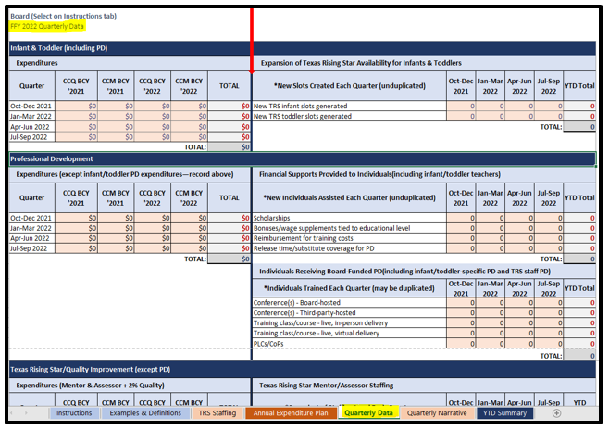

## Infant & Toddler (including Professional Development)

In the Infant & Toddler section of the Quarterly Data tab, Boards will report the following:

* Expenditures:
  + These are funds expended each quarter specifically on infant and toddler initiatives.
  + This includes all activities specific to infants and toddlers, such as specific professional development, materials and equipment, and expansion grants. For additional allowable expenditures, refer to the CCQ Strategic Planning and Expenditures Guide.
  + Be sure to denote which funding “bucket” expenditures came from (CCQ or CCM) and which year (previous or current).
  + Totals will auto-generate in the Total column.
* Expansion of Texas Rising Star Availability for Infants & Toddlers:
  + These are new slots (not previously available) that were added during the quarter within Texas Rising Star programs
  + Infant is 0–17 months, and Toddler is 18–35 months.
  + Totals will auto-generate in the YTD Total column.

All data reported in this section must also be reported in the Quarterly Narrative tab. The numbers of individuals or programs reported in the Quarterly Narrative tab must match the numbers reported in the Quarterly Data tab.

Below is a snapshot of the Infant & Toddler section in its entirety.

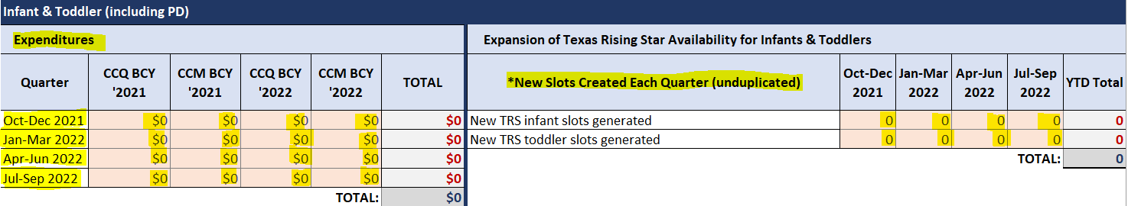

## Professional Development

In the Professional Development (PD) section of the Quarterly Data tab, Boards will report the following:

* Expenditures:
  + These are funds expended each quarter on professional development activities/initiatives. For examples of allowable expenditures, refer to the CCQ Strategic Planning and Expenditures Guide.
  + This does **not** include any PD specific to infants and toddlers (as reported in the Infant & Toddler section) or specified Health and Safety PD (as reported in the Health & Safety section).
  + Be sure to denote which funding “bucket” expenditures are from CCQ or CCM and from which year (previous or current).
  + Totals will auto-generate within the Total column.
* Financial Supports Provided to Individuals (unduplicated for each type of support):
  + Boards report the number of **scholarships** awarded to individuals to support obtainment of higher education such as a CDA, an associate’s degree, or a bachelor’s degree. (This can include apprenticeship scholarships.)
  + Boards report the number of **bonuses or wage supplements** tied to education achieved awarded to individuals.
  + Boards report the number of individuals who received a **reimbursement for training costs.** (This is strictly for those who were reimbursed.)
  + Boards report the number of individuals who received **paid release time or substitute coverage** to support the obtainment of higher education or participation in PD.

Note: Financial supports provided to individuals receiving specific infant and toddler PD and Health & Safety PD (as described in the respective sections) must **not** be reported in this category. Please report these individuals in the Infant & Toddler category and the Health & Safety category, as applicable.

* Individuals receiving Board-funded PD, which does include infant- and toddler-specific PD as well as PD provided to the Board’s Texas Rising Star staff. Please note that the numbers reported below may contain duplicated individuals for each type:
  + The number of individuals who participated in a **Board-funded conference**
  + The number of individuals who participated in a **Conference hosted by a third party** (a conference that was hosted by an entity other than the Board, but registration or fees for participants were funded by the Board) (This does not include participants who were reimbursed, as that is reported in the financial support type: **reimbursement for training costs**.)
  + The number of individuals who participated in aBoard-funded **training class or course that was conducted in person**
  + The number of individuals who participated in aBoard-funded **training class or course that was conducted live and virtually**
  + The number of individuals who participated in one of the following:
    - Professional Learning Communities (PLC):A team of educators learning together in a supportive environment
    - Community of Practice (CoP):A team of educators who share ideas, best practices, successes, and challenges in the field to enhance their teaching practices

All data reported in this section must also be reported in the Quarterly Narrative tab. The numbers of individuals or programs reported in the Quarterly Narrative tab must match the numbers reported in the Quarterly Data tab.

Below is a snapshot of the Profesional Development section in its entirety.

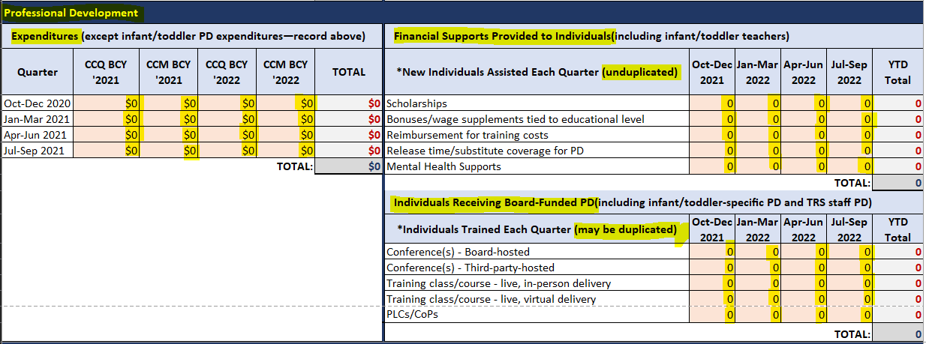

## Texas Rising Star/Quality Improvement (except professional development)

In the Texas Rising Star/Quality Improvement section of the Quarterly Data tab, Boards will report **only** the following:

* Expenditures:
  + These are funds expended each quarter on Texas Rising Star/Quality initiative activities. For examples of allowable expenditures, refer to the CCQ Strategic Planning and Expenditures Guide.
  + This does **not** include any professional development, as it is reported in the Professional Development section.
  + This **does** include expenditures related to Texas Rising Star staff, such as salaries, fringe benefits, and travel costs.
  + Be sure to denote which funding “bucket” expenditures are from CCQ or CCM and from which year (previous or current).
  + Totals will auto-generate within the Total column.

For the Texas Rising Star Staffing section, these fields are auto-populated based on the data that the Board entered in the TRS Staffing tab. Boards must **review this section** and make updates to the TRS Staffing tab, which includes the following:

* Budgeted FTEs: The number of staff members the Board plans to support, which includes vacant positions
* Filled FTEs: The number of staff members the Board currently supports, which does not include vacant positions

**Reminder**: Unlike other sections of the Quarterly Data tab, the calculated YTD column is an average of each quarter’s FTEs, rather than a total.

All data reported in this section must also be reported in the Quarterly Narrative tab. The numbers of individuals or programs reported in the Quarterly Narrative tab must match the numbers reported in the Quarterly Data tab.

Below is a snapshot of the Texas Rising Star/Quality Improvement (except PD) section in its entirety.

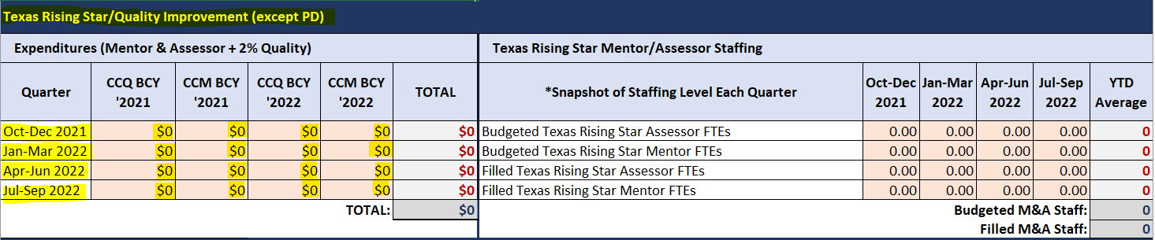

## Supporting Health & Safety Standards (including Health & Safety–specific training)

In the Supporting Health & Safety Standards section of the Quarterly Data tab, Boards will report the following:

* Expenditures:
  + These are funds expended each quarter on Supporting Health & Safety Standards activities and/or initiatives or professional development that are specific only to First Aid/CPR, food handlers, or transportation. For examples of allowable expenditures, refer to the CCQ Strategic Planning and Expenditures Guide.
  + This does **not** include any other professional development, as it is reported in the Professional Development section.
  + Be sure to denote which funding “bucket” expenditures are from CCQ or CCM and from which year (previous or current).
  + Totals will auto-generate within the Total column.
* Providers Receiving Health and Safety Supports (unduplicated):
  + The number of new providers that received **defibrillators** (AED machines)
  + The number of new providers that received **security systems, cameras, or coded entry** systems
  + The number of new unduplicated providers that received cleaning materials, foggers, personal protective equipment (PPE), or health-related services
  + The number of new providers that received a **support that does not fit into the types above** **(other)** and is not professional development

All data reported in this section must also be reported in the Quarterly Narrative tab. The numbers of individuals or programs reported in the Quarterly Narrative tab must match the numbers reported in the Quarterly Data tab.

Below is a snapshot of the Supporting Health & Safety Standards (including Health & Safety–specific training) section in its entirety.

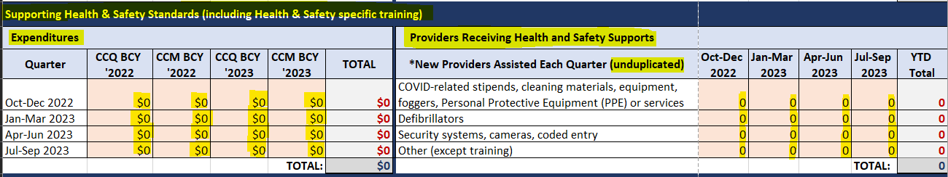

## Evaluation & Assessment (Tools to measure effective practice or to measure age-appropriate child development)

In the Evaluation & Assessment section of the Quarterly Data tab, Boards will report the following:

* Expenditures:
  + These are funds expended each quarter on Evaluation & Assessment activities and/or initiatives. For examples of allowable expenditures, refer to the CCQ Strategic Planning and Expenditures Guide.
  + This does **not** include any professional development, as it is reported in the Professional Development section.
  + Be sure to denote which funding “bucket” expenditures are from CCQ or CCM and from which year (previous or current.)
  + Totals will auto-generate within the Total column.
* Evaluation and Assessment Tools Used:
  + From the drop-down menu, Boards will select one of the following evaluations or assessment tools that was purchased or used **and** indicate the number of new providers that were supported by each of the following tools:
    - Environmental Rating Scales (ERS), such as ITERS (infant/toddler), ECERS (early childhood), or SCERS (school-age)
    - Other Evaluation Tools, including CLASS, Program Administration Scale (PAS) or Business Administration Scale (BAS), and Language Environment Analysis (LENA)
    - Teaching Strategies Gold (TS Gold)
    - Ages and Stages Questionnaire (ASQ)
    - Other child assessment tools

All data reported in this section must also be reported in the Quarterly Narrative tab. The numbers of individuals or programs reported in the Quarterly Narrative tab must match the numbers reported in the Quarterly Data tab.

Below is a snapshot of the Evaluation & Assessment (tools to measure effective practice or to measure age-appropriate child development) section in its entirety.

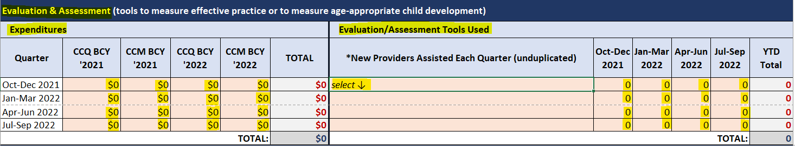

## Supporting National Accreditation

In the Supporting National Accreditation section of the Quarterly Data tab, Boards will report the following:

* Expenditures:
  + These are funds expended each quarter on Supporting National Accreditation activities and/or initiatives. For examples of allowable expenditures, refer to the CCQ Strategic Planning and Expenditures Guide.
  + This does **not** include any professional development, as it is reported in the Professional Development section, or membership fees to national organizations.
  + Be sure to denote which funding “bucket” expenditures are from CCQ or CCM and from which year (previous or current).
  + Totals will auto-generate within the Total column.
* Providers assisted in pursuit or maintenance of national accreditation, as follows:
  + The number of new **licensed child care center** providers assisted in pursuit or maintaining of national accreditation
  + The number of new **licensed or registered child care home** providers assisted in pursuit or maintaining of national accreditation

Boards must be aware that Texas Rising Star recognizes the following national accreditations:

* National Association for the Education of Young Children (NAEYC)
* National Association for Family Child Care (NAFCC)
* National Early Childhood Program Accreditation (NECPA)
* National Accreditation Commission for Early Child Care and Education (NAC)
* Council of Accreditation (COA)
* Cognia Quality Early Learning Standards (QELS)
* Early Head Start and Head Start programs licensed by CCR (providing wraparound services)

All data reported in this section must also be reported in the Quarterly Narrative tab. The numbers of individuals or programs reported in the Quarterly Narrative tab must match the numbers reported in the Quarterly Data tab.

Below is a snapshot of the Supporting National Accreditation section in its entirety.

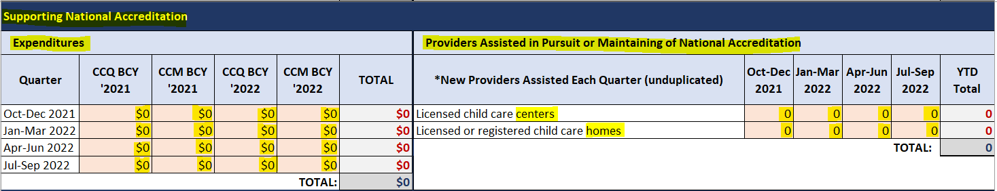

## Other Activities (Shared Services, Pre-K Partnership Supports, Supply-Building Activities, Mental Health Supports)

In the Other Activities section of the Quarterly Data tab, Boards will report the following:

* Expenditures:
  + These are funds expended each quarter on Other Activities, specific to Shared Services, Pre-K Partnership Supports, and/or Supports to Child Care Providers in Response to the Impacts of COVID-19 activities/initiatives. For examples of allowable expenditures, refer to the CCQ Strategic Planning and Expenditures Guide.
  + This does **not** include any professional development, as it is reported in the Professional Development section.
  + Be sure to denote which funding “bucket” expenditures are from CCQ or CCM and from which year (previous or current).
  + Totals will auto-generate within the Total column.
* New Formal Partnerships (unduplicated):
  + The number of new **formal partnerships developed in a prekindergarten (Pre-K)** setting
  + The number of new **formal partnerships developed in a Head Start (HS)/Early Head Start (EHS)** setting
* Supply-Building Activities:
  + The number of new unduplicated providers that received wage supports for child care program staff
  + The number of new unduplicated providers that received start-up funding for new programs
  + The number of new unduplicated providers that received stabilization or supply-building stipends
* The number of new unduplicated providers that received mental health supports (excluding PD specific to mental health)

All data reported in this section must also be reported in the Quarterly Narrative tab. The numbers of individuals or programs reported in the Quarterly Narrative tab must match the numbers reported in the Quarterly Data tab.

Below is a snapshot of the Other Activities (Shared Services, Pre-K Partnership Supports, Supply-Building Activities, Mental Health Supports) section in its entirety.

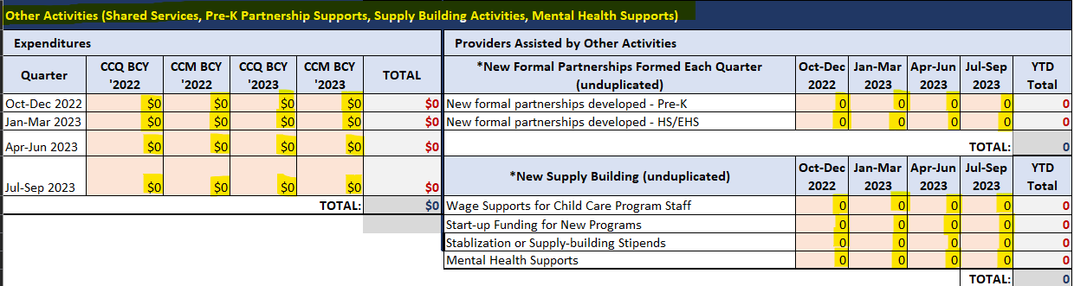

## End of Worksheet Totals

At the bottom of the Quarterly Data tab, totals for each quarter for each funding year will auto-generate.

Please do **not** attempt to manipulate these cells, as these totals will auto-populate in the YTD Summary Tab.

Due to these totals auto-generating, there is no longer a need for EOY reports.

Boards may use this as a quick glance at the total amounts expended to ensure that they match what is reported in TWC’s Cash Draw & Expenditure Reporting system (CDER) and to verify that spending is on track for the year.

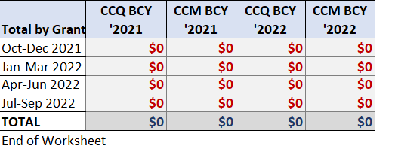

# Quarterly Narrative

All numbers documented on the right side of the Quarterly Data tab must be reported in the Quarterly Narrative tab. The Quarterly Narrative tab serves as a check and balance against what has been reported in the Quarterly Data tab (which includes both the left and right sides).

Therefore, for each quarter, transfer the participants’ supported information for each activity to this tab. For example, if there are 27 individuals who received scholarships in Quarter 1, a narrative about the 27 individuals must be included in the quarterly narrative for Quarter 1.

Additionally, for each category, Boards must report each activity that was completed for its applicable quarter and **not** captured in the specified data sections (right side of the Quarterly Data tab).

Boards will report **all** activities implemented by taking the following steps:

1. Select the correlating activity type in the first column. There is a drop-down menu for selection.
2. Describe the activity. This must include enough details to adequately describe what activity took place and how it was conducted. More details are better than fewer.
3. Indicate the project’s status at the time of reporting, which helps TWC understand that an activity may roll over into another quarter but have new participants.
4. Indicate the number of participants. Numeric values are preferred, as the description of the activity will indicate whether the participants are individuals, staff members, parents, or child care programs. If the number is unknown or not applicable, denote N/A.
5. In the last column enter the measurable outcomes for the activity, which allows the Board to measure success when analyzing data before, during, and at the conclusion of the activity.

**Note: It may be more efficient for Boards to report in the Quarterly Data tab and describe the activity reported in the Quarterly Narrative tab to account for each activity.**

Below is a snapshot of the Quarterly Narrative for one quarter that lists examples of activities provided by a Board. The number of participants and programs reported in the Quarterly Narrative tab must match the numbers reported in the Quarterly Data tab.

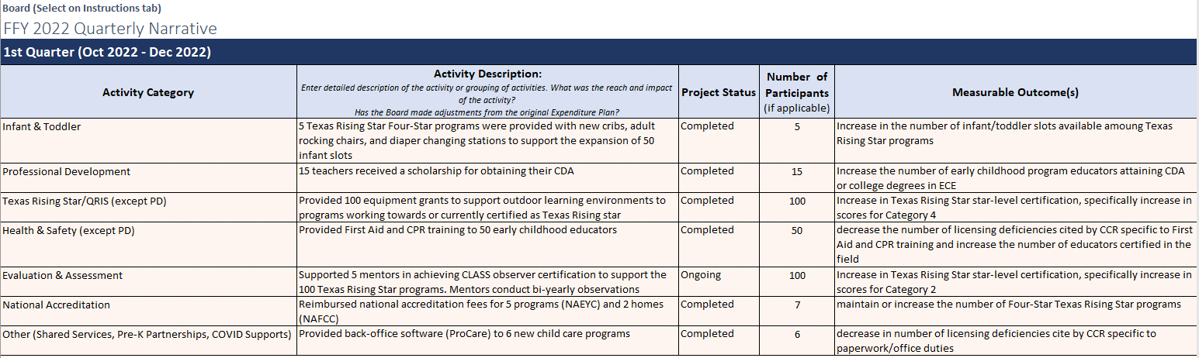

For more examples of activities and measurable outcomes by category, please review either the Examples & Definitions tab and/or the CCQ Strategic Planning and Expenditures Guide.

# Year-to-Date Summary Tab

In the Year-to-Date (YTD) Summary tab, shown below, totals will auto-populate based on what is reported in the Quarterly Data tab.

Boards must not manipulate or report any data in this tab. This tab is read-only and available only for Boards to review totals in order to ensure accuracy across quarters.

It is recommended that Boards closely review the information in the following columns in the YTD Summary tab:

* **Expended YTD:** The column auto-calculates totals, quarter over quarter, showing up-to-date amounts expended in each category.
* **YTD % of Total Expended:** The column auto-calculates the total percentage expended in each category as a total of all expenditures. Boards may review this column to note whether any category shows higher-than-expected percentage totals in order to consider reevaluating their plan and/or budget.
* **% Planned for Year:** The column shows the percentage of planned funds that have been spent in the current fiscal year. Boards may review this column to note the current quarter and what percentage of the budget has or has not been expended in order to ensure that they stay within their budget.
* **% Planned vs YTD % Expended:** The column shows the difference in the amount planned and the YTD expended. If there is a high percentage expended in the first quarter, Boards may consider investigating further in order to ensure that they stay within their budget for the remaining quarters. Conversely, if there is a low percentage of the total expended during the third quarter, Boards may need to adjust their plan and/or budget accordingly.

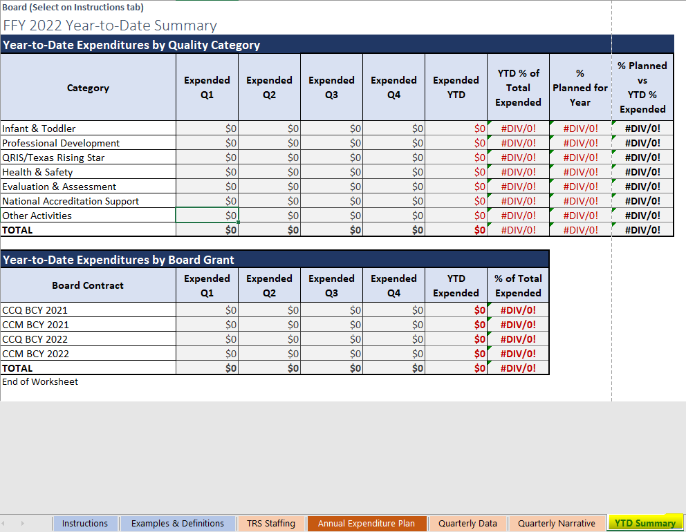

# WD Letter Revisions Tab

The WD Letter Revisions tab shows information related to WD Letter revisions and/or information in a reporting template that would result in a change letter.