Texas Rising Star 4-Year Review State Workgroup Conference Call # 10
Monday, 01/06/2020
11:30 am- 1:30 pm

The Workgroup continued to use the poll pod feature to assist with the flow of the conference call and to determine consensus within the group.

Agenda Overview

The Workgroup reviewed the two options proposed for the screening form, director and staff qualification indicators, and the system-wide recommendations that have been proposed so far.

Screening Form Options
Option 1:
- For any Level 1 or Level 2 occurrence the reduction time is moved to 3-months instead of 6-months.
- Probation remains as is.
- CQIP is provided to assist the program.
Option 2:
- For any initial Level 1 or Level 2 occurrence program is placed on probation with an implemented CQIP.
- Probation remains as is.
- If within the 6-month probation the program has any additional deficiencies the program is immediately reduced a star level and placed on a 2nd probation.
- No program may exceed 2 consecutive Probation Periods.
- The Workgroup discussed that the additional deficiencies referenced should only pertain to Level 1, Level 2 or total deficiencies.

Via the polling pod the Workgroup agreed with the modified Option 2. Additionally, they proposed that programs can only have a total of 4 probations during the 3-year certification period.

Director Qualifications
- The Workgroup discussed the current qualifying indicators for Director Qualifications specific to each facility type: P-DEQT-01 (centers), P-DEQT-02 (homes), and P-DEQT-03 (school age)
- The Workgroup expressed the desire to move the field to a higher level of education qualification and there was a concern of a non-expiring certificate overriding the determined Texas Rising Star indicators.
- The Workgroup reviewed the scoring indicator specific to associate degrees and college hours specific to child development being amended to match child care licensing indicators. There was consensus to not modify this indicator at this time.
- Via the polling pod, the Workgroup agreed to change the “non expiring certificate” scoring indicator from 3 points to 2 points. Additionally, the Workgroup agreed to match the change to all facility types, updating the indicators for homes and school age directors.

Staff Qualifications
The Workgroup discussed the current qualifying indicators for staff qualifications (centers and school age): P-CQT-01 and P-CQT-02
- The Workgroup expressed the desire to move the field to a higher level of education qualification for staff as well and a concern about the indicators specific to training hours and working on a CDA was expressed.
- The Workgroup requested additional clarification/guidance within the Technical Scoring Manual to define what “working on a CDA” means in regard to supporting documentation.
- Via the polling pod, the Workgroup agreed to revisit the indicators in the next 4-year review.

System-wide Recommendations Review
The Workgroup reviewed the system-wide recommendations that will be presented for approval to ensure there was no additional discussion needed.
- 1-star Programs
- Development of long-range plan to move CCS programs to higher levels of quality: The Workgroup requested for this to also include moving early learning program staff to higher levels of qualifications.
- Mentor Investment and Centralized Assessors
- TRS Staff Supports: The Workgroup requested to ensure cross training with Child Care Licensing was part of these supports.
- Reimbursement Rates
- Statewide WF Registry
- Outreach/ Marketing

Next Steps
- TWC will present the final recommendations to the Commission on January 21, 2020.
- Stakeholder Meetings will take place in February at 7 local Board area offices. All meetings will begin at 6pm, lasting approximately an hour and half long.
- The Workgroup requested an additional call after the culmination of the stakeholder meetings to debrief before final recommendations are sent to the Commission.
- Next conference call will be moved to January 13, 2020 at 11:30 am to accommodate the timeline for Commission review.
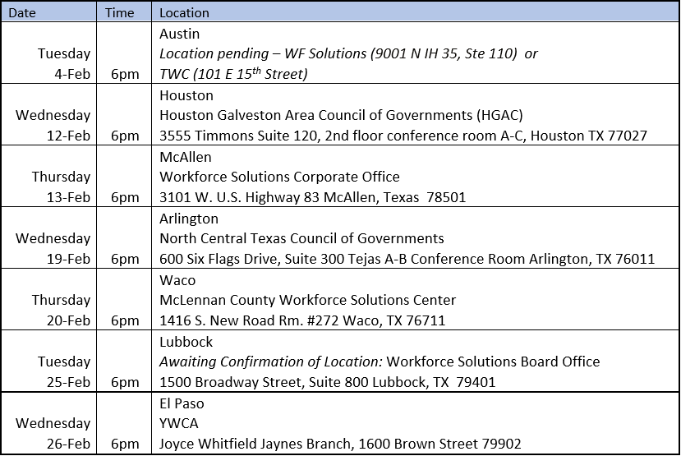

- Next Conference Call is January 13,2020 at 11:30 am- 1:30 pm.

